

Sewerage Incident Emergency Response Manual

January 2010

Queensland Water Directorate (qldwater)

Level 1, Local Government House
25 Evelyn Street
Newstead Qld 4006
PO Box 2100
Telephone +61 7 3252 4701
Facsimile +61 7 3257 2392
Email enquiry@qldwater.com.au

DISCLAIMER AND COPYRIGHT

Disclaimer
This Policy Discussion Paper is current as at January 2010. However, the Queensland Water Directorate (qldwater) and its advisory committee:
- do not guarantee the accuracy, currency or completeness of the information contained in the manual;
- are not responsible for the result of any actions taken on the basis of the information contained in this manual, nor for any errors or omissions;
- do not accept liability for any loss or damages arising from the use of the information contained in this manual; and
- expressly disclaim all and any liability and responsibility to any person, whether a recipient, reader or otherwise, in respect of anything, and of the consequences of anything, done or omitted to be done by any such person in reliance upon the whole or part of the contents of this manual.

The Queensland Water Directorate (qldwater) also advises that some of the information contained in this manual is provided by third parties. Therefore we do not:
- Warrant that such information is accurate or that its reproduction is free from errors; nor
- Accept liability for any loss or damages arising from the use of, or reliance on, the information contained in this publication.

Copyright

Except as permitted by the Copyright Act, the format and templates provided should not be reproduced without written permission. Photocopying and modifying the O&M Manual is permitted when undertaken in accordance with the recommendations provided in the manual. Institute of Public Works Engineering Australia Queensland (IPWEAQ) Division Inc. © 2009.

Acknowledgements

In developing this document a number of WSPs have provided interest and feedback:
- Cairns Regional Council Water and Waste;
- Carpentaria Shire Council;
- Ipswich Water;
- Mackay Regional Council;
- Fitzroy River Water, Rockhampton Regional Council;
- Sunshine Coast Water; and
- Townsville Water.

Documentation has been provided by some of these WSPs and this has been referenced where appropriate. An initial draft of the document was subsequently circulated to a number of WSPs for comment. We thank all those who have input to the preparation of this document, including our consultants, Water Strategies and PB.

All Queensland Water Service Providers are encouraged to provide feedback and corrections for incorporation in any future versions.

Queensland Water Directorate (qldwater) is a business unit of IPWEAQ and is an initiative of:
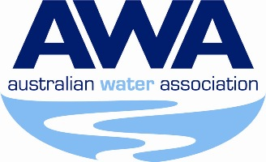



Contents

Page Number
1. Introduction - 5 -
2. Internal structure during emergencies - 6 -
3. Emergency Response Plans - 7 -
3.1 Flow Charts for Emergency Response Plans - 7 -
3.2 Detailed Incident Response Plan - 10 -
3.3 Remediation and Clean-Up - 12 -
4. Improvement Plans - 15 -
4.1 Incident Debrief - 16 -
4.2 Improvement Action Plan - 17 -
5. DERM REPORTING PROCESS - 18 -
6. DERM Notifications - 19 -
6.1 Table 6-1 Summary of DERM Notification Procedures - 19 -
6.1.1 Pollution Hotline - 20 -
6.1.2 Formal Notifications - 20 -
6.1.3 Quarterly Summary Report - 20 -
6.2 Record keeping requirements - 21 -
7. Pump Station Locations - 22 -
8. Risk Assessments at Overflow Locations - 23 -
8.1 Tankering from designated overflow locations - 24 -
9. Sewer Network Plans - 25 -
10. Overflow Technical Data Sheets - 28 -
11. Emergency Contacts - 30 -
11.1 Internal Emergency Contacts - 30 -
11.2 External Emergency Contacts - 31 -
12. Water quality sampling procedures - 32 -
13. Emergency Spill Kit Checklist - 33 -
14. Forms - 34 -
14.1 DERM Notification Form - 34 -
14.2 Overflow Report Form - 37 -
15. Templates - 40 -

List of tables

Table 2-1 Authorities during emergencies - 6 -
Table 3-1 Operational Plans - 7 -
Table 3-2 Detailed incident response plan - 10 -
Table 3-3 Detailed incident response plan - 13 -
Table 4-1 Summary of Investigation and Improvement Plans and Responsibilities - 15 -
Table 6-1 Summary of DERM Notification Procedures - 19 -
Table 6-2 Reporting requirements for Overflow Events - 21 -
Table 7-1 Details of Pump Stations - 22 -
Table 8-1 Designated overflow locations and risk - 23 -
Table 8-2 Guidance for Tankering from Overflow Locations - 24 -
Table 11-1 Internal Emergency Contacts - 30 -
Table 11-2 External Emergency Contacts - 31 -
Table 12-1 Water quality sampling procedures - 32 -

Introduction
This document provides a template for developing an Emergency Response Manual. It is accompanied by a set of guidelines that will assist in populating the template. The template provides plans, templates, forms and procedures that can be tailored for specific Water Service Providers (WSP’s). The Guidelines provide advice that may be useful when the template is being developed.
This manual should be modified and adapted as the service provider sees fit to reflect their system and the information available. Guidance notes are included in blue and should be deleted or replaced with input data in the final document.
This Manual contains WSP’s emergency response procedure for responding to sewage overflows. It also contains key information that may be required when responding to such events. The primary objectives of the manual are:
- To reduce the impacts of overflows on the environment and the community;
- To meet the general environmental duty defined under DERM’s “Framework for managing sewerage infrastructure to reduce overflow and environmental impacts”;
- To reduce the number of overflows that occur from the sewerage system ;
- To bring together the following information to prepare for an emergency: system plans, emergency response procedures, overflow locations, critical contacts and procedures; and
- To assist WSP officers to consistently manage responses to sewage overflows.
The manual requires an annual review to ensure procedures are up to date and reflect higher standards for environmental performance.
Copies of the manual should be accessible to all staff involved in managing incidents. Copies of the document should be maintained: electronically, in operator vehicles, in supervisor offices and at customer service centres. The manual should be used with the Technical Guidelines.
This manual is accompanied by guidelines. The guidelines describe a best practice approach to managing sewerage infrastructure to reduce impacts of overflows through planning, implementing emergency response plans and documenting incidents as follows:
- Planning ensures the sewerage network is designed to reduce risk of failures and future upgrades to the system will work towards achieving this objective. Planning undertaken in developing this document includes: (insert list of planning activities, i.e. system network studies, environmental audits, risk assessments, analysis of overflow and operational data.) In the first instance planning minimises the risk of spills occurring. In the second instance it has collated relevant system information, improved awareness of the system and reduced the pressure on operational staff to make decisions on complex matters during emergencies.
- Implementation is done by following the procedures developed and documented in this manual. Checklists, forms and procedures are provided in the Manual and should be followed during emergencies.
- Documentation requires that all information is documented by completing the emergency response forms and making contact with DERM as per the manual.

Internal structure during emergencies
Describe the key personnel who will react to emergencies, giving consideration to on ground clean up procedures, communication to DERM, authorities and delegations. The following paragraphs may be used as a guide.
The established hierarchy, already applying to normal work related activity, will generally apply during an emergency. Under normal operating conditions this will mean responsibilities are distributed as follows.
Table 2-2 Authorities during emergencies
Officer | Contact Details | Responsibilities
Customer Service Officer | Office phone no. | Receiving the notifications from the public, Record details in customer request system,  Contacting relevant field staff,  Notify management if spill is considered major,  Provide information to the public on request.
Field Staff, Sewerage Ganger, | Office phone no  Mobile Phone | Attend the scene,  Assess the overflow,  Contact the co-ordinator/ manager,  Organise clean-up and spill remediation.
Coordinator, Technical Officer | Office phone no  Mobile Phone | Notify Manager,  Attend site,  Determine cause,  Notify DERM immediately by phone and give formal written notification,  Organise collection, storage and delivery of samples to laboratory,  Notify land owner/resident(s) of incident, proposed actions,  Arrange letterbox drops and door-knocks where appropriate,  Arrange warning signs where appropriate,  Notify relevant STP staff regarding tanker deliveries,  Ensure all relevant follow-up notifications as required,  Investigate and implement factors which will prevent recurrence.
Manager | Office phone no  Mobile Phone | Notify media and liaise with media unit,  Notify senior management/ CEO,  Ensure DERM notifications occurs by phone and in writing,  Arrange for notification email to be circulated in WSP,  Ensure follow-up investigation and reporting is undertaken.
Media Liaison | Office phone no  Mobile Phone | Liaise with manager to identify key risks and communicate them to the public.

Emergency Response Plans

Emergency response plans will be used by managers, field staff and supervisors to ensure responses to emergencies are efficient and safe. There are two emergency response plans contained in this document as described in Table 3-1.
Table 3-3 Operational Plans
Plan | Responsibility | Description
Incident Response | Field officer/Supervisor/ Manager | Applies from when a notification is received and applies until flow is contained and the site has been made safe
Remediation and Clean-Up | Field officer/Supervisor/ Manager | Follows on from the incident response plan, it contains a procedure for remediating the site in a safe and efficient manner

Flow Charts for Emergency Response Plans

Flow charts for incident response and remediation and clean-up are provided on the following pages. Detailed descriptions of these processes are contained in Section 3 and 4.
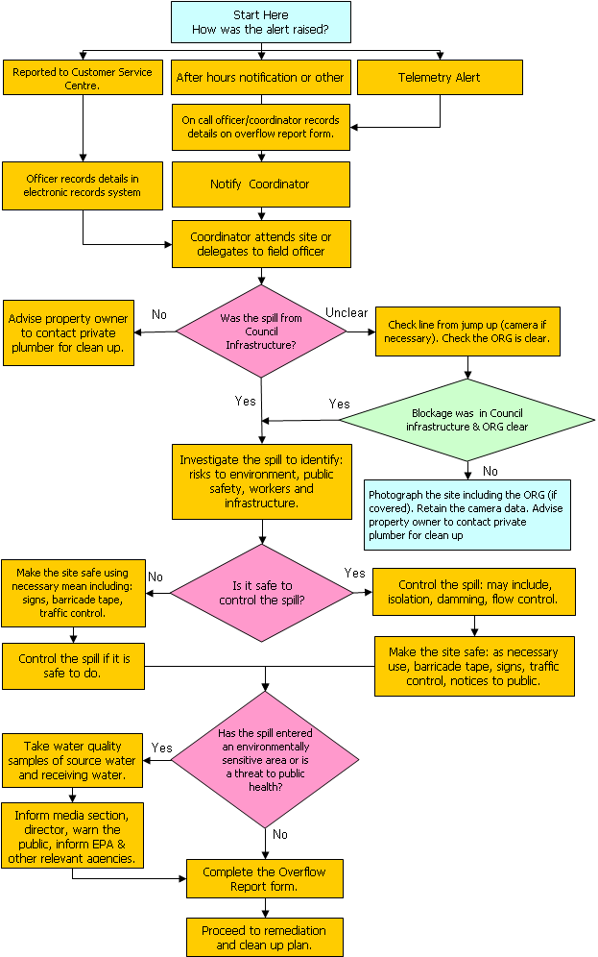
Incident Response Plan
Remediation and Clean-Up Plan
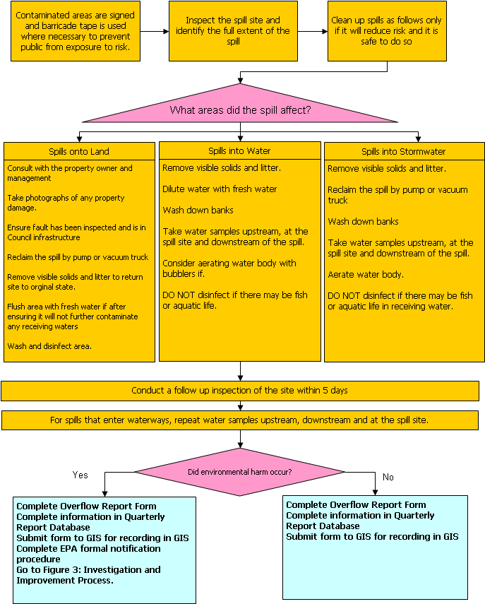

Detailed Incident Response Plan
The plan is triggered when notification is received that an overflow has occurred. It involves customer service operators, field officers, managers and may extend to include public relations and other WSP departments in severe cases.
Table 3-4 Detailed incident response plan
Description | Actions Required
1. Receiving notification of an overflow
Notification may be received from a telemetry alarm, a member of the public, a WSP employee or another system. In instances where the notification has been reported, the officer must collect the details of the overflow and record them in the electronic records system. | - Obtain site details and nature of surcharge,  - Enter details into the customer request record system,  - Contact field crew and field coordinator,  - Alert the manager/supervisor.
2. Respond to the emergency
Where possible, emergency events should be responded to immediately or within (xxx) hours as stated in WSP’s Customer Service Standards.  If several overflows occur at one time priority is given to sites with high environmental risk. If the spill is from a designated overflow location, consult the Technical Data Sheet. | - Response recorded in the Overflow Report Form.
3. Investigate who is responsible for the spill if it occurs on private property
If the spill is caused by a blockage or fault in privately owned drains, or the ORG has been covered, the property owner should be advised to contact their insurance agency and a private plumber to organise clean up. | - Camera the line to determine if the fault is in WSP infrastructure or private pipe using a house drain camera from the jump up,  - Check the ORG to see if it has been blocked.
4. Assess risk of environmental harm
Assess the risk of environmental harm or public safety and notify appropriate people.  Environmental harm occurs if the spill results in, or is likely to result in any of the following:  - environmental impacts e.g. fish kill, distress to wild life, marine plants or aquatic life;  - immediate public or environmental risk;  - a spill of more than 10,000 litres  - environmental or public health risks have been identified in a previous risk assessment  - poses a threat to public health or public amenity | - Identify if environmental harm has, or is likely to occur.
 | - Inform supervisor if an immediate risk to public or environmental health.
 | - Contact DERM on the pollution hotline (1300 130 372) if Environmental harm occurred.
5. Investigate the spill source, cause and extent
Investigate the source, cause and extent of the spill by walking around the site, consulting the Technical Data Sheet in Section 10 | - Inspect full extent of spill.  - If spill is from a designated spill location, consult Technical Data Sheet.  - Identify risks to public safety & environment  - Supervisor informed of risks to environment and public safety
6. Initiate response
WSP’s emergency spill kits are to be used in the following circumstances and are stored in the following locations:  (Enter name, purpose and storage locations of emergency Spill kits – for example: Emergency Spill Kit 1 is used for responding to all sewerage spills. It is located in the Works Carpark. An inventory list for this spill kit is contained in Section 13. | Inform supervisor if environmental harm has occurred.
 | Inform supervisor if there is an immediate risk to public or environmental health.
7. Control and Manage the Spill
Where the cause is WSP’s infrastructure the following actions may be used to control discharge and make the site safe.  - Protect the public and field staff: redirect traffic, erect hazard signs, supervise the site, erect barrier tape etc.  - Isolate and stop the spill if possible. Tankering should be used if it is safe to do so and there is expected to be a significant environmental benefit.  - If possible dam the spill to stop it spreading (consult the Technical Data Sheet).  - Contact Coordinator and document spill details in Wastewater Spill Report Form.  - Inform relevant Critical Contacts of the spill. Critical Contacts are listed in the Critical Contacts Register of the Emergency Response Manual.  - If the spill runs into a stormwater system or water body, or if it contains unidentifiable material, collect samples of the material as per the Sampling Procedure. | Erect signs and barricade tape to secure the site
 | Isolate the spill
 | Inform supervisor if there is an immediate risk to public or environmental health
 | Document spill details in the Overflow Report Form
 | Undertake sampling if required (refer to sampling procedure Section 12)
8. Informing critical contacts
If the spill poses a serious threat to public safety or environment harm then the following key personnel/agencies should be contacted:  - (Insert names of relevant staff/sections of WSP, for example):  - Manager of Infrastructure  - CEO  - Media Liaison Officer  - Local community groups  If the spill has caused damage to personal property, the spill should be cleaned up by the relevant insurance agency  Identify and contact other agencies for assistance from the Emergency Contacts List.  Identify and contact other agencies or departments that may be affected by the spill from the Notification Register in Section 6. | Contacted key personnel to inform of major spill event
 | Identified and contacted other agencies from the Emergency Response List.
9. Collect evidence and undertake sampling of spill
If the spill has entered a waterway or water body, water quality sampling should be undertaken as per Section 12.  Evidence of the spill should also be documented including site photos of the spill, the failure, damage and control measures. Complete the Overflow report form. |  | Photos of site taken
 |  | Sampling undertaken
 |  | Samples delivered to laboratory
 |  | Overflow report form filled out
10. Reporting
Records of all spills should be maintained by:  - Completing the overflow report form  - Submitting the overflow report form to GIS Officers to include in the GIS System  - Record details in a Quarterly Report Database containing information on all sewage spills  - Completing the DERM Notification form after the spill has been remediated  The overflow report form should be completed immediately |  | - Complete relevant sections of overflow report form (form provided in Section 14)  - Complete relevant sections of Quarterly Report Database (Template in Section 15)  - Submit overflow report form to GIS officers if complete.

Remediation and Clean-Up
The remediation and clean-up plan follows on from the incident response plan. It commences when the spill has been contained and the site is safe. The remediation and clean-up plan ensures all appropriate measures are taken to return the site to its previous condition, in a safe and efficient manner.
Table 3-5 Detailed incident response plan
Description | Actions Required
1. Ensure signage and barricade tape is in place.
Signage and barricades are required to secure contaminated areas from the public. Give consideration to the location of the spill and the whereabouts of nearby schools and areas where children may frequent. Ensure the area is well fenced in these instances | - Assess the site to determine if there is a threat to public health or safety  - Install appropriate signage and barricade tape
2. Take Appropriate Remediation Action
Different remediation measures apply to spills on land, spills into waterways or water bodies and spills into stormwater systems.  For spills onto land disinfection may be required but only if there is no chance of the disinfectant polluting a waterway or waterbody. In extreme instances land spills may also be remediated by excavating contaminated soil. It is recommended that DERM is consulted before commencing. The clean-up procedure is determined by whether the spill was caused by a fault in WSP infrastructure or private property. Where the spill is due to a fault on private property, or where the ORG has been covered by the property owner, the clean up should be undertaken by the property owner.  Where a minor spill occurs, it should be cleaned up by attending officers, as per the procedures for a land spill, but in consultation with the property owners.  For major spills or where damage has been caused to internal fit out (carpets, furniture etc) or the building structure, then the clean up will be directed by the insurance company.  Dilution reduces the concentration of pollutants and will increase the rest of organic breakdown. It may be beneficial where fish and aquatic life are threatened. It may also assist to reduce odours.  - Aeration with bubblers or blowers can be used in a water body where aquatic life is stressed. Aeration will promote the breakdown of organic material and will reduce odours from septic water. | - Assess the site and the receiving environment to determine where the spill is likely to cause impacts. Walk around the entire spill site if necessary.  - Where practical reclaim the spill using a vacuum truck or pump.  - Remove any visible solids and clean the area.  For Spills onto Land  - Make all possible attempts to reclaim the spill.  - Consider flushing and disinfecting the area only if there is no chance of it affecting sensitive areas or aquatic life.  - Consider excavating the contaminated soil and transporting it to a safe site (STP or landfill). Fresh clean soil should be used as a replacement.  For Spills into waterways/waterbodies  - Take samples upstream, at the spill site and downstream of the spill.  - Consider diluting with fresh water or aerating with bubblers or blowers if the spill can’t be contained and poses a threat to aquatic life. Aeration may also reduce odour issues.  For spills into stormwater systems:  - Aeration with bubblers or blowers will promote the breakdown of organic material and can reduce odours from septic water.  - Disinfectants should not be used in the stormwater system as these will end up in receiving waters.  For all Spills:  - Inspect the site. Leave barricade tape and warning until contamination risk is gone. This may be up to one week for public access areas.  - Continue to monitor the site until to identify any lasting effects or when the site has returned to normal. Monitoring of a site may include: visual observations of environmental stresses (dying trees, aquatic life etc), observations of odours, feedback from the public.
3. Follow up actions
These including: reporting the incident details, making any necessary parties aware that the incident occurred, ensuring the site remains safe and risks are managed. | - Complete relevant sections of the Overflow Report Form (14.1).  - Where necessary make residents/businesses/schools aware of the spill and warn of potential risks.  - Check barricades and signage are in place.  - Ensure all other risks at the site have been managed, manhole lids are in place, pumps are working etc.
4. Site Inspection
Signs and barricades should remain in place where practical until the area is no longer contaminated. For land spills this may be approximately 1 week after the spill has occurred. For spills into waterways and water bodies, testing will be used to confirm when water quality has resumed to normal levels. When removing signs and barricades, check the site for any other noticeable signs of the spill occurring. | - Return to the site as necessary to inspect barricades and tape.  - Remove signs and barriers the site is deemed safe and the contamination gone.
5. Inform DERM of the remediation process and any lasting impacts of the spill
Complete any necessary reporting requirements and ensure information is stored in the appropriate places to be communicated to DERM. Where Environmental Harm was deemed to have occurred, DERM Notification Form must be submitted within one week. | - Complete Overflow Report Form  - Complete information in Quarterly Report Database  - Submit form to GIS for recording in GIS  - If Environmental Harm occurred you must complete and submit DERM formal notification form within one week of the spill occurring

Improvement Plans
Improvement plans will be used by managers, planners and technical officers to investigate causes and responses to sewage overflows.
There are two improvement plans in this document: an incident debrief is contained in Section 4.1 and an Improvement Action Plan is contained in Section 4.2. These plans are described below.
Table 4-6 Summary of Investigation and Improvement Plans and Responsibilities
Plan | Responsibility | Description
Incident Debrief | Manager/Technical Officer/Supervisor | To assess the response to the emergency and identify improvements to the emergency response plan.
Improvement Action Plan | Manager/Technical Officer/ Supervisor | The Improvement Action Plan ensures overflow events are appropriately investigated and improvements are made to minimise the risk of a repeat occurrence. This information is then fed into DERM Notifications and future network planning. The plan is a guide for answering the following questions.  - Why did the spill occur?  - What were the impacts of the spill?  - How was the spill reacted to?  - What measures were in place to minimise the occurrence and impact of the spill?  - What were the consequences of the spill?  - What actions will be taken to minimise risk of reoccurrence?

INCIDENT DEBRIEF

IMPROVEMENT ACTION PLAN
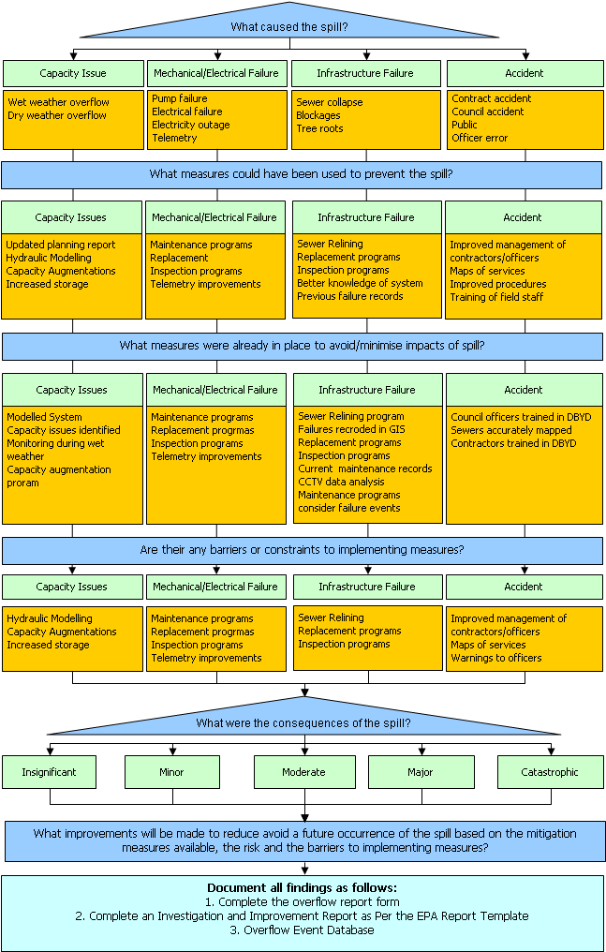

DERM REPORTING PROCESS
Start Here
Establish whether the incident caused, or is likely to cause environmental harm.
Did the incident result in, or is the incident likely to result in?

- A threat to public health
- An observable environmental impact
- fish kill, distress to wild life, plants or aquatic life
- Community reaction
- A release in excess of 10 000 litres
- Harm to: land, air, water, ecosystems, human-made or modified structures or areas,
- Amenity of: land, air, water, ecosystems, human-made or modified structures or areas.
Environmental Harm has occurred
Environmental Harm has not occurred
3. Summarise details of all spills and follow up actions in quarterly reports to DERM. The reports should include:
- Locations of Spill
- Asset identification
- Reason for failure
- Did environmental harm occur?
- Follow up actions and improvements

1. Contact DERM Immediately on Pollution Hotline
Ph: 1300 130 372
No to All
Yes to one or more
2. Complete and submit DERM Notification Form within 1 week of when the spill occurred
Form should contain:
All details of spill including a description of the environmental harm and any improvement actions
Summarise details of all spills and follow up actions in quarterly report to DERM.
The reports should include:
- Locations of Spill
- Asset identification
- Reason for failure
- Did environmental harm occur
- Follow up actions and improvements

4. Consider entering into a voluntary Environmental Management Plan (EMP) with DERM to rectify the issue.
An EMP template is attached in the Section 15 of this manual

DERM Notifications
DERM must be notified of events that create or are likely to create environmental harm. The formal definition of Environmental Harm is in the Environmental Protection Act. In this instance it is defined as any harm or potential harm to the environment or the amenity of the environment, including land, air, water, organisms and ecosystems, human-made or modified structures or areas. The following situations provide examples of environmental harm:
- Where the release poses a threat to public health
- Where there is an observable environmental impact e.g. fish kill, distress to wildlife, marine plants or other aquatic life
- Where the release has generated, or is likely to generate, community reaction
- Where the release occurs in dry weather and is in excess of 10 000 litres.
Table 6-7 Summary of DERM Notification Procedures
Notification Procedure | Applicable To | Information Contained | Template / Reporting Structure
Quarterly Reports to DERM | All overflows that occur | - Location  - Asset identification  - Reason for failure  - Did environmental harm occur?  - Follow up actions and improvements | Insert file path to electronic database, a sample excel template is provided with this report
Immediate notification on the pollution hotline | All spills where environmental harm has occurred or is deemed likely to occur | - Location of Spill  - Asset identification  - Potential risks and impacts  - Action being taken | Pollution Hotline  Ph: 1300 130 372
Formal notification in writing within one week of the spill occurring. | All spills where environmental harm has occurred or is deemed likely to occur | - Locations of Spill  - Asset identification  - Reason for failure  - Description of impacts  - Results of investigations into response and mitigation measures.  - Follow up actions and improvements  - Results of monitoring. | DERM Notification Form Template in Section 14.
Voluntary Environmental Management Plan | Situations where environmental harm has occurred and the WSP needs to demonstrate to DERM a commitment to improvement.

Pollution Hotline
The pollution hotline is used to notify DERM immediately of any incidents that have resulted or a likely to result in environmental harm. The Pollution Hotline number is 1300 130 372. It can be contacted 24 hours a day.

Formal Notifications
Formal notification is used to provide full details to DERM of a spill that has resulted, or is likely to result in environmental harm. This notification will contain details of the spill recorded during the Emergency Response, Remediation and Clean-Up. The form will also contain results of investigations into why the spill occurred and whether the reaction to the emergency event was appropriate. Information for formal notifications will therefore be collated from the outcomes of the investigation and improvement plan.
A template for DERM Notification form is provided in Section 14.

Quarterly Summary Report
The quarterly summary reports will contain details of all overflows. The purpose of this report is to provide an overview of how the WSP’s system is functioning and what actions are being taken to improve it.
The information should be stored in a database or excel spreadsheet, and a summary report produced for DERM from this information.
The information for this WSP is stored at: insert file path and location database.
A template for the Quarterly Report is provided in Section 15

Record keeping requirements
The following recording systems are in place to retain details of overflow events that can be used for tracking emergency responses, using information for planning and asset management, identifying high risk areas and reporting to DERM.
Table 6-8 Reporting requirements for Overflow Events
Report/Record | Information | Location/Responsibility
Record of notification in Electronic Record System | - Details of notification, including property details, asset name, report information.  - Details of actions taken and findings reported by the officer’s attending site | - (Insert name of customer request system)
Overflow report form | - All details of visit including asset information, condition information, cause of failure. | - Template in Section 14
GIS Record | Key asset condition information from the overflow report form, including:  - Fault type  - Cause of failure  - Asset condition | - Stored in the GIS system or alternatively, maintained in a spreadsheet if mapping isn’t available.
Overflow Event Database | Key Summary details of overflows including:  - Asset name and location  - Cause of failure  - Condition of asset  - Actions taken  - Recommended actions | - Maintained by (insert position name, i.e. Operations coordinator or technical officer)  - Template in Section 15
DERM Report Form | Details of events which caused environmental harm  - Summarises important information from the overflow Report Form.  - Summarises findings of the Investigation and Improvement Plan | - Template in Section 14

Pump Station Locations
The following table can be used as a template for storing key information on pump stations. This should be populated to ensure locations and access details are easily accessible during an emergency. Other information that you may consider adding to this table includes: telemetry system, access details, dangers and annoyances, odour issues, etc.
Table 7-9 Details of Pump Stations
Station Name | PS Address/ Location | Storage Capacity | Alarm System | Other Information
(Name of PS | PS Address | (pump station volume) | (Yes or no) | (any other information to be included))

Risk Assessments at Overflow Locations
This table will contain the results of an environmental risk assessment of overflow locations. The purpose of the risk assessment is to determine the likelihood and consequence of spills occurring from designated overflow locations.
The environmental risk assessment may be undertaken through a full environmental audit of the sewerage system that examines sewerage surcharge locations in modelling, and relates this information to the receiving environment of the designated overflow location.
Alternatively, a Desktop Environmental Audit of Designated Overflow Locations may be used to prioritise risks at pump stations.
The desk top audit considers:
- the receiving environment including waterways and residential areas
- pump station size
- storage at pump station
- environmental values
A desk top risk assessment tool has been provided with this document. The tool uses Microsoft Excel and provides a basic methodology for categorising risk into high, medium and low.
The following table describes designated overflow locations for the sewerage system and the degree of risk associated with each. An electronic version of this information is stored at the following location.
(Insert directory location of electronic storage location)
Table 8-10 Designated overflow locations and risk
Pump Station/ Manhole | Address | Ultimate Discharge to | Risk (environment and public health)
(Name of PS/Manhole) | (address of PS/Overflow) | (waterway or description of receiving environment) | (high, moderate, low)

Tankering from designated overflow locations
Using tanker trucks to avoid or reduce overflows is a standard mitigating measure in the Emergency Response. Tankering may give significant benefits in instances where small volumes of undiluted water overflow to high risk areas. However, in some instances where diluted effluent is involved, there may be minimal benefits. These benefits should be weighed up against the risks of tankering to determine whether tankering is the best remediation measure.
It is up to individual WSP’s to decide if it is worthwhile investigating this issue and populating the following table.
A desktop study of the benefits of tankering during wet weather events may be conducted to identify stations where tankering is required:
- Environmental and residential impacts of spillage,
- Capacity of pump station and assumed dilution during wet weather overflow events,
- Priority stations for tankering.
The outcome of this study will be to identify:
- Pump stations where tankering is likely to provide benefits,
- Pump stations where tankering may provide benefits and should be considered after priority stations,
- Pump stations where tankering is unlikely to provide benefit.
This information will be fed into Environmental Risk Assessment and Tankering Options in the ERM.
This table contains the results of an investigation into the benefits of tankering overflows from pump stations. The table may be used to make decisions regarding tankering during wet weather events. Tankering should only be used as mitigation measures where there is a significant environmental gain to be achieved and there is no risk to worker safety.
Table 8-11 Guidance for Tankering from Overflow Locations
Pump Station/ Manhole | Comment on Tankering
(Name of PS/Manhole) | Include instructions, comments on tankering from the location.

Sewer Network Plans
This section contains hard copies of sewer network plans and describes how to access electronic plans during an emergency during or after business hours.

Hard copies of plans are required if field officers do not have laptop computers with access to GIS.
Insert hard copies of your local sewer network, to ensure plans are available during emergencies. Plans should be as detailed as possible and include where possible:
  - Sewers,
  - Manholes,
  - Connections,
  - Pump stations,
  - Sewerage treatment plants,
  - Street names

(Insert name of sewer network plan)
Other plans may include: map of known surcharge locations, previous blockages, etc.
Electronic Copies of Sewer Network Plans
Define where sewerage network plans are located and how they may be accessed, for example:
The sewerage network plans are available during office hours from the operations office.
Sewerage network plans will be provided to officer’s attending callouts during office hours when emergency call outs are received.
The sewerage network plans are available after hours to on call officers on laptop computers, or will be made available by the supervising officer.

Overflow Technical Data Sheets
These data sheets provide technical information required to operate and manage overflow points. Technical data sheets are attached for the following overflow locations:
The data sheets provide technical information required to operate and manage overflow points during an emergency. One data sheet should be developed for each overflow location. Data sheets may include the following information:
- Photograph
- Locality and layout plans
- Other relevant information including a description of how to operate/remediate the overflow.
(List the pump stations with overflow data sheets)

(Insert WSP Name) Overflow Technical Data Sheet

Overflow Point Description: | (Address and pump station/manhole number)
Overflow I.D. | (I.D. Number)
Overflow operation Details | Insert instructions required to operate the overflow point, i.e. Valves to be left opened/closed)
Environment/ Community Risk | (High, Moderate or Low)

Diagram Attachments:
Attachments may include:
Photograph
Locality Plan including location of discharge point.
Layout Plan

Emergency Contacts

Internal Emergency Contacts
This register contains contact details for person/s and agencies that may need to be called upon during an emergency.
The register provides a suggested list of people or agencies that may be required to respond to emergencies. The table should be populated with phone numbers for local providers. You should also identify any other agencies that may be called upon during emergency response including, local contractors, major industries or other service providers.
Table 11-12 Internal Emergency Contacts
ROLE | CONTACT PERSON/S | CONTACT DETAILS
Internal
Supervisor | (Enter job title or staff names of coordinator/s and or technical officer/s). | Office hours Ph: (xxxxx)  After hours Ph: (xxxxx)
Clean Up Crew |  | Office hours Ph: (xxxxx)  After hours Ph: (xxxxx)
Media Liaison Officer | (Insert job title/staff member name). | Office hours Ph: (xxxxx)  After hours Ph: (xxxxx)
WSP Customer Service Centre |  | Office hours Ph: (xxxxx)  After hours Ph: (xxxxx)
Manager |  | Office hours Ph: (xxxxx)  After hours Ph: (xxxxx)
Director |  | Office hours Ph: (xxxxx)  After hours Ph: (xxxxx)
CEO |  | Office hours Ph: (xxxxx)  After hours Ph: (xxxxx)
Waterways |  | Office hours Ph: (xxxxx)  After hours Ph: (xxxxx)
Environmental/ Public Health |  | Office hours Ph: (xxxxx)  After hours Ph: (xxxxx)
Stormwater Services |  | Office hours Ph: (xxxxx)  After hours Ph: (xxxxx)
Corporate Communications |  | Office hours Ph: (xxxxx)  After hours Ph: (xxxxx)
WSP departments where relevant: community groups, infrastructure, planning, waterways, parks and gardens. |  | Office hours Ph: (xxxxx)  After hours Ph: (xxxxx)

External Emergency Contacts
This register contains contact details for person/s and agencies that have been identified as ‘at risk.’
To populate this chart, identify any high risk customers or stakeholders and include contact details. Examples could include:
- Schools or kindergartens in the vicinity of an overflow discharge locations,
- Downstream users, such as surf life savers, tourist operators and irrigators,
- Sporting clubs that use sports grounds where designated overflows occur,
- Radio stations.
Table 11-13 External Emergency Contacts
Organisation | Contact Person | Phone Numbers
Liquid Waste Tankers |  | Office hours Ph: (xxxxx)  After hours Ph: (xxxxx)
DERM |  | Office hours Ph: (xxxxx)  After hours Ph: (xxxxx)
Energex |  | Office hours Ph: (xxxxx)  After hours Ph: (xxxxx)
Telstra |  | Office hours Ph: (xxxxx)  After hours Ph: (xxxxx)
Main Roads |  | Office hours Ph: (xxxxx)  After hours Ph: (xxxxx)
Traffic Control Agencies |  | Office hours Ph: (xxxxx)  After hours Ph: (xxxxx)
Qld Health (public) |  | Office hours Ph: (xxxxx)  After hours Ph: (xxxxx)
Qld health (environmental) |  | Office hours Ph: (xxxxx)  After hours Ph: (xxxxx)
DPI and Fisheries |  | Office hours Ph: (xxxxx)  After hours Ph: (xxxxx)
Qld Trans, marine Ops |  | Office hours Ph: (xxxxx)  After hours Ph: (xxxxx)
Qld Transport |  | Office hours Ph: (xxxxx)  After hours Ph: (xxxxx)
Local Media (radio, television, press) |  | Office hours Ph: (xxxxx)  After hours Ph: (xxxxx)
Schools and public facilities in the vicinity of overflow points. |  | Office hours Ph: (xxxxx)  After hours Ph: (xxxxx)
National Parks |  | Office hours Ph: (xxxxx)  After hours Ph: (xxxxx)

Water quality sampling procedures
This procedure outlines the specific requirements for testing sewerage spills and assumes all sampling, preservation and testing methods shall be in accordance with methods prescribed in the Environmental Protection Agency’s Water Quality Sampling Manual 1999.
Table 12-14 Water quality sampling procedures
SAMPLE COLLECTION AND ANALYSIS PROCEDURE
Records of sampling | All samples must have:  - Date and time off sampling,  - A description of the sampling site(s) and a map showing the exact sample location(s),  - Name of sampling officer.  - Name of Samples
Timing of sampling | - Collect between 24 and 48 hours after the spill has occurred. For major spills, testing may be required to be carried out sooner.  - Additional samples shall be collected as required until the test results have reduced to baseline levels of the receiving water
Locations of sampling | Samples shall be collected from the receiving waterway upstream and downstream of the point of entry of the spill or at the exit point of the stormwater system onto land.
Equipment List | - Esky  - Laboratory supplied plastic bottles (microbial 100ml & chemical 1L)  - Gloves  - Sampling stick  - Jar labels
Parameters to be tested | Microbiological - E.coli and faecal coliforms  Chemical/ Physical – Nitrogen, Phosphorous, pH, Conductivity, Ammonia
Sampling Procedure | - Wash hands thoroughly before sampling and wear gloves.  - Use a sterilised bottles as follows:  - Microbial – 100 ml clear plastic sterile bottle  - Chemical - 1 litre opaque plastic bottle  - Collect one sample at a time directly from the waterway or use a sample rod if necessary. When sampling from a waterbody select a location to minimise the risk of picking up solids.  - For physical-chemical samples, rinse bottle with some of the sample then pour out and fill bottle so there is no air gap.  - Microbiological samples – keep the sample bottle closed until ready to sample. Avoid touching the lip, inside lid, or inside of the bottle. Do not rinse the bottle. Replace cap immediately. Try to leave about 2 cm head space for mixing.  - Clearly label samples with the date, time, location and a contact person.  - Store the samples in the Esky for delivery to the laboratory.

Emergency Spill Kit Checklist
The emergency spill kit should be readily accessible during an emergency. The kit should be maintained and checked regularly to ensure it is complete and all items are in working order.

PURPOSE | To ensure staff and vehicles attending incidents are suitably equipped to manage and contain the incident.
Location | (Describe where the kit is stored and how it can be accessed)
REVIEW DATE | (date when procedure was developed/reviewed)
DESCRIPTION | The list below describes standard equipment that is used during emergencies. This “Spill Kit” should be maintained and made available during emergencies.

EQUIPMENT LIST
PURPOSE | EQUIPMENT | LOCATION
Isolation Equipment | 5 Public notification signs,  Barricade tape | Wastewater distribution trucks
Isolation Equipment | Backup diesel pumps, back up generator if possible. | Wastewater distribution trucks or depot
Containment Equipment | Shovels, sandbags, earth plastic bunds | Wastewater distribution trucks
Containment Equipment | Earth moving machinery | Depot
Reclamation Equipment | Vacuum sucker truck, screens, rakes, pumps and diversion pipe work. | Depot
Sampling Equipment (to be provided on at least one vehicle) | 6 approved laboratory sample containers for microbial analyses,  1esky and  1 sampling rod,  Labels for sample containers,  Plastic gloves. | Wastewater distribution trucks
Remediation Equipment | Disinfectant, spray pack, hose and hose attachments for freshwater supply. | Wastewater distribution trucks
Notification Forms | Emergency notification phone numbers/contact details, physical plans of the system, Emergency Response Manual. | Wastewater distribution trucks

Forms

DERM Notification Form
The DERM Notification form is referred to in the Emergency Response Procedures. The form must be completed for all spills that result, or are likely to result in environmental harm. This form constitutes the formal notification required after such a spill has occurred. The form may be submitted by fax or by post up to 1 week after the event.
If the site is not remediated within this time frame, a follow up form should be submitted to demonstrate that final site remediation is complete.

INSERT LOGO HERE
(Date)

(Water Authority Name)
(Water Authority Address)
(Address cont.)
Ph: 07 xxxx xxxx
Fax: 07 xxxx xxxx

Department of Environment and Resource Management
(Branch and address)
(xxxxx)

DETAILS OF NOTIFICATON
Officer Submitting Form
Name
Title
Contact Phone
Time & Date first Reported to DERM
Date form submitted

INCIDENT REFERENCE INFORMATION
Name of wastewater treatment plant normally receiving sewage
Name and number of the relevant environmental authority
Date reported to DERM

SEWAGE RELEASE INFORMATION
Time and Date when:
Licence holder aware of incident
First attended site
Release stopped

Location of incident (infrastructure where failure occurred)
Was the release from a single point or from multiple points?
Spill Type | Dry Weather Wet Weather
Est. volume of sewage released
Cause of release

RECEIVING ENVIRONMENT
What environments were affected by the spill?
(i.e. Land, waterway, confined water body)

How would you describe the receiving environment

What environmental/community values are associated with the spill site?
What is the estimated volume of the release that has entered a stormwater drain or water body?
Comment on known or suspected environmental impacts.

ACTIONS TAKEN
What actions were taken to stop the release?
What actions were taken to cleanup the release?
Were water quality samples taken? (Attach copy if available)
What measures have been taken or are being taken to eliminate recurrence of such releases?

Overflow Report Form
The overflow report form must be completed for all overflow events regardless of whether environmental harm has occurred.
The one exception to this rule is where an overflow is found to have been caused by a fault in a customer’s system. In this instance, the officer must record only record general location details and the measures that were used to assess where the fault occurred.
- After the form is complete it must be submitted to the following people:
- Supervisor
- GIS Officer
The information from the form must then be recorded in the following locations:
- GIS System,
- Overflow record database,

SEWERAGE INCIDENT OVERFLOW REPORT FORM
RECEIVING THE CALL
Time Report was received |  |  | : am/pm |  | Date Report received |  |  | / /
Location Details
Spill Location/Address
Asset Type and ID (pump station, manhole, sewer etc)
WWTP Associated with spill
How was spill reported? |  | Reported by public |  |  |  | Comments
 |  | Telemetry
 |  | Other (explain)
ATTENDING THE INCIDENT
Name of officer/s attending site
Attended Site | Time |  | : am pm |  | Date |  | / /
Spill controlled | Time |  | : am pm |  | Date |  | / /
RESPONSIBILITY FOR CLEAN UP – INTERNAL SPILLS AND SPILLS ON PRIVATE PROPERTY
The attending officer must determine if the spill is caused from WSP infrastructure by inspecting the line with a house drain camera. If the fault is in a customer’s pipes, they should be advised to contact a plumber and their insurance. This will also apply if the ORG was blocked and resulted in a spill.
Responsibility for spill – where was the failure/ blockage |  | In WSP infrastructure |  |  | Comments:
 |  | In private pipes after jump up
 |  | ORG was blocked (if yes, attach photo)
DESCRIPTION AND DETAILS OF THE SPILL (tick boxes which apply)
Water quality |  | Untreated wastewater |  |  | Comments:
 |  | Recycled Water (include Class)
Spill Source |  | Customer premises (call supervisor) |  |  | Comments:
 |  | Overflow from ORG/DT
 |  | House connection
 |  | Manhole
 |  | Gravity Main
 |  | Rising Main
 |  | Pump Station
 |  | Seepage
 |  | Other (describe)
Cause of Spill
Conditions |  | Dry weather
 |  | Wet Weather

Cause of Spill (cont)
Failure Reason | Blockage/debris |  |  | Provide details of cause:
Failure Reason | Pipework failure
Failure Reason | Pump station failure (describe)
Failure Reason | Householder responsibility
Failure Reason | Damaged by WSP/ Contractor/ other
Failure Reason | Wet weather overflow
Failure Reason | Tree Roots
Failure Reason | Other (provide details)
For Pump Station Overflows | Telemetry |  |  | Non telemetry
For Pump Station Overflows | Telemetry failure |  |  | Blocked pumps
For Pump Station Overflows | Mechanical Failure |  |  | Power outage
For Pump Station Overflows | Wet weather overflow |  |  | Other
For Pump Station Overflows | Comments:
Receiving Environment and Comment on Risk
Note: The coordinator should be notified immediately of any events at risk of causing Environmental Harm. It is the responsibility of the supervisor to contact DERM on the Pollution Hotline to inform them of such events. An approximation of risk for the following events is provided below.
Extent of Spill  (tick which applies) | Fully contained within defined area |  |  | Comments:
Extent of Spill  (tick which applies) | Partially contained (portion of spill has escaped)
Extent of Spill  (tick which applies) | Uncontained - entered surrounding environment waterway, stormwater)
Receiving environments with high risk of causing environmental harm | Environmentally sensitive area
 | Waterway or confined water body
 | Public high use area
 | Risk to public health
 | Private property – Internal
 | Other high risk environment
Mitigation Measures
What steps were taken to reduce impacts | Tankering |  |  | Provide details:
What steps were taken to reduce impacts | Area flushed with town water
What steps were taken to reduce impacts | Area was disinfected (not for waterways)
 | Barrier around area
 | Contaminated soil removed and restored
 | Signage used for public notification
 | Other
Return Inspection
Return inspection required |  |  |  | Comments
Scheduled inspection date |  | / /
Inspection carried out |  | / /

Templates

Templates for the following documents are attached:
- Quarterly Report - may be used as a guide for quarterly reports to DERM on sewage overflows. The template includes a cover letter, report and attachment summary of overflow events. The attachment will summarise information from a database that is maintained to retain all information on sewage overflows. It is important that this information is stored in one place so that data will be commonalities between failures are picked up.
- Overflow Summary Sheet – used to contain details of blockages. This becomes a permanent record that can be used and manipulated for planning purposes
- Voluntary Environmental Management Plan - may be used to provide DERM with information if WSP has elected to undertake an Environmental Management Program to address issues with the system.

Quarterly Report of Overflow Events
(Insert WSP Name)
(Insert Time Period)
  - Summary of Overflow Events
Table 1 contains a summary of overflow events that occurred in this period, alongside target performance indicators and previous records.
Table 1: Summary of Overflow Events for the Period
Description | Target  (include name, KPI etc) | This period  (mmm-mmm)  (yyyy) | Last Period  (mmm-mmm  (yyyy) | Year to Date
Total number of overflow events
Number of overflow where environmental harm occurred.
Number of wet weather overflows
Number of events caused by infrastructure failure.
Number of events caused by electrical failure
Number of dry weather overflows caused by hydraulic capacity.
Number of breaks

  - Comment on Overflows and Performance
Summarise the events that occurred, performance against targets, whether incidents were well managed or could have been avoided. What were the key events? Were the any patterns in the location of events? Etc.
  - List of Events
WSP maintains a record of overflow events in its “Overflow events database.” Attachment One is taken from this database and contains a complete list of overflow events which occurred during this period. This attachment also contains information pertaining to:
- How we responded to events
- Description of the event impacts
- Asset failure details
- How we responded to the event
- Actions implemented for improvements

  - Actions and Improvements

(Summarise what actions have been taken to reduce the likelihood of events occurring or the impacts of overflow events). Include comment on actions that were identified but have not yet been implemented.

  - Conclusions and Recommendations

Comment how the improvement actions have performed and planned or future works.

Overflow Summary
This template is generated in Microsoft Excel. All overflow events should be recorded in a WSP maintained database which is made available for planning purposes.

Event Details |  |  | Asset Data |  | Reason for failure |  | Did environmental harm occur? |  | Response followed emergency procedures? |  | Actions to avoid reoccurrence
No | Date | Street Address | Type | Name/Description | Cause | Details | Y/N | Brief description of details | Y/N | Provide Details | Describe recommended and/or implemented actions
1
2
3
4
5
6
7
8
9
10
11
12
13
14
15
16
17
18
19
20

VOLUNTARY ENVIRONMENTAL MANAGEMENT PROGRAM

ENVIRONMENTAL MANAGEMENT PROGRAM
(insert name of relevant infrastructure, catchment etc)

Applicant

Name of Application: l

Postal Address:

Registered Office Address:

Contact Name:

Contact Phone Number:

Contact Fax Number:

Background and Context

Objectives

The key objective of the EMP is to ….

Scope

Provide a description of what will be covered the EMP including,
  - The infrastructure system,
  - Investigation scope, i.e. Assessment of hydraulic capacity, environmental issues, renewals, replacements etc.

Actions

For example:
The voluntary EMP is made up of a series of actions that have been developed to achieve the objectives described above. WSP is committed to undertaking the following actions in this EMP.

Objective 1: (enter in the objective, i.e. Condition assessment)

Task No. | Action Description | Status | Projected Completion Date | DERM Report Date | KPI | Comment
1 | (Describe the action that is proposed, i.e. Assess the condition of sewer mains in the catchment by using CCTV on all identified sections.)
2
3

Objective 2: (enter in the objective, i.e. Renewals Program)

Task No. | Action Description | Status | Projected Completion Date | DERM Report Date | KPI | Comment
1 | i.e. Renew any….
2
3

