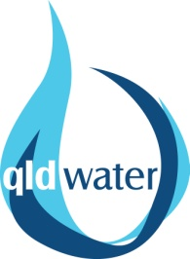

Queensland Young Operator of the Year Award 2020

Nomination Form

Employer:
Contact Person:
Address:
Town / City:
Telephone:
Email:
Name of Nominee:
Position:
Years of Employment:
Qualifications/Trade:

Please complete the contact information above and provide responses to the supporting information requirements on the following page.

Nominations are due by Friday 1 May 2020 to csargent@qldwater.com.au and will be judged on the following criteria:

- Continuing education / training achievement;
- Overall plant management and condition or overall customer service focus;
- Demonstrated attention to Occupational Health and Safety and other regulatory responsibilities; and
- Initiative and innovation demonstrated in improved operations, treatment and/or efficiency.

Awards will be presented at the Annual Queensland Water Industry Operations Conference Awards Dinner, to be held in Toowoomba on Thursday 4 June 2020.
Please contact Carlie Sargent on 07 3632 6853 or csargent@qldwater.com.au to discuss any queries in relation to your nomination.

Supporting Information:

- Outline activities and ideas of the nominee which illustrate initiative and innovation demonstrating improved practices, (note, reference here should be made to the nominees achievements)

- Outline activities which demonstrate commitment of the nominee to customer service and ensuring that all works are completed to the highest possible standards, (detail the nominee’s specific contribution to these areas).

- Detail the nominee’s demonstrated attention to occupational health and safety and other regulatory responsibilities.

- Personal Development/training achievement: Detail all relevant vocational education and training.

- Other Community involvement: please attach separate sheet if required.

