qldwater COVID-19 hotspot response information

Background
Essential water services for Queensland communities are provided by council-owned Water and Sewerage Service Providers (WSPs). Many regional WSPs are remote, have small, dispersed communities and limited resources. The COVID-19 pandemic in 2020 resulted in staffing impacts being identified as the highest risk to ongoing service by numerous service providers, and resulted in common steps being taken by all councils to minimise risk of transmission including:
- Isolation of shift crews (no shift handover, separate crib areas, no shift rotations).;
- Direct travel from home to site instead of to the work base;
- Toolbox and management meetings conducted via web meetings instead of face to face;
- Physical distancing during travel (one person per vehicle);
- Working from home arrangements implemented for staff not "on the tools."

Staffing levels remain a key issue in Queensland and future incidences of COVID-19 in regional Queensland could result in a town's water and sewerage operators being unable to work requiring relief staff to maintain operations for a temporary period. As many WSPs are already suffering a shortage of skilled staff, external support may be required. This document outlines information to assist in the provision and safe deployment of relief staff to ensure that water and sewerage services are maintained for the safety of communities impacted by a COVID-19 outbreak.
The risk assessment process that will be used by Queensland Health to assess the risk of a contact has not been disclosed. An example of the contact assessment and management matrix used by the Department of Health Victoria is provided below.

COVID-19 positive detection actions
In the event of a COVID-19 positive test result in a workplace, there are a number of actions that should be taken by a water service provider. An example of a work procedure from Melbourne Water is included as Attachment 1 and can provide guidance for development of procedures for Queensland water service providers. The procedure outlines specifically for employees the actions that should be taken under the following scenarios:
- tested due to symptoms
- notified of contact with confirmed case
- positive covid-19 test result
It also outlines a process for a COVID-19 infected employee to return to work.
Risks of communication of the disease to other workers should also be assessed. A risk assessment process to be used by Queensland Health was not available at the time of writing. The following tables provides an example of the contact assessment and management matrix used by the Department of Health Victoria.

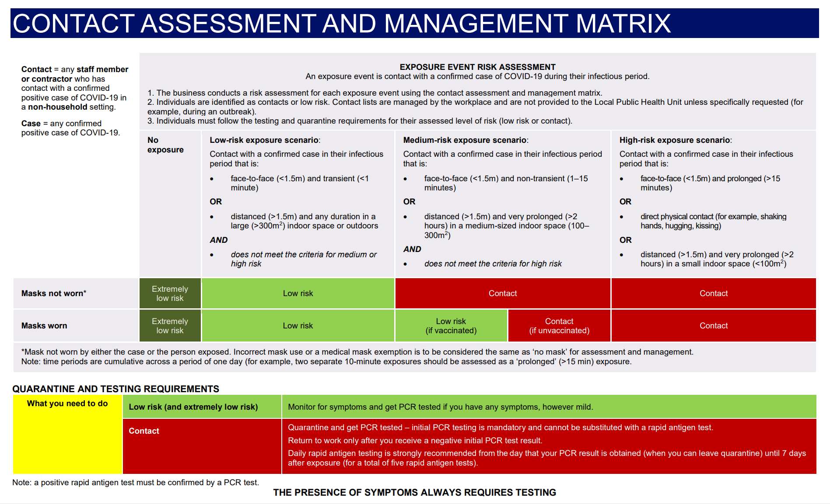

Mutual aid during disasters
In the event of local disasters such as cyclones, floods and fires, affected service providers typically call for assistance within the sector based on:
- similar infrastructure and staff skills;
- proximity for ease of deployment;
- existing relationships and similar cultural/community expectations.

Mutual aid commonly occurs across local Regional Organisations of Councils (ROC), Water Alliances and District Disaster Management Groups (DDMGs). A summary of groupings of ROCs and Water Alliances is provided in Appendix 1 and DDMGs in Appendix 2. Many Service Providers also turn to contractors and private service providers with which they have existing relationships for assistance. State-wide matching of needs and offers of assistance are regularly undertaken by qldwater and LGAQ.
These arrangements provide a high level of resilience for Queensland’s dispersed water sector but may not be as effective during a widespread pandemic or when relief operators are unable to leave/enter an identified area. The following considerations are provided in case additional operator relief is required.

Mutual Aid and Operator Relief
qldwater convened a working group to address potential operator shortages in early 2020 and identified the need for the following roles in the event of mutual aid being required in response to regional COVID-19 outbreaks:
- Receive requests for assistance and match suitable operators from outside the affected area and the needs of the WSP requiring aid, including national through TISN Mutual Aid for the Water Sector where possible (see Box 1).

Box 1: TISN Mutual Aid Guidelines for the water services sector
The national urban water industry is served by the Water Services Sector Group (WSSG) which provides a forum for water utilities to share knowledge and develop capability in areas including incident and emergency management. The WSSG is also the representative group for the water industry, under the Australian Government’s Trusted Information Sharing Network (TISN) for Critical Infrastructure Resilience, coordinated by the Department of Home Affairs. The state lead agency for WSSG in Queensland is the Department of Regional Development, Manufacturing and Water (RDMW).

WSSG has developed the Australian Water Sector Mutual Aid Guidelines, which have recently been revised and are currently in review. These guidelines define the role of a "Mutual Aid Coordination Cell" that can be established at the request of a service provider in need. The Guidelines also describe the formal and legal steps that should be taken to request and provide aid in the event that aid is required. Mutual Aid Coordination Cells are created to respond to a particular event, with no pre-defined boundaries or membership.
- Provide a point of contact for those requiring assistance and facilitating aid specific to the water and sewerage services.
- To provide sitreps and a direct point of contact with the affected WSPs about water and sewerage needs to relay information as required including to the DNRME Business Continuity Taskforce.
- Ensure that requirements for assisting operators are communicated clearly to all parties.
- Report on the learnings from mutual aid arrangements at the end of the process and provide recommendations for future incidents.

Mutual Aid Considerations
The WSSG Australian Water Sector Mutual Aid Guidelines provide an Employee Deployment Checklist to assist with safe deployment of workforce. The list is not exhaustive but provides a foundation for open and early communication between the aid provider and recipient to ensure that there is a shared understanding in spite of any urgency during periods of duress. Relevant items have been summarised with respect to COVID-19 outbreaks in regional Queensland as follows.

Pre-deployment checklist
Personnel: | Comments | Check
Certified /suitably qualified for the tasks they are asked to do
Are medically and physically capable of doing the tasks the are asked to do (e.g. have an up-to-date medical examination appropriate vaccinations)
Are not placed at undue risk due to their personal medical history with respect to COVID-19
Transport to the region and to and from site is organised | Including social distancing if required
Tools available | Worker's own or provided by host if transport is not possible
Accommodation arrangements | Host to provide and fund
Reporting arrangements
Crib/smoko arrangements
Shift/roster arrangements
Time, including consideration of:
Mobilisation and site inductions | This can take hours to days depending on the site
Inductions with local systems (preferably paper-based but including job allocation software/ email if needed) | May be covered in existing procedures
IT setup required for visiting personnel
Time for COVID testing pre-and post-deployment
If isolation is required pre-and/or post-deployment | Needs to be included in paid time
Safety:
Transport safety to site and on the job | Own vehicle/hire vehicle is it roadworthy/ council compliant?  Risk assessment completed?
SOPs available for new personnel
Inductions to all sites required
Is equipment certified for use on site | e.g. current test and tag, safety certificate for heavy equipment
Ensure wash-down all areas (offices, lunch room, labs etc prior to arrival on site and on departure)
Rostering to manage fatigue for extended deployments
Has the operator been trained to manage the risks and protocols associated with COVID-19 | e.g. mask fitting, handwashing, other PPE
Appropriate measures for loan worker issues onsite, during travels and when isolation is required
PPE:
Gloves (nitrile/latex) | provided or operator to bring
Work gloves | provided or operator to bring
Hand sanitiser | provided or operator to bring
Earplugs | provided or operator to bring
Safety glasses | provided or operator to bring
Protective face masks | provided or operator to bring
disposable overalls | provided or operator to bring
Equipment:
Tools available/required
Radios/ tablets for local work
Local phones available | Mobile coverage in remote areas can be patchy for some networks
Legal:
Insurance for tools brought with workers
Insurance for workers remains with Operator’s employer (in case injured on the job) | Refer Mutual Aid Guidelines
Payment arrangements for local services e.g. use of private/work phone while on deployment.
Confidentiality arrangements? NDAs?
Contact(s) in the event of disaster? | Policy position to be communicated
Provision for isolation from other workers pre- or post- deployment as needed
Costs:
Transport
Accommodation
Salaries/wages paid by current employer | Incl. the Operator’s standard Award conditions (e.g. shift allowances, remote allowances, live sewer, isolation periods).

Appendix 1: Regional Organisations of Councils and Water Alliances

Far North Queensland Regional Organisation of Councils | Cairns Regional Council  Carpentaria Shire Council  Cassowary Coast Regional Council  Cook Shire Council  Croydon Shire Council  Douglas Shire Council  Etheridge Shire Council  Hinchinbrook Shire Council  Hope Vale Aboriginal Shire Council  Mareeba Shire Council  Tablelands Regional Council  Yarrabah Aboriginal Shire Council  Wujal Wujal Aboriginal Council
North West Queensland Regional Organisation of Councils | Burke Shire Council  Carpentaria Shire Council  Cloncurry Shire Council  Doomadgee Aboriginal Shire Council  Flinders Shire Council  McKinlay Shire Council  Mornington Shire Council  Mount Isa City Council  Richmond Shire Council
Remote Area Planning and Development Board  (and RAPAD Water Alliance) | Barcaldine Regional Council  Barcoo Shire Council  Blackall-Tambo Regional Council  Boulia Shire Council  Diamantina Shire Council  Longreach Regional Council  Winton Shire Council
Wide Bay Burnett Regional Organisation of Councils  (and WBBROC Water Alliance) | Bundaberg Regional Council  ​Cherbourg Aboriginal Shire Council  Fraser Coast Regional Council  Gympie Regional Council  North Burnett Regional Council  South Burnett Regional Council
Greater Whitsunday Council of Mayors  (and Whitsunday-Isaac-Mackay Water Alliance) | Isaac Regional Council  Mackay City Council  Whitsunday Regional Council
Central Queensland Regional Organisation of Councils | Banana Shire Council  Central Highlands Regional Council  Gladstone Regional Council  Livingstone Shire Council  Rockhampton Regional Council  Woorabinda Aboriginal Shire Council
North Queensland Regional Organisation of Councils | Burdekin Shire Council  Charters Towers Regional Council  Hinchinbrook Shire Council  Palm Island Aboriginal Shire Council  Townsville City Council
Darling Downs and Southwest Queensland Council of Mayors | Balonne Shire Council  Bulloo Regional Council  Goondiwindi Regional Council  Maranoa Regional Council  Murweh Regional Council  Paroo Regional Council  Quilpie Regional Council  Southern Downs Regional Council  Toowoomba Regional Council  Western Downs Regional Council
Council of Mayors Southeast Queensland | Brisbane City Council  Ipswich City Council  Lockyer Valley Regional Council  Logan City Council  Moreton Bay Regional Council  Redland City Council  Scenic Rim Regional Council  Somerset Regional Council  Sunshine Coast Regional Council  Toowoomba Regional Council
CTM Alliance | Cairns Regional Council  Townsville Regional Council  Mackay Regional Council

Appendix 2: Disaster districts

(from Disaster Management Act 2003, Disaster Management Regulation 2014)
Brisbane | Brisbane  Redland
Bundaberg | Bundaberg  North Burnett
Cairns | Aurukun  Cairns  Cook  Douglas  Hope Vale  Kowanyama  Lockhart River  Mapoon  Napranum  Northern Peninsula Area  Pormpuraaw  Torres  Torres Strait Island  Wujal Wujal  Yarrabah
Charleville | Bulloo  Murweh  Paroo  Quilpie
Dalby | Western Downs
Gladstone | Banana  Gladstone
Gold Coast | Gold Coast
Gympie | Cherbourg  Gympie  South Burnett
Innisfail | Cassowary Coast
Ipswich | Ipswich  Somerset
Logan | Logan  Scenic Rim
Longreach | Barcaldine  Barcoo  Blackall-Tambo  Longreach  Winton
Mackay | Isaac  Mackay  Whitsunday
Mareeba | Croydon  Etheridge  Mareeba  Tablelands
Maryborough | Fraser Coast
Mount Isa | Boulia  Burke  Carpentaria  Cloncurry  Diamantina  Doomadgee  McKinlay  Mornington  Mount Isa
Redcliffe | Moreton Bay
Rockhampton | Central Highlands  Livingstone  Rockhampton  Woorabinda
Roma | Balonne  Maranoa
Sunshine Coast | Noosa  Sunshine Coast
Toowoomba | Lockyer Valley  Toowoomba
Townsville | Burdekin  Charters Towers  Flinders  Hinchinbrook  Palm Island  Richmond  Townsville
Warwick | Goondiwindi  Southern Downs

Under the Disaster Management Act 2003 and Regulation 2014, the Chair for each District is filled by the Queensland Police Service and reports to the State Disaster Coordination Centre.

