QWRAP Bid Pool Arrangements

2020-2022

Document 1 – Bid Pool Overview

February 2020

Overview

The Queensland Water Regional Alliance Program (QWRAP) is funded by the Queensland Government to support local governments wishing to progress regional approaches for provision of drinking water and sewerage services. QWRAP was initiated in July 2011 and is administered by the Queensland Government, Local Government Association of Queensland (LGAQ), and qldwater with the participation of local government service providers.

QWRAP’s central objective is to assist groups of Queensland council service providers to increase regional collaboration aligned with the “regional collaboration maturity model” (see Table 1). The model encompasses eight stages ranging from minimal collaboration through to the creation of alternative institutional service delivery arrangements.

Table 1: Description of maturity levels.

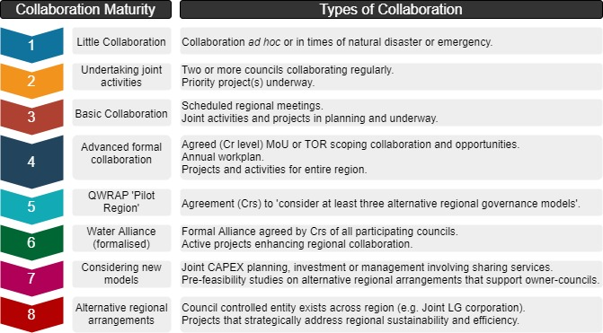

QWRAP competitive bid pool funding is available for designated regional groups for work that contributes to the region progressing through the collaboration model, the groups are:
- RAPAD Water Alliance,
- WBBROC Water Alliance,
- FNQROC group,
- WIM Water Alliance and,
- DASB.
Limited funding may be allocated to other regions subject to availability (see Table 2).

Figure 1. Typical stages of development of QWRAP regional collaboration

Bid Pool

The Bid Pool consists of two components:

1. Funding for Joint Activities and Projects

This component supports joint activities building regional collaboration. Generally, a co-contribution in cash and kind will be expected for joint activities. The proportion of Bid Pool contribution to a joint activity may increase as a regional alliance progresses through the regional collaboration maturity model (see Table 2).

Examples of typical projects and activities undertaken at each level of the maturity model are provided in Attachment 1. The standard process for developing bid pool projects is summarised in Figure 2 and a template and guideline for applying for bid pool funding for projects and activities is provided in DOCUMENT 2 and a template for reporting at finalisation of the project is in DOCUMENT 3.

Figure 2. Processes for accessing bid pool funding for projects and activities

Joint Projects and Activities

2. Annual funding for Regional Coordination

This component subsidises salary costs of a regional coordinator. The regional coordinator acts as secretariat and provides administrative and project management support to a regional alliance. This includes, among other things, preparation of funding requests, funding acquittals and reporting documents.

The regional coordinator supports the leadership and strategic direction of a regional alliance, and monitors and reports on project outcomes. The role may be performed by a local government employee, Regional Organisation of Councils (ROC) employee or an external party and may be shared. No co-contribution is required.

The regional coordinator must prepare an Annual Workplan (see Template and Guideline in DOCUMENT 4) each year describing their tasks and the objectives of the group (see Figure 3). An annual report and acquittal must be prepared annually (see Template and Guideline in DOCUMENT 5) outlining the benefits accrued during the year and acquitting all funding provided through QWRAP.

Figure 3. Processes for accessing bid pool funding for regional coordinator

3.0 Bid Pool funding allocation

QWRAP funding is fixed annually and is allocated to the coordinator in each of the five funded regions and then on a competitive, first-come, first-served basis. Regional coordinators or chairpersons are encouraged to discuss opportunities or develop applications iteratively with the LGAQ. A summary of availability of QWRAP funding is provided in Table 2.

Figure 4. Summary of the QWRAP funding Guidelines and Templates

Table 2: QWRAP Support provided at each level or collaboration maturity.
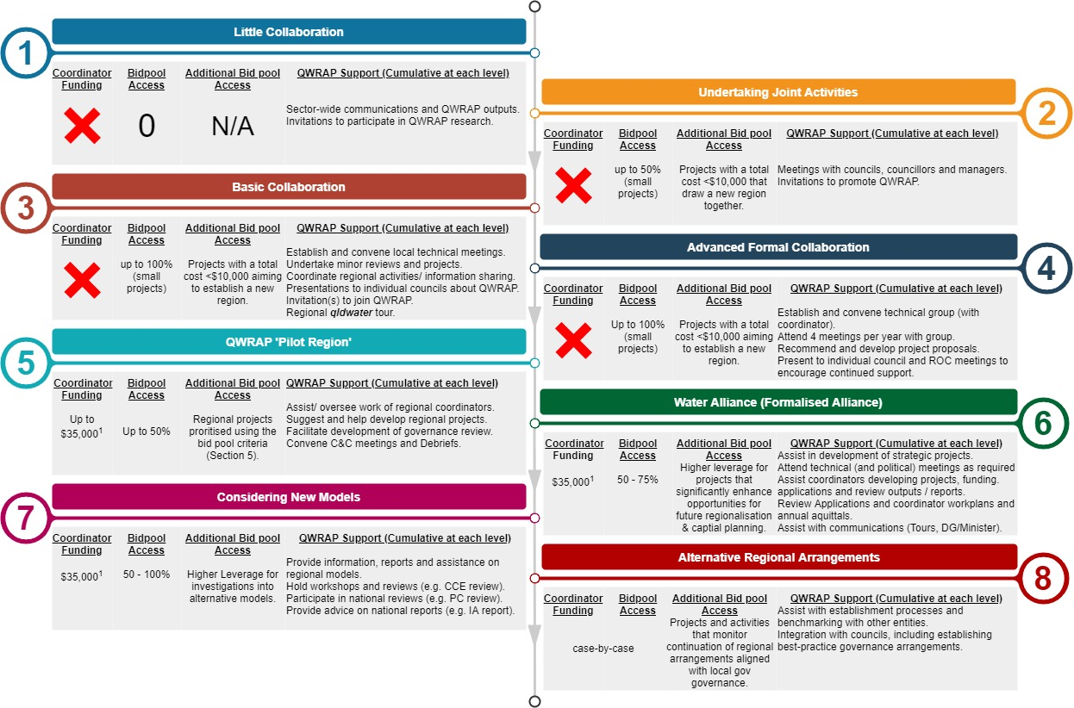
- Coordinator funding need not be matched but Bid Pool funding allocations require contributions from participating councils.

Key Contacts

Organisation | Name | Position | Phone Number | Email
LGAQ | Subathra Ramachandram | Lead Water and Wastewater | 07 3000 2237 | Subathra_ramachandram@lgaq.asn.au
qldwater | Dr Rob Fearon | Director, Innovation Partnerships | 07 3632 6850 | rfearon@qldwater.com.au
qldwater | Ryan Cosgrove | Research Coordinator | 07 3632 6852 | rcosgrove@qldwater.com.au

Further information is available at the QWRAP website: http://www.qldwater.com.au/QWRAP

Attachment 1: Examples of typical projects and activities undertaken at each level of the maturity model.

Stage 1. Minor collaboration.
- Collaboration ad hoc or in times of emergency or natural disaster.
Level of Competence | Descriptors
Basic | - Occasional joint operations in unusual or emergency circumstances
Moderate | As above, plus:  - Occasional sharing of plant and equipment
High | As above, plus:  - Occasional joint training
Examples of joint activities & projects | - Assistance provided during emergencies or in disaster recovery  - Informal arrangements for sharing plant and equipment  - Training, information or conferences provided for staff of multiple councils

Stage 2. Undertaking joint activities.
- Two or more councils collaborating regularly.
Level of Competence | Descriptors
Basic | Stage 1 High Competence, plus:  - Administrative arrangements for undertaking a joint project(s).
Moderate | As above, plus:  - Formal arrangements for joint skills development and/or multiple joint projects.
High | As above, plus:  - Joint activities related to financial, operational, WHS, customer sustainability risks
Examples of joint activities & projects | - Projects to analyse and/or mitigate financial, operational, WHS or customer risks.  - Joint operations, planning or procurement.  - Joint Skills development activities and programs.

Stage 3. Basic collaboration.

Level of Competence | Descriptors
Basic | Stage 2 High Competence, plus:  - Technical working committees established
Moderate | As above, plus:  - Regular meetings to plan and execute joint project(s)
High | As above, plus:  - Planning for formalised collaboration
Examples of joint activities & projects | - Alignment of regulatory and reporting requirements (e.g. DWQMPs, annual STP reports).  - Joint regulatory (e.g. KPI) reporting and process improvement.  - Projects to review or plan for more formal regional approaches  - Projects that examine strategic needs or sustainability for the region

Stage 4. Advanced collaboration.

Level of Competence | Descriptors
Basic | Stage 3 High Competence, plus:  - Elected member Memorandum of Understanding, TOR or other agreement
Moderate | As above, plus:  - Annual workplan  - Common contracting and procurement documentation
High | As above, plus:  - Joint activities in process cover a range of activities (i.e. beyond joint procurement)  - Projects leverage other external funding
Examples of joint activities & projects | - Common approaches to aspects of asset management or planning  - Skills and staff-sharing across the region or with other regions  - Strategic infrastructure planning and investment  - Examination of standards, documentation and reporting formats  - Planning or reviews to underpin analysis of alternative institutional arrangements

Stage 5. QWRAP Pilot Region.
Level of Competence | Descriptors
Basic | Stage 4 High Competence, plus:  - Agreement at Cr level to consider at least three alternative institutional arrangements for managing water and sewerage services.
Moderate | As above, plus:  - Institutional review planned and underway
High | As above, plus:  - Individual councils considering alternative institutional models and responding to recommendations
Examples of joint activities & projects | - Review of alternative institutional arrangements

Stage 6. Established Regional Water Alliance.

Level of Competence | Descriptors
Basic | Stage 5 High Competence, plus:  - Establishment of regional alliance with agreement on process to undertake joint activities with opt-out provisions and endorsement from strategic (councillor) group.
Moderate | As above, plus:  - Water Alliance undertaking regular, planned activities and joint projects
High | As above, plus:  - Examination of full cost recovery  - Joint activities that enable regional integration of services and processes  - Strategic asset management  - Strategic Regional Plan
Examples of joint activities & projects | - Assessment of barriers to regional full-cost pricing.  - Agreement on regional standards and processes.  - Joint negotiation with regulators and Qld Government.  - Regional Strategic Planning (e.g. water security, environmental stewardship, investment)  - Joint and customer engagement programs.  - Regional asset condition assessment, failure analysis and attribution of criticality

Stage 7. Implementation and investigation of new models.

Competence | Descriptors
Basic | Stage 6 High Competence, plus:  - Revisit Regional Governance review  - Investigation reports on alternative institutional service delivery models
Moderate | As above, plus:  - Joint asset planning, investment and management
High | As above, plus:  - Joint investment for regional water security  - Quantification of community service obligations  - Examination of transparent pricing models for full cost recovery  - Joint design and procurement of repair and renewal services  - Investigating regional customer service standards  - Consistent customer complaint and response practices  - Demonstrated leadership in environmental stewardship
Examples of joint activities & projects | - Regional capital planning, investment  - Joint outsourcing of major operations to contractors  - Regional W&S asset management  - Formal and ongoing staff-sharing arrangements.  - Shared approach to ensuring customer service standards.  - Regional benchmarking.

Stage 8. Alternative institutional service delivery arrangements.

Level of Competence | Descriptors
Basic | Stage 7 High Competence, plus:  - Agreement to form statutory body, LG owned corporation, joint local government or some other entity
Moderate | As above, plus:  - Independent utility formed and governed by participating councils
High | As above, plus;  - Adoption of transparent pricing models for full cost recovery (identifying community service obligation payments)  - Successful benchmarking against entities of a similar size nationally  - Sustainable financial ratios with transparent investment strategies
Examples of joint activities & projects | - Examination and implementation of regional price path for cost recovery (regional CSOs).  - Regional, strategic infrastructure planning and investment.  - Guidance and training on good governance measures  - Benchmarking against other entities.  - Whole-of-water cycle planning and development.  - Independent budgeting, borrowing and strategic planning oversight.  - Alignment with council customer engagement and liveability programs.  - Alignment with Sustainability Development Goals.

