GoToWebinar How to guide:

Upon clicking the weblink included in your invitation you will be taken to a registration screen:

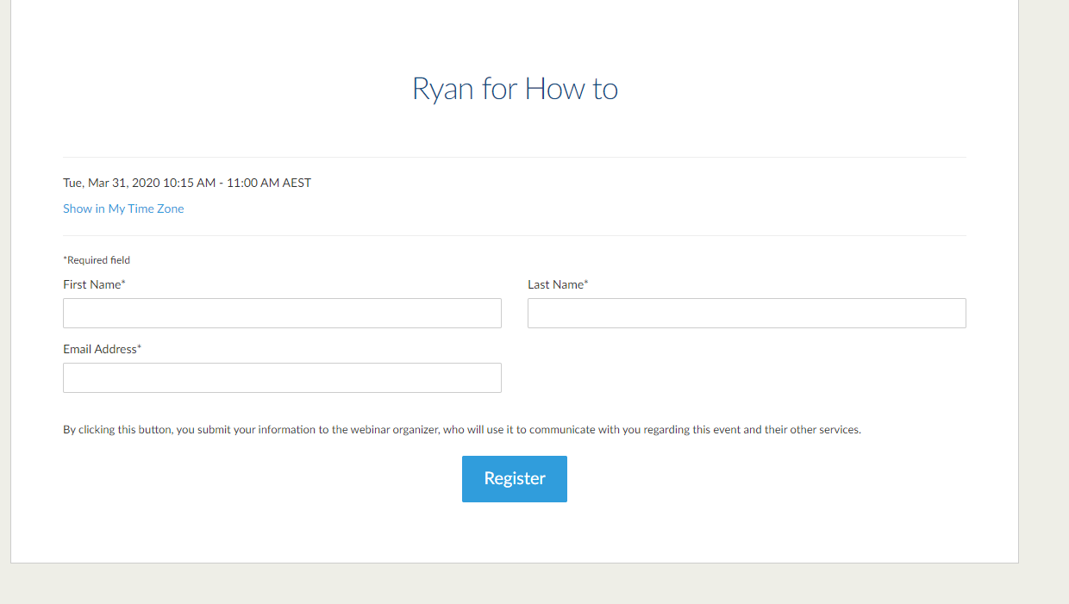

Registering your details allows the qldwater staff to see who you are in the webinar. This allows us to easily communicate, unmute and ensure you can participate fully.

Once registered you will see this screen

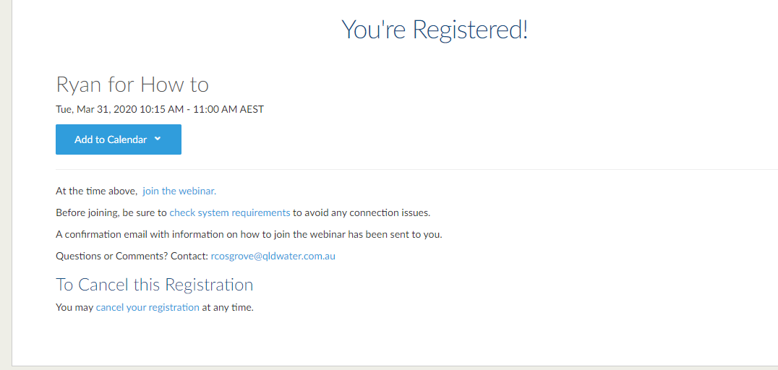

To pre-download the GoTo software you can click the ‘Join the webinar’.

You will also receive an email confirmation:

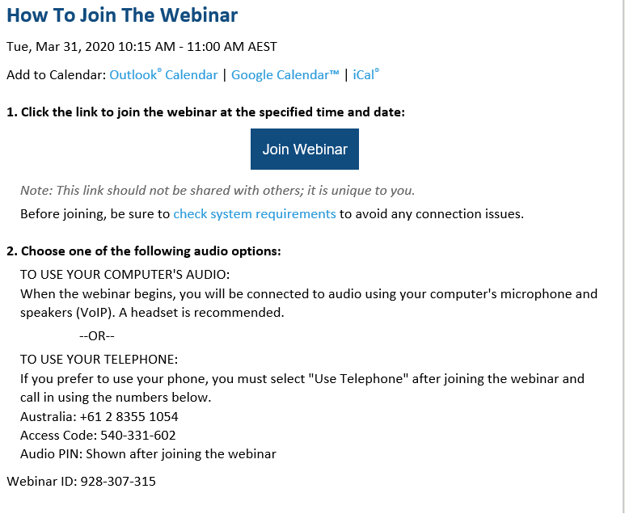

This email contains dial in details. Dial in details are also provided at multiple points within the webinar so don’t stress about finding the email again if it’s lost.

You can access the Webinar by clicking the Join webinar link in the confirmation email OR by using the original Weblink for registration. Once registered the button will change to “Join Webinar in Progress” once the webinar is about to start, see below

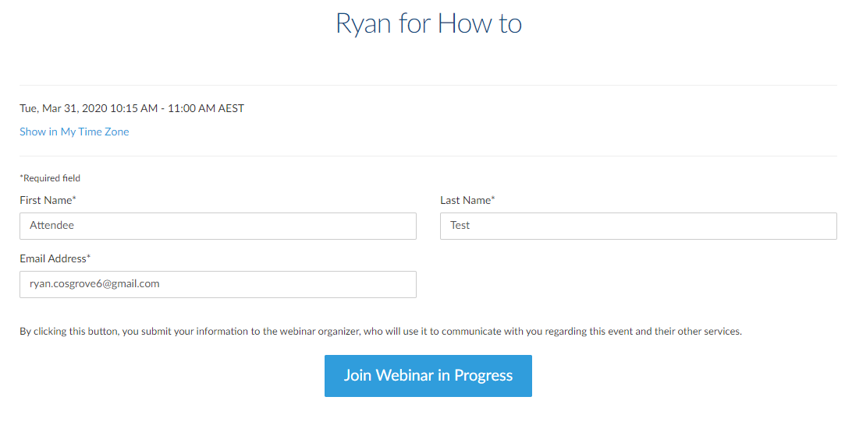

The below sections talk through using the goto system

PLEASE NOTE UPON ENTERING THE WEBINAR ALL ATTENDEES ARE MUTED

Please read through what each of the areas do below. For understanding phone dial in controls see next page.

Blue Circle:

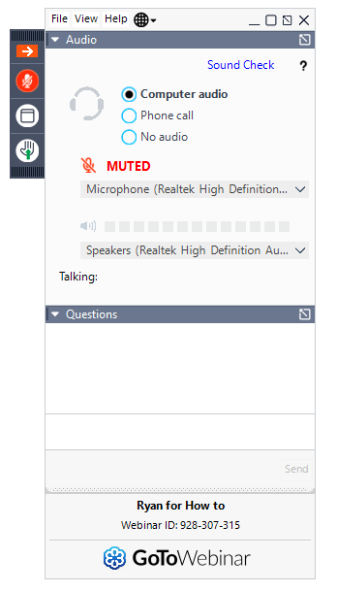

If using computer audio you will be able to change the microphone being used and speakers through the drop down menus.

Red Circle:

Questions can be asked to the organisers, this is a useful way to ask a question of the presenters. This is a great way for us to capture questions throughout the talks and answer them at the end of the session.

Feel free to use this if you’re having tech issues.

Green Circle:

These are your controls and have important features. From top to bottom:

Red arrow hides the GoTo window to that of the column in the green circle. Unclick to gain access to larger window.

The microphone allows you to mute and unmute yourself (this is if you have been given permission to do so). A general curtesy is to mute yourself when someone is presenting.

Window button; makes the webinar appear in full screen mode, unclick to revert back to a smaller version.

Raise hand; this feature is very important. Please raise your hand to be unmuted and ask a question to the group. This is a way to signal a question to the qldwater staff.

Phone Audio Controls:

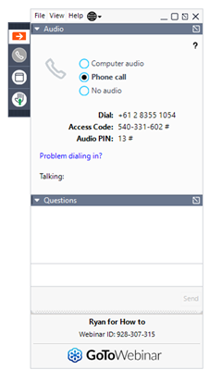

If you prefer to use the phone for audio this is how the system will look. Note the system provides the dial in numbers, Code and your personal Audio Pin.

It is important to enter your audio pin when dialling in. Entering your audio pin joins your Webinar Name with the audio, this means instead of caller one being shown when talking it would come as your name... e.g. Ryan Cosgrove is talking.