

SWIM Annual Data Manual: data entry and user setup

Version 3

SWIM

Annual Data Tool (ADT)



SWIM

Admin Tool



June 2025

***qldwater***

STATEWIDE WATER INFORMATION MANAGEMENT (SWIM) SYSTEM

[www.qldwater.com.au/swim](http://www.qldwater.com.au/swim)



Contents

Web Admin (Administration) Tool 4

Login Screen 4

Home Screen 4

Manage SWIM Users 5

Adding/editing a user 5

User roles 7

Annual Data Access Groups 8

Create a new access group 8

Edit an annual data access group 10

Common Alert/Error Messages during User Login 10

SWIM Web Annual Data Tool (ADT) 11

Accessing the Web ADT 11

Login errors 12

ADT home screen (data entry) 13

Columns (left to right) and their function: 13

Left hand column menu bar 14

Filtering indicators 15

Search function 17

Mouse (cursor) hover-over functionality 18

Viewing indicator definitions 18

Missing data (MD) 19

Not relevant (NR) indicators 19

Calculated indicators 20

Invalid (yellow cells) values 21

Error (red cells) values 22

Adding a comment to a data point 23

Mandatory comments 23

Text dropdown boxes 24

Publishing data 24

Exporting data 26

Quirks and known issues with the Web ADT 26

Notes column 26

Search function not showing result 27

***qldwater***– The Queensland Water DirectorateSWIM contacts 27

# Web Admin (Administration) Tool

Each Service Provider (SP) will need to have at least one SWIM Administrator who is responsible for administering/co-ordinating the SP’s metadata, annual data and user accounts (we recommend at least two administrators to cover for absentees).

Web Admin Tool website: <https://www.swim.qldwater.com.au/admin>

The Web Admin Tool contains the following 4 management windows:

* Schemes
* Sites
* Users
* Annual data access groups

These screens are explained in more detail below.

## Login Screen

The login screen provides login (username, password, and Region ID) fields.

Your SWIM login/password is the same for all SWIM Tools (please remember that both username and password are case sensitive).

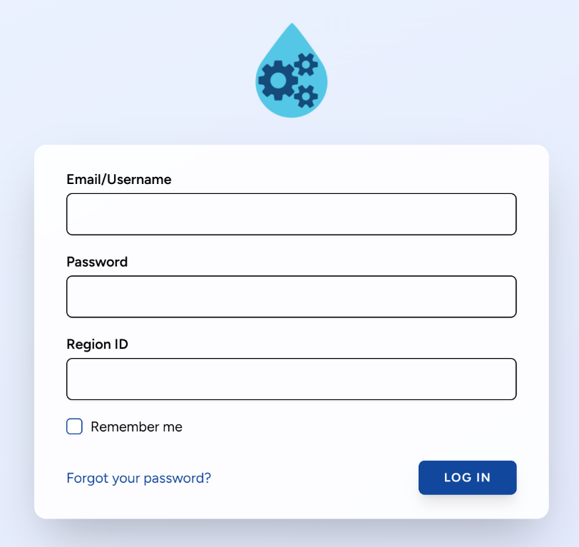A user must have a System Administrator ‘role’ in order to log in to the Admin Tool.

## Home Screen

The home screen is the first screen seen when logged in. The home screen provides buttons to access all data management functionality. Functions are organised into logical groups within two sections ‘Sites and Indicators’ (green) and ‘Users and Groups’ (blue).

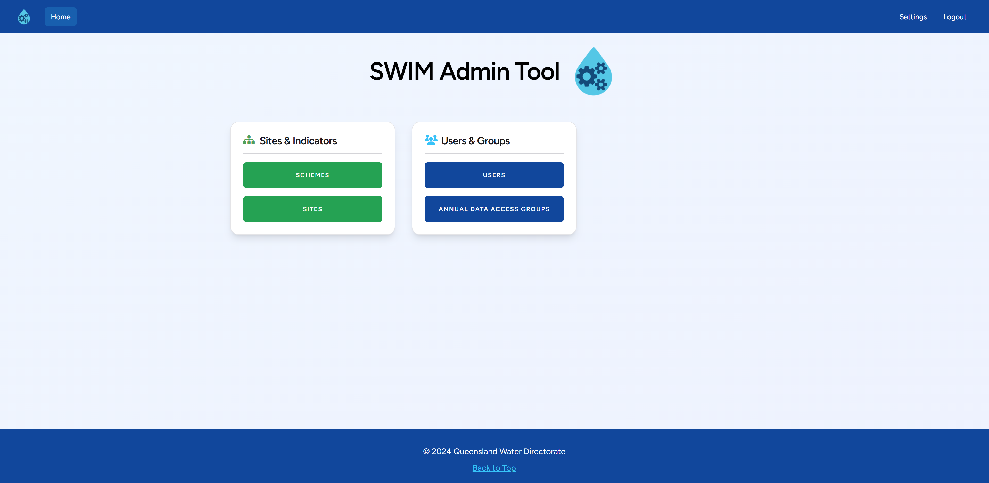

## Manage SWIM Users

SWIM uses different user roles and access groups to help limit which components of the system that people can access and use. There are two ways in which this is done; firstly, via user ‘roles’ which limits which SWIM tools a user can login to; and secondly, via ‘annual data access groups’ which limits which schemes and categories a user can see (interact with) within those tools. Every user must have at least one role and one access group associated with them.

### Adding/editing a user

Click on the ‘Users’ button.

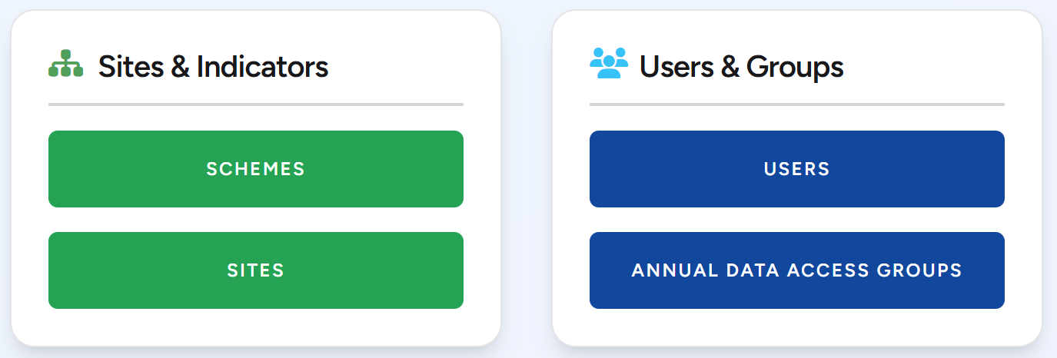

As shown below, the ‘User Management’ screen lists all users for the SP (list of user logins, first name and last name, roles and active status). It is sortable by clicking on arrow next to the column header. It provides functions to add or edit a user. Inactive users are not shown in the list unless the ‘Show Inactive’ tick box is selected (top left under ‘Filters’).

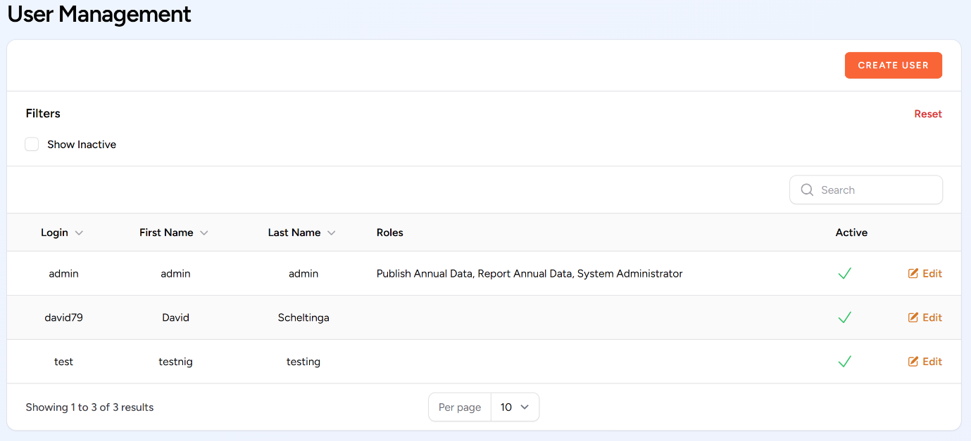

Any user can be edited from this window.

To create a new User, click the ‘Create User’ button in the top right-hand corner. This opens the screen below.

Complete all the SWIM user fields (mobile number can be left blank).

We recommend using a familiar login system consistent with your organisation or at the least within SWIM.

Only a single email can be entered and must be unique for the organisation.

A mobile number is optional but is needed for other swimlocal functionality like receiving SMS alerts. A mobile number must be entered without spaces, and multiple mobile numbers can be entered and must be separated by a comma, e.g. 0415123456, 0414654321. **Note** that mobile numbers can be in international format (e.g. +61) if you wish or national (e.g. no +61).

A user can be made inactive by un-selecting the ‘Active User’ tick box. For referential integrity reasons users cannot be deleted once created and they can only be made inactive. An inactive user cannot login to SWIM system.

User roles and access groups can be selected by clicking (ticking) the appropriate boxes. Refer to the ‘user roles’ section below.

Ensure a password is entered and confirmed.

Once the form is complete, select ‘Create User’ at the bottom left corner.

To edit a user, select the user you wish to change and then click ‘Edit User.’ You can then change any of their details such as roles/access level and password.

### User roles

Eight swimlocal user role types have been set up within the software as described in the following table. Only the 3 related to SWIM Annual Data are included here.

Users can be assigned multiple roles (by selecting multiple roles) to allow access to the different SWIMtools they need.

Table 1. User roles.

|  |  |  |
| --- | --- | --- |
| **User Role** | **Using SWIM for** | **SWIM Tool that user role can access** |
| Report annual data | * Annual data entry (SWIM) | * Annual data Tool |
| Publish annual data | * Annual data entry (SWIM) * Releasing annual data for publication | * Annual data Tool |
| System administrator | * Administer swimlocal metadata and user accounts (but may also do operations and annual data entry (including ‘publish’), task completion and all reporting) | * Admin Tool * Annual data Tool * Reports |

## Annual Data Access Groups

Annual data access groups gives the SWIM Administrator control over exactly what schemes and SWIM indicator categories a user can access. Click on the ‘Annual Data Access Groups’ button.



As shown below, the ‘Annual Data Access Groups’ screen lists all annual data access groups for the Service Provider. It provides functions to add or edit an access group. Inactive access groups are not shown in the list unless the ‘Show Inactive’ tick box is selected (top left under ‘Filters’).

### Create a new access group

To create a new access group, click the ‘Create New Group’ button and the below window will appear. From this window you can add, edit, delete or show inactive access groups

Enter an appropriate ‘Group Name’ for your annual data access group.

Groups can be made active or inactive by selecting the ‘Active’ tick box.

Click the ‘Add Users’ button to select which users will be included in the group.

Click the ‘Add Schemes’ button to select which schemes and click the ‘Add Categories’ button to select which SWIM categories are included (see below window).

Once the appropriate details have been selected/entered then click the ‘Create Group’ button in the bottom left corner.

### Edit an annual data access group

To edit members, schemes and categories of an access group, click edit as shown below. You can then edit what you need by selecting/unselecting the appropriate tick boxes. Once you have completed editing ensure you select ‘Save Changes’.

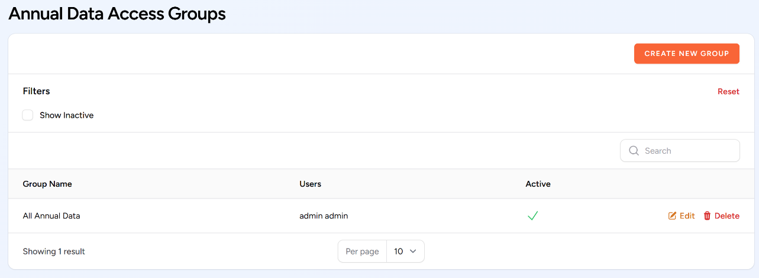

## Common Alert/Error Messages during User Login

If a user tries to access the Web Admin Tool but the password or username is incorrect, or if they don’t have a ‘System Administrator’ role then they will receive the following message. First try ‘Forgot your password?’ and follow the prompts to update your password. If this doesn’t work you will need another system administrator to login and fix the error (correct username or role). Or contact ***qldwater***.

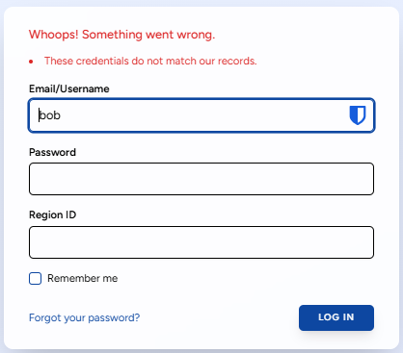

# SWIM Web Annual Data Tool (ADT)

The SWIM Annual Data Tool is used to report your regulatory required annual water and sewerage data to the requesting organisations (e.g., NPR, ABS, BoM, State Govt). This section of this manual explains how to use the SWIM Web ADT to enter your annual water and/or sewerage data.

## Accessing the Web ADT

Access to the Web ADT is controlled by your organisation’s SWIM System Administrator via the Web Admin Tool (as described above).

* The Website is located at: <https://www.swim.qldwater.com.au/adt>
* A User must have a role of ‘Report annual data’ or ‘Publish annual data’ and be in an appropriate ‘Annual Data Access Group’ in order to log in to this tool.
* You will need your Region ID, Username and Password to access the Web ADT. If you are unsure what your login details are, discuss with your System Administrator.
* Both the login and password are case sensitive.
* Closing the website will not log you out of the Web ADT system. This means that the next time you open the website you will be automatically logged in. Only by selecting ‘Log Out’ will the user be logged out of the website and need to re-enter your login details.
* To change the screen size in the browser press: Ctrl- (to decrease font size) or Ctrl+ (to increase font size). This will allow you to see more columns/rows on the screen at any one particular time.
* The Web ADT works best/fastest when using the Chrome web browser.
* A screenshot of a login form

  AI-generated content may be incorrect.The Web ADT automatically synchronises every 30 seconds.

## Login errors

If your Username and/or Password details are incorrect you will receive the following message. **Note** that both Username and Password are case sensitive.

If you receive the following login error, it means that your Username and Password are correct but you have not been given the correct User Role (‘Report annual data’ or ‘Publish annual data’) by your SWIM System Administrator to access the Web ADT. You need to contact them.

If you login and the Web ADT opens up but there are no indicators or anything shown (see below) then it means that you have not been given the correct annual data access privileges (assigned an ‘Annual Data Access Group’) by your System Administrator. You need to contact them.

## ADT home screen (data entry)

The data entry home screen is the primary data entry screen of the tool. It presents a grid control (spreadsheet format). Users input values by typing into the grid cell for the appropriate indicator and scheme. Only the darker coloured cells require data (i.e. white cells do not require data to be entered).

**Note** that the background colour of all ‘calculated cells’ is half shade of the normal colour (i.e. lighter) and don’t need data entered manually as the system will populate them for you.

Once data has been entered the cell cannot be made blank/empty again. If the value was wrong then it must be replaced with either the correct value or “MD” (Missing Data).

All column widths can be adjusted by placing the cursor on the column heading join line. The screen can scroll left and right if needed but will not scroll past the ‘Units’ column.

### Columns (left to right) and their function:

* *Notes* (beige background) – allows the user to enter any notes/comments/related text that is useful for now and future users (e.g., Data from Jenny Smith from Finance, Data estimated using the following method “X divided by C”). This information is **not** sent to anyone and will be included/visible in next year’s ‘sheet’.
* *Code* – lists the SWIM code of the indicator.
* *Indicator* – lists the short indicator title.
* *Units* – lists the units that the indicator **must** be reported in.
* *Drinking (Potable) water scheme[1]* (light blue background[2]) – shows (as columns) all the drinking water schemes that were active during the reporting period that require data to be entered. Drinking (potable) water is intended for drinking and should materially meet the Australian Drinking Water Guidelines 2004, or equivalent.
* *Non-drinking (Non-potable/Raw-Partially Treated) water scheme* (purple background) – shows (as columns) all the non-drinking water schemes that were active during the reporting period that require data to be entered. Non-drinking water is non-potable water. It is sourced from surface or groundwater.
* *Recycled water scheme* (green background) – shows (as columns) all the recycled water schemes that were active during the reporting period that require data to be entered. Recycled water can be either drinking or non-drinking water standard. It is sourced from either sewage or stormwater.
* *Sewerage scheme* (orange background) – shows (as columns) all the sewerage schemes that were active during the reporting period that require data to be entered.
* *WSP-wide scheme* (dark blue background) – is where data for the ‘Whole of Service Provider’ scheme is entered. In most cases the WSP-wide value is a calculation (often sum) of other indicators/schemes.
* *Category* – lists the SWIM category that the indicators sit within. You can filter by category (top left dropdown selection box).

## Left hand column menu bar

From the menu bar you can view the Annual Data sheet, look at the statistics of the session (see below) or logout.

Clicking the expand/reduce button (circled red below) will change the width of the dark blue left-hand column menu bar of the Web ADT (giving you slightly more/less room on the screen for viewing the data).

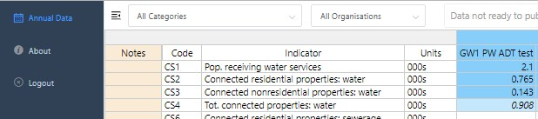

Reduced menu bar shown below (dark blue left-hand side).

Selecting the information button (the *i* - About) will provide some basic statistics as shown below.

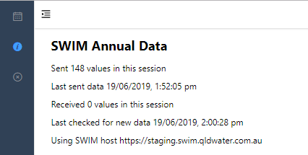

Selecting the annual data button (the *Calendar symbol* – Annual data) will take you back to the annual data entry page.

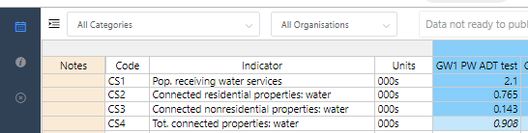

Selecting the cross button will log you out.



X

## Filtering indicators

You can filter which indicators are visible by either indicator category or by the name of the agency/organisation the indicators are requested by. Indicator categories used in the filter are the SWIM categories used to link similar groups of indicators (as shown in the extreme right column). To do this click on the ‘Categories’ drop-down box at top left and select the indicator category you wish to look at (see below). You can only select one category at a time.

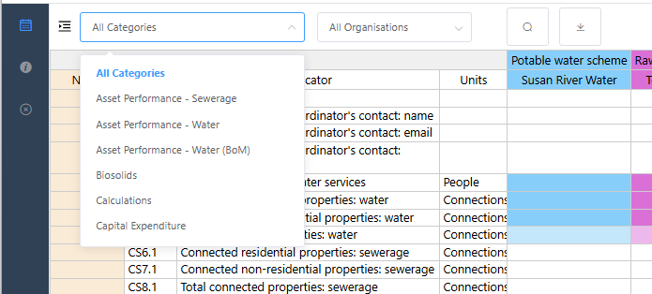

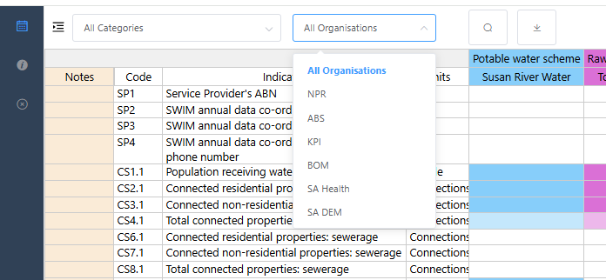You can also filter by the organisation requesting the indicators via the second drop-down box at the top right. To do this click on the ‘Organisation’ drop-down box and select the ‘organisation’ you wish to look at (see below). You can only select one organisation at a time.

The agencies are:

* NPR – National Performance Report. Data required from all Service Providers
* ABS – Australian Bureau of Statistics (Annual Water and Sewerage Survey). Data required from all Service Providers
* KPI – Qld Govt Key Performance Indicators (Dept of Local Government, Water and Volunteers). Data required from all Qld Service Providers
* BoM U-code – Bureau of Meteorology (Category 7 (U-code) indicators). Data required from Category L persons (the five SEQ entities) named in the Water Regulations
* SA Health – South Australia Health Dept. Data required from all SA Service Providers
* SA DEM – South Australia Dept of Energy and Mining (Office of the Regulator). Data required from all SA Service Providers.

**Note** that in most cases all organisations will appear in the list even if you are not required to report to them. This is because SWIM takes out indicator duplication for you and only shows one indicator even if it is requested by multiple organisations. **Note** that data will only ever be sent to the organisation that you are required to send data to. So, for example, WA1 (Volume water self sourced: surface water) is requested by NPR, ABS, KPI and BoM. If a SA Service Provider is not required to report to BoM or KPI then the data will only be sent to NPR and ABS, but if you are a similar Qld Service Provider then your data will be sent to NPR, ABS and KPI – as required by regulation/legislation.

## Search function

To open the ‘search’ function click the search icon (magnifying glass) or press ctrl-f or ctrl-g.

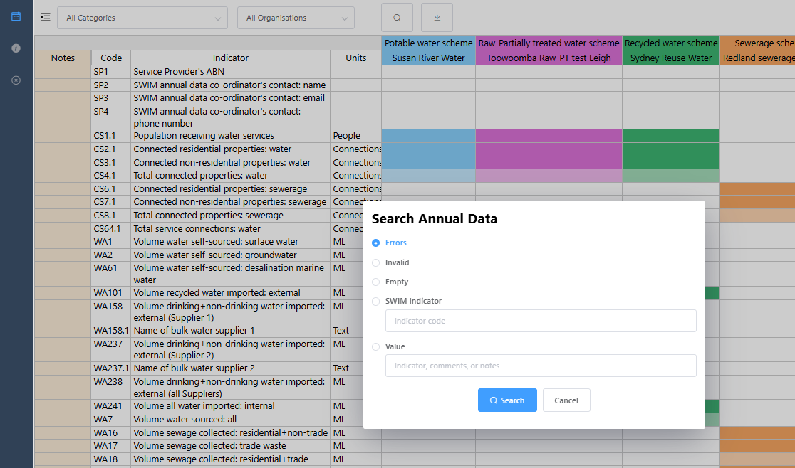

From the ‘search form’ you can search for:

* Error values (red highlighted cells)
* Invalid values (yellow highlighted cells)
* Empty cells (no values entered)
* SWIM indicator (enter the SWIM indicator code you wish to search for, e.g., WA1)
* Value (enter a particular value or word you wish to search for. This searches both ‘values’ and ‘comments’)
* Pressing ctrl-f will also open the ‘search form’.
* Pressing ctrl-g will repeat the previous search without opening the ‘search form’so pressing ctrl-g repeatedly will take you through all the ‘invalid cells’, for example. If there is no previous search then ctrl-g just opens the search box like ctrl-f.

The search function looks for things from the current active cell downward through the grid but does not automatically restart from the start of the grid. Once it has searched the entire grid it offers to start again at the top, so pressing ‘search’ (or ‘ctrl-g’) repeatedly will let you loop through the entire grid/sheet.

**NOTE:** when searching sometimes the screen will not display (jump to) the search result on the current screen view so to see the result just press the ‘up’ or ‘down’ arrow button on your key board and the cell above or below the search value will be selected and the screen will now jump to that section and show that cell.

## Mouse (cursor) hover-over functionality

The mouse (cursor) hover-over function allows the user to see further information about a particular aspect of the indicators by moving the cursor on a cell (no clicking), as follows:

* SWIM Code – allows the user to see the other codes used for this indicator by all the requesting organisations
* Scheme name – allows the user to see the scheme’s long name
* A screenshot of a computer

  AI-generated content may be incorrect.Data cells - allows the user to see the further information about the value, such as, SWIM code, indicator title, who entered the data, calculation used (if appropriate), validation rule used, previous year’s values (a maximum of the previous 4 years), comment (if appropriate). See image below.

## Viewing indicator definitions

To view the indicator definitions in the Web ADT you need to right click on the indicator’s short title and select ‘View indicator description’ as shown below.

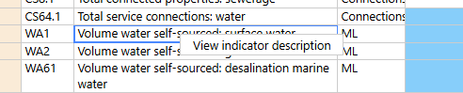

A window containing the indicator definition will pop up (as shown below).

## Missing data (MD)

The user can enter ‘MD’ into any cell to identify that an indicator has Missing Data.

**Note** that a zero (0) **must not** be used for missing data. Missing data (MD) is used when you do perform an activity but for some reason (e.g., a broken meter) you do not have any data for that indicator.

## Not relevant (NR) indicators

The user can enter ‘NR’ into any cell to identify that an indicator is Not Relevant. **Note** an indicator is only ‘Not Relevant’ if the organisation does not do the activity now and never has, never plans to. For example, volume groundwater extracted, if you have no bores and do not extract any groundwater for use in water supply then you should report this indicator (SWIM Code WA2) as ‘NR’. **Note** that it is possible to have some schemes as ‘NR’ and others with values for the same indicator, e.g., Drinking Water Scheme A uses bore water (a value is entered for groundwater extracted (SWIM code WA2) but Drinking Water Scheme B only uses surface water (NR is entered for groundwater extracted (SWIM code WA2).

**It is good to use NR where appropriate as the ‘NR’ will carry over (pre-populate) from year to year and you will not have to retype it each reporting year.**

The system can handle ‘NR’ in source/raw data indicators used to generate calculated cells (it considers it a ‘0’ for calculation purposes).

**Note** that ‘MD’ or ‘NR’ is the only text that can be entered into a numeric cell.

## Calculated indicators

Cells with calculated (i.e., derived) indicators are populated with values as soon as the necessary raw (related) values are entered.

The calculated indicator value can be replaced/over-written by a typed-in value – if over-written then changing the source raw data values of the calculated indicator **will not** change the typed-in calculated value. Calculated indicator cells are recognised by being a ‘half shade’ lighter than the raw (user entered) data cells and with the calculated value appearing in *italics*. **Note** that if a calculated value is over-written then the value will no longer appear in italics. See screen grab below – indicator WA45 (*7.0*) is calculated (light blue background and in italics), while WA7 (20.0) is calculated but has been over-written (light blue background and not italics).

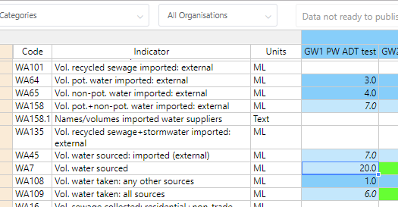

If you have over-written a calculated value you can revert back to a calculated value by right clicking the appropriate cell and selecting ‘Revert to calculated value’. The cell will then recalculate from the raw data and the font will then return to *italics*.

**Note:** it is rare that a calculated cell is/should be over-written.

The program can handle ‘NR’ values for raw value indicators from which calculations are derived (it considers it a ‘0’ for calculation purposes).

If there is ‘MD’ (missing data) entered for some of the raw data used in a calculation then the calculated cell will still calculate. You will then have two options:

1. if the calculated value is appropriate (i.e. the missing value is insignificant) then you would use that value, or
2. if the calculated value is not appropriate (i.e. the missing value is significant) then you would either:
   1. replace the calculated value with the real value if know or estimated, or
   2. replace the calculated value with ‘MD’ (Missing Data).

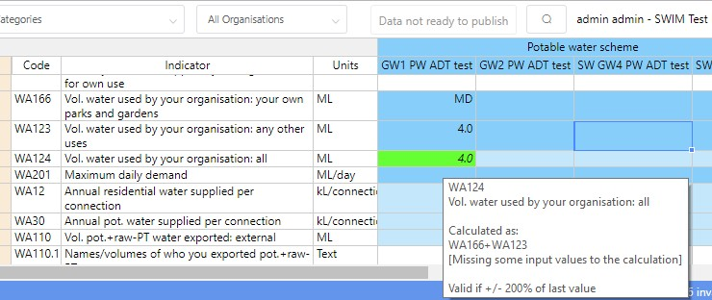

Note that if all the raw/input values are reported as ‘MD’ then a “0” will appear in the calculated cell and you will need to replace it with either an estimate or ‘MD’.

If a MD or ‘0’ is used in a raw data cell for a multiplied or divided calculated cell then a ‘Div/0’ or ‘Error’ will appear in the calculated cell and the cell will turn red. You will need to replace it with either an appropriate estimate, ‘0’ or ‘MD’.

## Invalid (yellow cells) values

A yellow invalid cell is where a value could be true but it needs checking as it breaks the validation rule for the indicator/scheme.

The value **cannot be** published while it is highlighted yellow. If the value is incorrect (e.g., incorrect units used) then enter the correct value and the yellow highlighted should vanish. If the yellow invalid cell is correct, then the user needs to accept the value as true. To do this right click the cell and select the ‘Accept as true value’ option (see below). Once this has been done the cell background colour will return to normal. It is a good idea to add a comment to all yellow invalid cells that are accepted as true to explain the difference from the previous year’s value.

## Error (red cells) values

Red error cells are ones that cannot be true, i.e. they are errors, e.g., text in numeric cells, incorrect text value entered, Div/0, etc. and cannot be saved. On logout the cell will remain ‘empty’ and no value is saved.

There are 3 reasons for a red error cell:

1. The system has done a calculation which has tried to use a ‘MD’ (Missing Data), ‘NR’ (Not Relevant) or ‘0’ in a complex multiplied/divided by calculation. The cell will either contain the text ‘Div/0’ or ‘ERROR’. These error cells are not always immediately obvious as they may be anywhere in the system/screen. They can be found via the search function.

Once you find the red error cells you will need to decide on what has caused it and what to do. Use the mouse hover-over functionality to see how the calculation is done. In general, these calculation errors can be replaced with either MD, NR or 0. (See ‘Calculated indicators’ section above).

1. The program will not permit any input of non-number values, or values which are not a valid number (for example, containing repeated minus (--), plus (++), symbols). It does allow the use of negative (-), less than (<) and greater than (>) signs. These error cells are easily seen (and found) as they occur in the cell you have just entered data in and you will see them highlighted in red straight away.
2. A white background with black text

   AI-generated content may be incorrect.The information entered into a data cell is not in the correct format. For example, text entered into a number only cell or incorrect format/words in a text cell, e.g. ‘YES’ instead of ‘yes’. The system has been made to be very specific as too what can be entered into some text cells (as requested by the organisations requesting the data). The ‘units’ column will display the appropriate format. It will say ‘text’, ‘yes/no’, ‘1,2,3,4,5,6’, etc. (see below). It is case sensitive. If the units are ‘text’ it means that any text/words can be entered. These error cells are easily seen (and found) as they occur in the cell you have just entered data in and will be highlighted in red straight away.

**Note**: most of the text indicators now have a dropdown box function which will eliminate this last error.

## Adding a comment to a data point

You can add/edit/delete a comment to any value (cell) that you want to. You do this by ‘right clicking’ on the cell and select either ‘Add comment’ or ‘Delete comment’.

**Note** that this can only be done if there is a value in the cell.

If you click ‘Add comment’ then a comments text box will appear. You can add any text (no character limit, can use ‘return’) you want. Click out of the text box and the comment will automatically save and you will see a red triangle in the top right corner of the cell to indicate that it has a comment. Mouse hover-over will show what the comment is. **Note** that these comments will be sent with the data to the requesting organisation. If you want to add a comment related to scheme(s) for a particular indicator then it is probably best to add this comment to your organisation’s WSP-wide column’s cell as well as some organisations only receive the WSP-wide value. **Note** that while there is no character limit on a comment you should still try and keep them short but still sufficient to describe the situation.

The mouse hover-over function allows you to view/read/edit any comments. Comments can be edited or deleted at any time using this process.

## Mandatory comments

Some indicators require mandatory comments if you enter a certain value/response, e.g., if you don’t have a ‘water contingency supply’. The SWIM system will automatically open a comments box when this occurs and will contain some ‘greyed out’ text telling your what the comments needs to say/explain (see image below).

The indicator description will provide details of mandatory comment requirements for the appropriate indicators.

## Text dropdown boxes

Most text indicators now have a dropdown box function which allows you to select the appropriate response from a dropdown list. A small black triangle in the data cell will indicate if a dropdown list is available, either click the arrow or double click the cell to enable the dropdown list functionality.

## Publishing data

Only a user with a ‘Publish annual data’ role is able to publish the data (i.e., approve the data for release to the organisations requesting the information). These users are the only ones who will actually see the ‘publish data’ button (see image below).

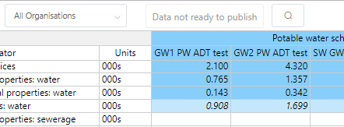

To ‘publish’ your data you **must** have zero (0) errors, zero (0) invalid and entered data for every cell required. This is shown in the bottom right corner of the Web ADT window.

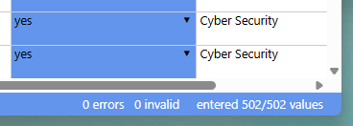

If you still have any empty, invalid or error cells the software will not let you ‘publish’ the data. To find any of these you can use the Search function. Once you have no empty, invalid or error cells then the ‘Publish’ button at the top right will then become active (as shown below).

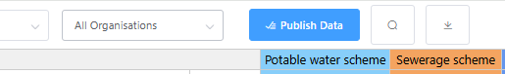

When you are happy with all your data, click the ‘Publish Data’ button and it will ask for confirmation, then it will say that the data is published and the button will now say ‘Data is Published’ and be bright yellow (as shown below).

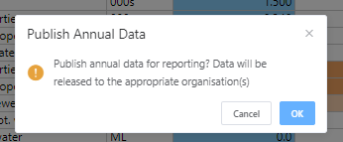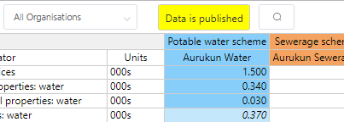

If you have ‘Published’ your data you can still check and correct/change the data at any time throughout the year **but** make certain that you check any changes do not result in any error or invalid cells (these will need to be checked/fixed and accepted as true before you re-publish).

When you change any data the system automatically sets the data to ‘unpublished’ and the ‘Publish data’ button will change back to its original plain colour. You will therefore need to click the publish data button again to re-publish it – otherwise no-one will not be able to access your updated data. The SWIM contact for your organisation will receive an email to notify them that this has occurred.

Once your data is ‘Published’ it will be sent to the appropriate organisation, at the appropriate time and in the appropriate format. This will occur just after 5 pm on the date that the data is due to each of the organisation. This means that you will need to publish all data that you wish to have reported prior to 5 pm on the due date. Due dates are communicated to all SWIM users each year and may change from time to time depending on business days and public holidays, but mostly it is 1 October each year.

A complete/exact Excel (.xlsx) copy of your published data will be sent to your SWIM contact when it is sent off to the requesting organisation.

## Exporting data

You can export data from the Web ADT at any time by clicking the download symbol (arrow). This will download the data as an Excel (.xlsx) file.

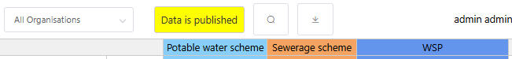

## Quirks and known issues with the Web ADT

### Notes column

The notes column (light brown left-hand column) doesn’t show the whole sentence in the Web ADT even when you widen the column (1st image). If you double click the cell, as if you were going to change the data, it does show everything (2nd image).

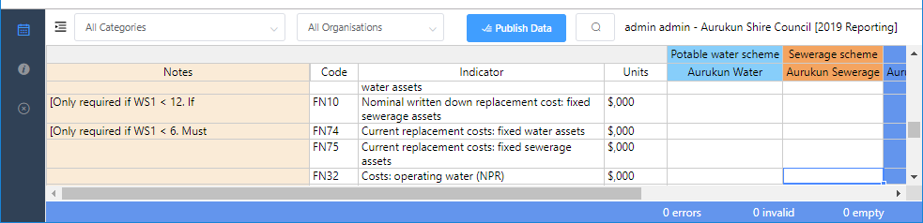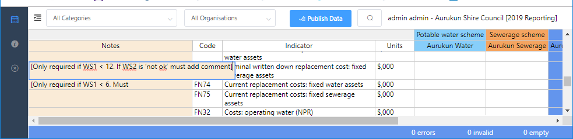

This is a limitation of the way columns are handled in the underlying grid library used to develop the webpage. If the column is dynamic it will always expand to show the full text on the first load of the data which means it takes up too much space. It is not fixable at present.

### Search function not showing result

When searching sometime the screen will not display (jump to) the search result on the current screen view. To see the result just press the ‘up’ or ‘down’ arrow button on your keyboard and the cell above or below the search value will be selected and the screen will now jump to that section and show that cell.

# ***qldwater***– The Queensland Water DirectorateSWIM contacts

Dr David Scheltinga

SWIM Manager

Mob: 0415 881 195

email: [dscheltinga@qldwater.com.au](mailto:dscheltinga@qldwater.com.au)

Ms Jess Dean

Project Manager - Data & Environment

Phone: (07) 3632 6852

Email: [jdean@qldwater.com.au](mailto:jdean@qldwater.com.au)

Submit an online SWIM IT support form here: <https://qldwater.com.au/SWIM_Help>

1. All schemes are controlled via the Web Admin Tool.
2. **Note** that the background colour of all calculated cells is half strength of the normal colour (i.e., lighter).