
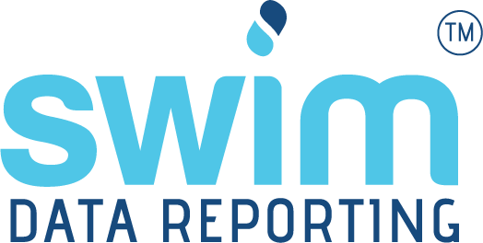

SWIMTM Annual Data Manual: data entry and user setup

June 2026
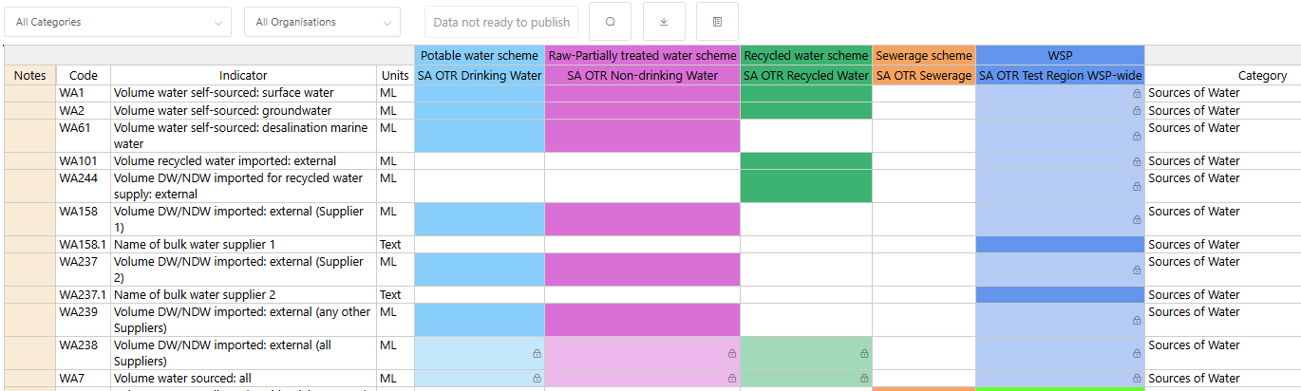

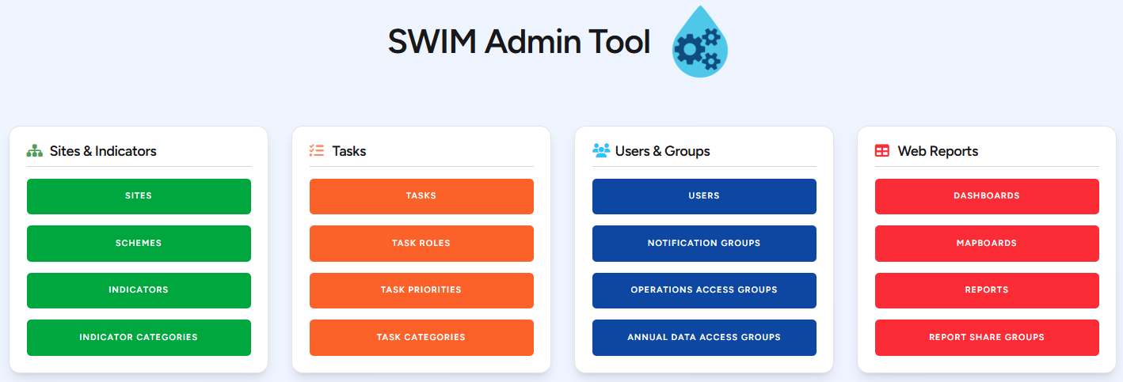

qldwater
STATEWIDE WATER INFORMATION MANAGEMENT (SWIM™) SYSTEM
www.qldwater.com.au/swim
Contents
swimlocalTM Admin (Administration) Tool 4
Login Screen 4
Home Screen 5
Managing SWIMTM Users 5
Adding/editing a user 5
User roles 7
Annual Data Access Groups 8
Create a new access group 8
Edit an annual data access group 9
Notification Groups 10
Error Messages During User Login 12
SWIMTM Annual Data Tool (ADT) 13
Accessing the ADT 13
Login errors 14
Annual Data Tool (ADT) – General Format and Menu Bar 14
Columns (left to right) and their function: 15
Filtering indicators 16
Search function 17
Download data 18
Glossary 18
About and Logout 18
Annual Data Tool (ADT) – Data Entry Form Functionality 19
Mouse (cursor) hover-over functionality 19
Viewing indicator definitions 20
Missing data (MD) 20
Not relevant (NR) indicators 21
Calculated indicators 21
Invalid (yellow cells) values 25
Error (red cells) values 25
Undoing edits 26
Comments 26
Mandatory comments 27
Text dropdown boxes 28
Publishing data 28
Quirks and known issues with the ADT 29
Notes column 29
Search function not showing result 30
Shortcuts 30
Help 30
Helpful Websites 30
Contacts 30
Contacts (Qld SWIMTM) 30
Contacts (SA SWIMTM) 31

SWIMTM is the system developed by qldwater to help Water Service Providers in Qld and SA submit their annual water and sewerage data to the requesting government departments and organisations. This is done via qldwater’s web-based swimlocalTM data management tools, i.e., the ‘Admin Tool’ and ‘Annual Data Tool’ (ADT).

swimlocalTM Admin (Administration) Tool
Each Service Provider (SP) will need to have at least one person with a ‘System Administrator’ role who is responsible for administering/co-ordinating the SP’s metadata, annual data and user accounts (we recommend at least two administrators to cover for absentees).
Admin Tool website: https://www.swim.qldwater.com.au/admin
The Admin Tool contains several management windows depending on a SPs level of access to the SWIMTM/swimlocalTM system, but the following are the key ones for SWIMTM Annual Data reporting:
- Sites & Indicators: Schemes
- Tasks: not needed
- Users & Groups: Annual Data Access Groups, Notification Groups, Users
- Web Reports: not needed
These screens are explained in more detail below.

Login Screen
The login screen provides login (username, password, and Region ID) fields.
Your SWIMTM login/password is the same for all SWIMTM tools (please remember that both username and password are case sensitive).
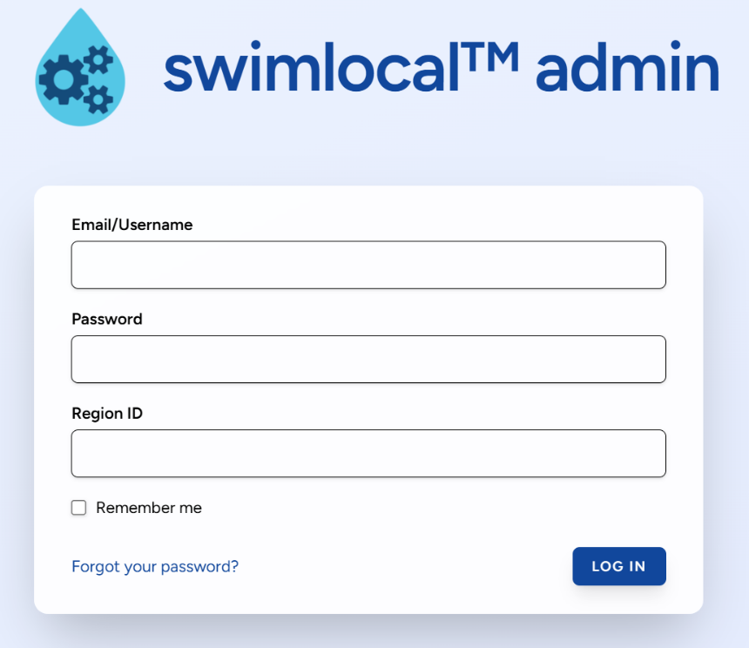
A user must have a ‘System Administrator’ role in order to login to the Admin Tool.

Home Screen
The home screen is the first screen seen when logged in. The home screen provides buttons to access all data management functionality. Functions are organised into logical groups within two sections relevant to SWIMTM reporting; ‘Sites & Indicators’ (green) and ‘Users & Groups’ (blue).
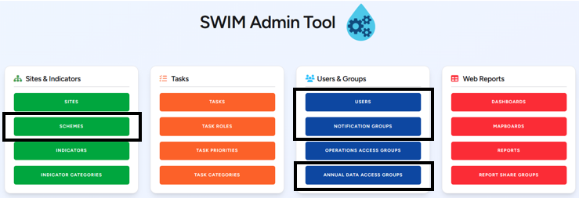

Managing SWIMTM Users
SWIMTM uses different user roles and access groups to help limit which components of the system that people can access. There are two ways in which this is done; firstly, via user ‘roles’ which limits which SWIMTM tools a user can login to; and secondly, via ‘annual data access groups’ which limits which schemes and categories a user can see (interact with) within those tools. Every user must have at least one role and one access group associated with them. In addition to roles and access groups, the Admin Tool lets you control what email notifications each user receives.

Adding/editing a user
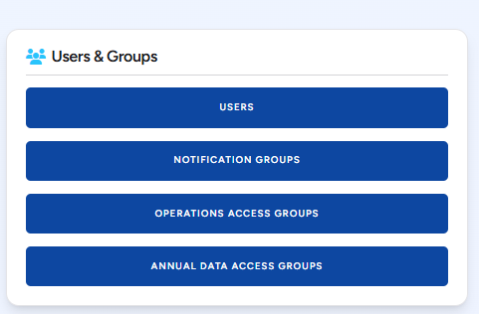
Click on the ‘Users’ button.

As shown below, the ‘User’ screen lists all users for the SP (list of user logins, emails, first name and last name, and roles). It is sortable by clicking on the arrow next to each column header. It provides functions to add or edit a user. Inactive users are not shown in the list unless the ‘Show Inactive’ tick box is selected (top left under ‘Filters’).
Any user can be edited from this window by clicking the user or the associated ‘Edit’ button on the right-hand side.

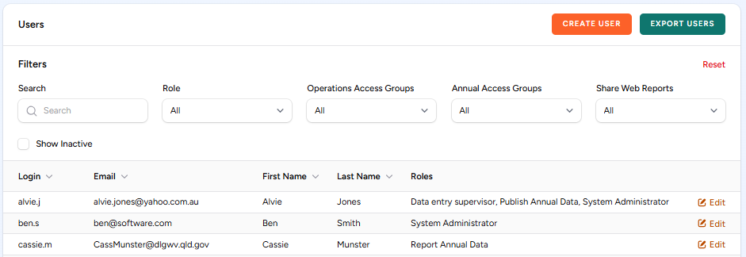

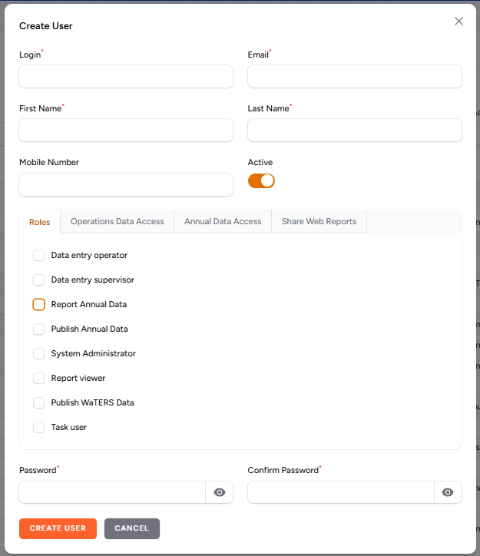
To create a new User, click the ‘Create User’ button in the top right-hand corner. This opens the screen below.

Complete all the SWIMTM user fields (mobile number can be left blank for SWIMTM Annual reporting).
We recommend using a familiar login system consistent with your organisation or at the least within SWIM.
Only a single email can be entered and must be unique for the organisation.
A mobile number is optional but is needed for other swimlocalTM functionality like receiving SMS alerts. A mobile number must be entered without spaces, and multiple mobile numbers can be entered and must be separated by a comma, e.g. 0415123456, 0414654321. Note that mobile numbers can be in international format (e.g., +61) if you wish or national (e.g., no +61).
A user can be made inactive by un-selecting the ‘Active User’ tick box. For referential integrity reasons users cannot be deleted once created and they can only be made inactive. An inactive user cannot login to the SWIMTM system.
User roles and access groups can be selected by clicking (ticking) the appropriate boxes. Refer to the ‘User roles’ and ‘Annual Data Access Groups’ sections below.
Ensure a password is entered and confirmed.
Once the form is complete, select ‘Create User’ at the bottom left corner.
To edit a user, select (click on) the user you wish to change or click the ‘Edit’ button on the right-hand side. You can then change any of their details such as roles/access level and password.

User roles
Eight swimlocalTM user role types have been set up within the software as described in the following table. Only the 3 related to SWIMTM Annual Data are included here.
Users can be assigned multiple roles (by selecting multiple roles) to allow access to the different SWIMTM tools they need. For SWIMTM Annual Data reporting the user will need either a ‘Report’ or ‘Publish’ annual data role.
Note: a ‘Publish Annual Data’ user will by default always be able to see/access all SWIMTM annual data irrespective of what Annual Data Access groups they are assigned to.

Table 1. SWIMTM Annual Data user roles.
User Role | Using SWIMTM for | Tools that user role can access
Report annual data | - Annual data entry | - Annual Data Tool (as per Annual Data Access group setup)  - Reports
Publish annual data | - Annual data entry  - Publishing (approving) annual data so that it can be released/sent off | - Annual Data Tool (all data, always)  - Reports
System administrator* | - Administer SWIMTM metadata and user accounts | - Admin Tool  - Reports
*If a system administrator is also entering SWIMTM Annual Data then they must also have an appropriate ‘Report’ or ‘Publish’ annual data role.

Annual Data Access Groups
Annual data access groups give you control over exactly what schemes and SWIMTM indicator categories a user can access. Click on the ‘Annual Data Access Groups’ button. Note: Users with the ‘Publish annual data’ role are an exception to the above. They can see all schemes and categories by default, regardless of the access group(s) they are assigned to.
Click on the ‘Annual Data Access Groups’ button.

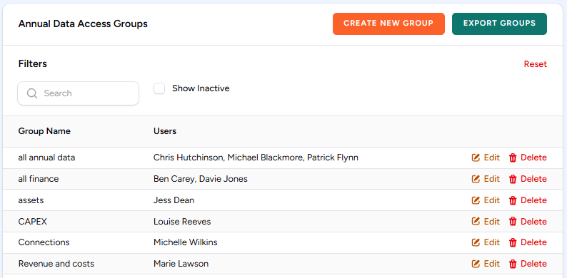
As shown below, the ‘Annual Data Access Groups’ screen lists all annual data access groups for the Service Provider. It provides functions to add or edit an access group. Inactive access groups are not shown in the list unless the ‘Show Inactive’ tick box is selected (top left under ‘Filters’).

Create a new access group
To create a new access group, click the ‘Create New Group’ button at the top right and the below window will appear.
Enter an appropriate ‘Group Name’ for your annual data access group.
Click the ‘Add Users’ to select which users will be included in the group. You must have previously set up the user via the ‘Users’ management window (see ‘Managing SWIMTM Users’ above).
Click the ‘Add Schemes’ to select which schemes are to be included.
Click the ‘Add Categories’ to select which SWIMTM categories are included.
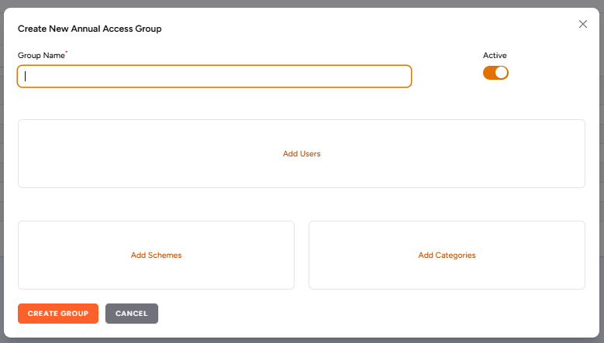
Once the appropriate details have been selected/entered then click the ‘Create Group’ button in the bottom left corner.

Edit an annual data access group
To edit an annual data access group, click the appropriate group or ‘Edit’ on the right-hand side. You can then edit what you need by selecting the appropriate edit Users / Schemes / Categories group. Once you have completed editing ensure you select ‘Save Changes’.
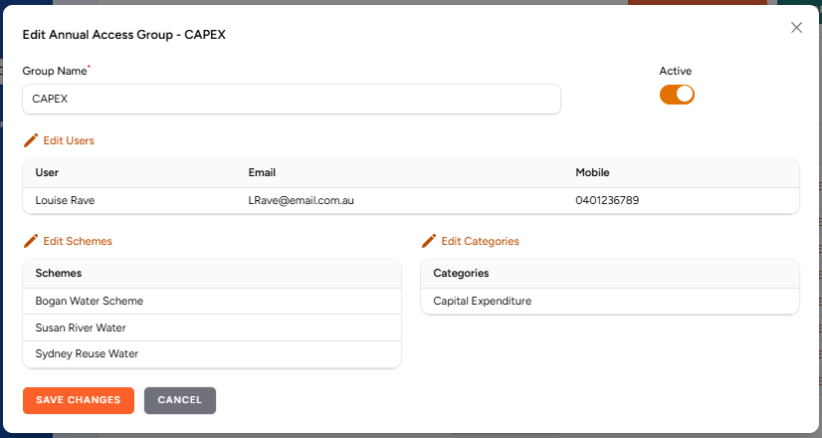
Below is an example of an ‘Edit’ Annual Data Access Group management window. Groups can be made active or inactive by selecting the ‘Active’ tick box.

Notification Groups
Notification groups give you control over exactly what communications each user receives. A set of built-in notification groups is provided, each covering a different type of email. Assign a user to one or more groups, and they will then receive the notifications associated with those groups.
Click on the ‘Notification Groups’ button.

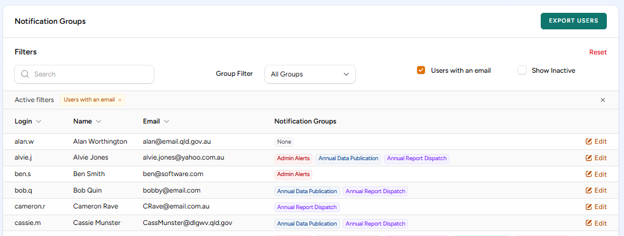
As shown below, the ‘Notification Groups’ window lists all users and what groups they are included in. It provides functions to add or edit notifications for a user. A User must be active and have an email address assigned to them to be able to receive notifications.

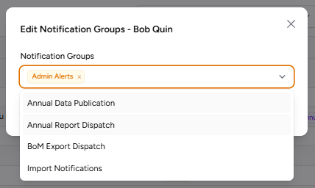
To edit a User either click the User row or ‘Edit’ on the right-hand side. The below window will appear, and you can then select which notification groups from the drop-down list that you want to include for that user. Multiple groups can be selected at one time.

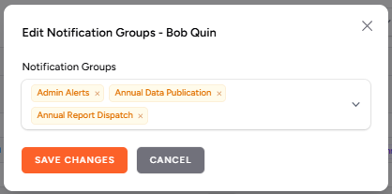
The 3 notification groups relevant to SWIMTM Annual Data are; Admin Alerts, Annual Data Publications, and Annual Report Dispatch. Once complete, make sure that you then click the ‘Save Changes' button.

Note: all system administrators should always be in the ‘Admin Alerts’ notification group at least, and probably all groups.
Table 2. Notification Groups.
Notification Group | Notifications Received | Examples
Admin Alerts | - System and administration emails for a region — calculation, SMS, and task problems that an administrator needs to act on | - Regular SWIMTM information emails  - Issues with calculations  - Issues with emails, notification groups, etc.  - Issues with sending alerts/SMS  - Issues with tasks
Annual Data Publications | - Changes to the publication status of a region's annual data | - "{year} Data published status changed" — set to Published / Unpublished, naming the user who made the change
Annual Report Dispatch | - Confirmation that annual data reports have been generated and dispatched, and a copy of the dispatched report files themselves | - Excel files of SWIMTM data  - NPR, QG KPI, ABS, BoM, SA Health and SA OTR report dispatches sent
Import Notifications* | - Outcomes of data-file import processing | - Excel file of rejected import file data  - "Data file import with no changes"  - "Cannot import file '{file}' — missing or unknown SWIM3 file type" (file attached)  - "Cannot import file '{file}'" — file-info / generic import errors (file attached)  - Inactive sites found in a data import  - Daily condensed import-status summary
BOM Export Dispatch* | - Confirmation of data exported to the Bureau of Meteorology | - "Data sent to BoM:" — listing the sites/indicators that were exported
*Not relevant to SWIMTM Annual Data reporting.
The fallback for notifications in all cases is that, if there are no active emails assigned to a group then the notification is sent to the first active ‘System Admin’ for the region (first in alphabetical order of their login name).

Error Messages During User Login
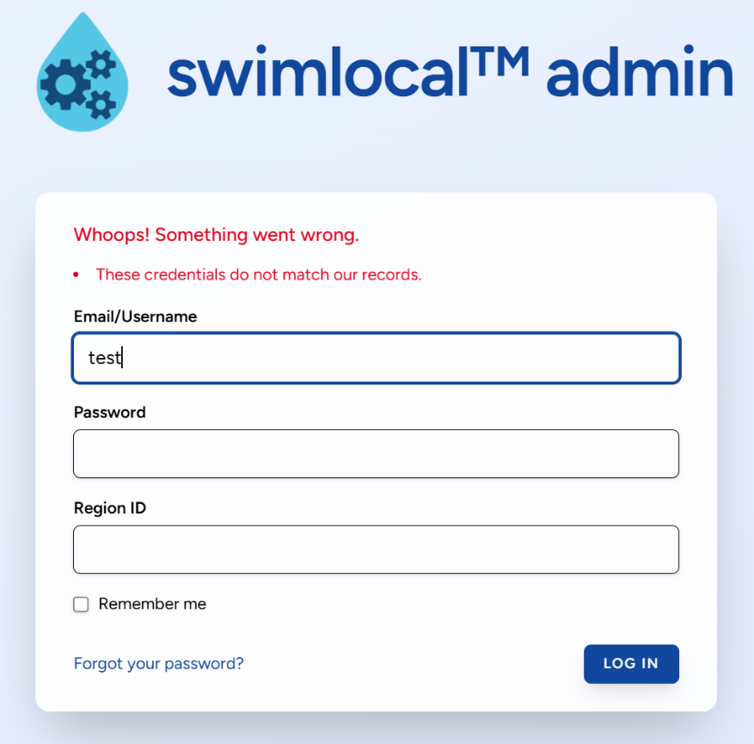
If a user tries to access the Admin Tool but the password or username is incorrect, or if they don’t have a ‘System Administrator’ role then they will receive the following message. First try ‘Forgot your password?’ and follow the prompts to update your password. If this doesn’t work, you will need another system administrator to login and fix the error (correct username or role). Or contact qldwater or the SA OTR (see Contacts Section at the very end of this document).

SWIMTM Annual Data Tool (ADT)
The SWIMTM ADT (Annual Data Tool) is used to report your regulatory required annual water and sewerage data to the requesting organisations (e.g., NPR, ABS, BoM, State Govt). This section explains how to use the SWIMTM ADT to enter your annual water and/or sewerage data.

Accessing the ADT
Access to the ADT is controlled by your organisation’s SWIMTM System Administrator via the Admin Tool (as described above).
- The Website is located at: https://www.swim.qldwater.com.au/adt
- A User must have a role of either ‘Report’ or ‘Publish’ annual data and be in an appropriate ‘Annual Data Access Group’ in order to log in to this tool.
- You will need your Region ID, Username and Password to access the ADT. If you are unsure what your login details are, discuss with your SWIMTM System Administrator.
- Both the login and password are case sensitive.
- Closing the website will not log you out of the ADT system. This means that the next time you open the website you will be automatically logged in. Only by selecting ‘Log Out’ will the user be logged out of the website and need to re-enter their login details.
- To change the screen size in the browser press Ctrl- (to decrease font size) or Ctrl+ (to increase font size). This will allow you to see more columns/rows on the screen at any one time.
- The ADT automatically synchronises every 30 seconds.
- The ADT checks for a new app version every 15 minutes. If one is available, it will prompt you to load it.
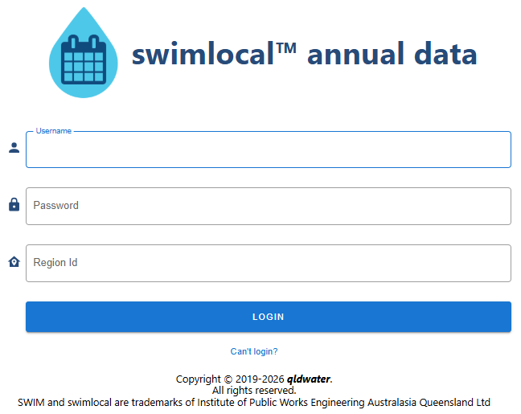

Login errors
If your Username, Password or Region ID details are incorrect you will receive the following message. Note that both Username and Password are case sensitive.
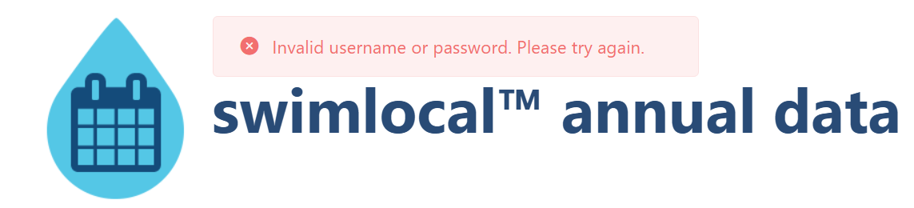

If you receive the following login error, it means that your Username and Password are correct but you have not been given the correct User Role (‘Report annual data’ or ‘Publish annual data’) by your SWIMTM System Administrator to access the ADT. You need to contact them.

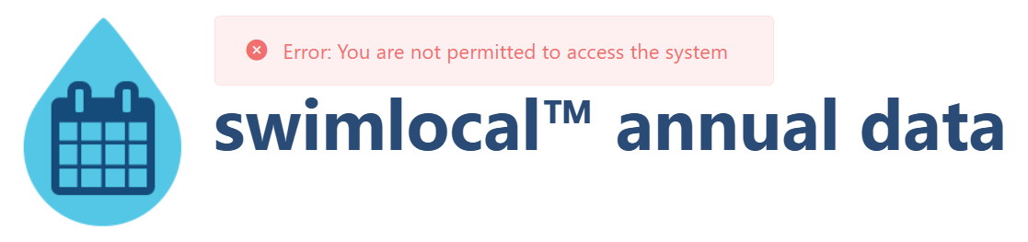

If you login and the ADT opens up but there are no indicators or anything shown (see below) then it means that you have not been given the correct ‘Annual Data Access’ privileges (assigned an ‘Annual Data Access Group’) by your System Administrator. You will need to contact them.
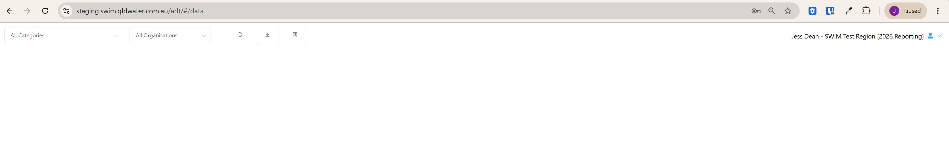

Annual Data Tool (ADT) – General Format and Menu Bar
The data entry home screen is the primary data entry screen of the tool. It presents as a grid control spreadsheet format. Users input values by typing into the grid cell for the appropriate indicator and scheme. Only the darker coloured cells require data (i.e. white cells do not require data to be entered).
Note that the background colour of all ‘calculated cells’ are a half shade of the normal colour (i.e. lighter) and don’t need data entered manually as the system will populate them for you. Calculated cells also have a ‘padlock’ symbol and the text is in italics.
All column widths can be adjusted by placing the cursor on the column heading join line. The screen can scroll left and right if needed but will not scroll past the ‘Units’ column.

Columns (left to right) and their function:
- Notes (beige background) – allows the user to enter any notes/comments/related text that is useful for now and future users (e.g., Data from Jenny Smith from Finance, Data estimated using the following method “X divided by C”). This information is not sent to anyone and will be included/visible in next year’s ‘ADT sheet’.
- Code – lists the SWIM™ code of the indicator.
- Indicator – lists the short indicator title.
- Units – lists the units that the indicator must be reported in.
- Drinking (Potable) water scheme (light blue background) – shows (as columns) all the drinking water schemes that were active during the reporting period that require data to be entered. Drinking (potable) water is intended for drinking and should materially meet the latest Australian Drinking Water Guidelines, or equivalent.
- Non-drinking (Non-potable/Raw-Partially Treated) water scheme (purple background) – shows (as columns) all the non-drinking water schemes that were active during the reporting period that require data to be entered.
- Recycled water scheme (green background) – shows (as columns) all the recycled water schemes that were active during the reporting period that require data to be entered. Recycled water can be either drinking or non-drinking water standard. It is sourced from either sewage, drainage water or stormwater.
- Sewerage scheme (orange background) – shows (as columns) all the sewerage schemes that were active during the reporting period that require data to be entered.
- WSP-wide scheme (dark blue background) – is where data for the ‘Whole of Service Provider’ scheme is entered. In most cases the WSP-wide value is a calculation (often sum) of other indicators/schemes.
- Category – lists the SWIM™ category that the indicators sit within. You can filter by category (top left dropdown selection box).

Filtering indicators
You can filter which indicators are visible by either indicator category or by the name of the agency/organisation the indicators are requested by. Indicator categories used in the filter are the SWIM™ categories used to link similar groups of indicators (as shown in the extreme right column). To do this click on the ‘Categories’ drop-down box at top left and select the indicator category you wish to look at (see below). You can only select one category at a time.

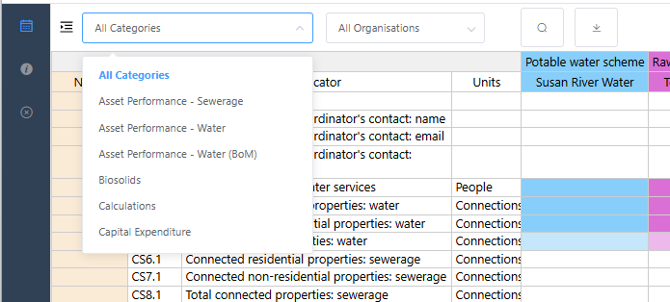
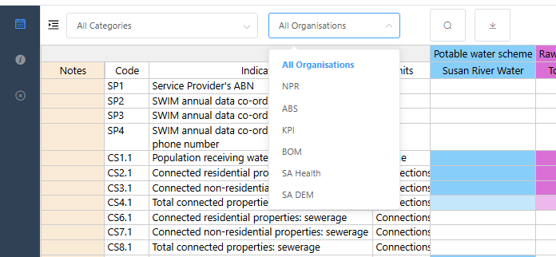
You can also filter by the organisation requesting the indicators via the second drop-down box at the top right. To do this click on the ‘Organisation’ drop-down box and select the ‘organisation’ you wish to look at (see below). You can only select one organisation at a time.

The agencies are:
- NPR – National Performance Report. Data required from all Service Providers
- ABS – Australian Bureau of Statistics (Annual Water and Sewerage Survey). Data required from all Service Providers
- KPI – Qld Govt Key Performance Indicators (Dept of Local Government, Water and Volunteers). Data required from all Qld Service Providers
- BoM U-code – Bureau of Meteorology (Category 7 (U-code) indicators). Data required from Category L persons (the five SEQ entities) named in the Water Regulations
- SA Health – South Australia Health Dept. Data required from most SA Service Providers
- SA DEM – South Australia Dept of Energy and Mining (Office of the Regulator (OTR)). Data required from all SA Service Providers.
Note: in most cases all organisations will appear in the list even if you are not required to report to them. This is because SWIM™ takes out indicator duplication for you and only shows one indicator even if it is requested by multiple organisations.
Note: data will only ever be sent to the organisation that you are required to send data to. So, for example, WA1 (Volume water self-sourced: surface water) is requested by NPR, ABS, KPI and BoM. If a SA Service Provider is not required to report to BoM or KPI then the data will only be sent to NPR and ABS, but if you are a similar Qld Service Provider then your data will be sent to NPR, ABS and KPI – as required by regulation/legislation.

Search function
To open the ‘search’ function click the search icon (magnifying glass) or press Ctrl+F or Ctrl+G.
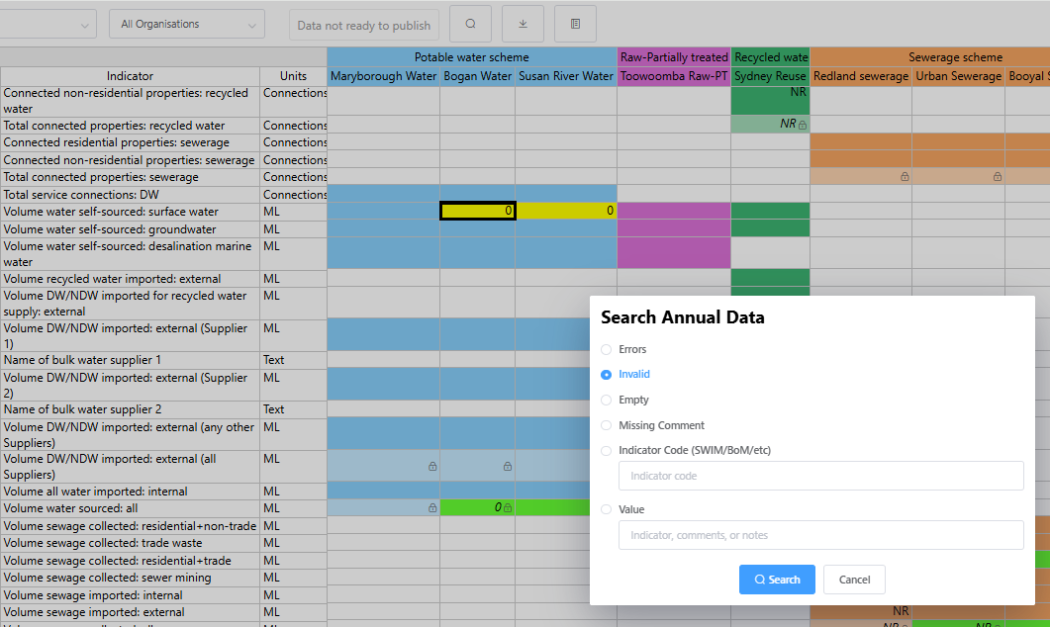

From the ‘search form’ you can search for:
- Error values (red highlighted cells)
- Invalid values (yellow highlighted cells)
- Empty cells (no values entered)
- Missing Comment (orange highlighted cells; requires a mandatory comment)
- SWIM™ indicator code (enter the SWIM™ indicator code you wish to search for, e.g., WA1)
- Value (enter a particular value or word you wish to search for. This searches both ‘values’ and ‘comments’
- Pressing Ctrl+F will also open the ‘search form’.
- Pressing Ctrl+G will repeat the previous search without opening the ‘search form’ so pressing Ctrl+G repeatedly will take you through all the ‘invalid cells’, for example. If there is no previous search then Ctrl+G just opens the search box like Ctrl+F.
Note: when searching, rarely the screen will not display (jump to) the search result on the current screen view (usually the search result is at the very bottom (or just below) the screen, so to see the result just use the ‘up’ or ‘down’ arrows and the cell above or below the search value will be selected and the screen will now jump to that section.

Download data
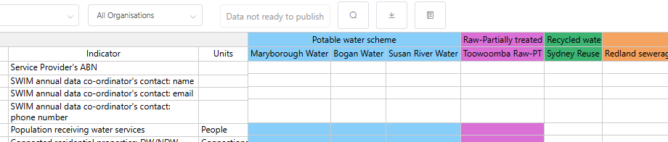
Select the download icon to download an excel spreadsheet of the data any time.

Glossary
The Glossary button opens a quick-reference window that brings together:
- definitions of the terms and abbreviations
- key SWIMTM contacts
- links to help websites
- useful shortcuts
Select the Glossary button to open it. The glossary is searchable.

About and Logout
Next to your username, select the dropdown arrow to:
- About: view basic statistics about your current session
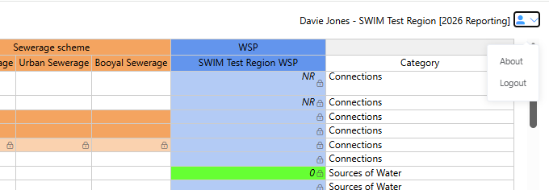
- Logout: logout of the ADT tool

Annual Data Tool (ADT) – Data Entry Form Functionality

Mouse (cursor) hover-over functionality
The mouse (cursor) hover-over function allows the user to see further information about a particular aspect of the indicators by moving the cursor on a cell (no clicking), as follows:
- SWIM™ Code – allows the user to see the other codes used for this indicator by all the requesting organisations
- Scheme name – allows the user to see the scheme’s long name
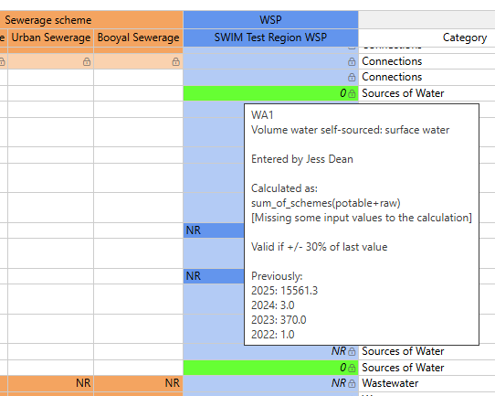
- Data cells – allows the user to see the further information about the value, such as, SWIM™ code, indicator short title, who entered the data, calculation used (if appropriate), validation rule used, and previous year’s values (a maximum of the previous 4 years). See image below.
- Comments – to ‘hover-over’ view a comment, place the cursor over the red triangle indicating the presence of a comment. See image below.
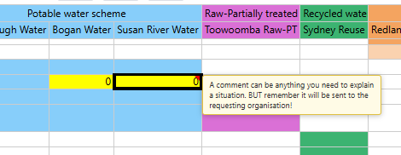

Viewing indicator definitions
To view the indicator definition you need to either; right click on the indicator’s short title and select ‘View indicator description’ (as shown below) or just double click the indicator short title.
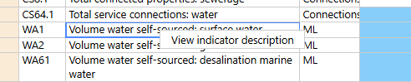

A window containing the indicator definition will pop up (as shown below). You can ‘Open in a new window’ from which you can print the indicator definition.
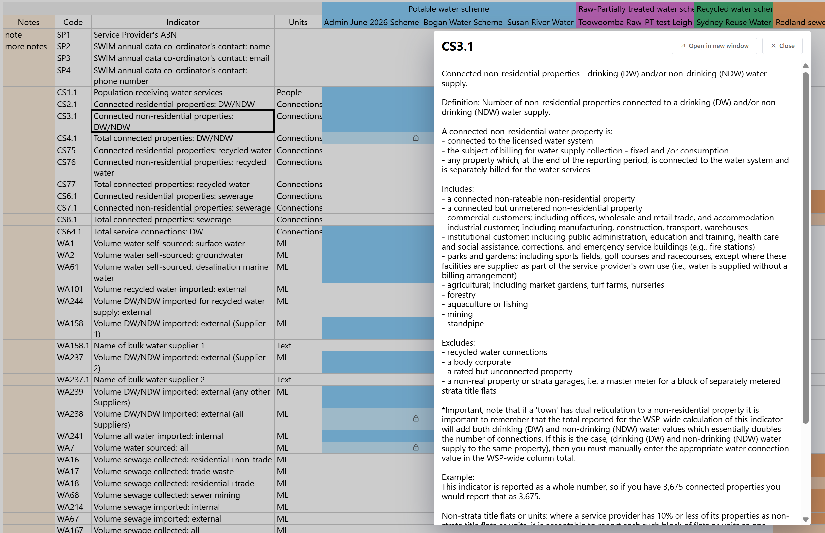

Missing data (MD)
A user can enter ‘MD’ into any cell to identify that an indicator has Missing Data.
Note that a zero (0) must not be used for missing data. Missing data (MD) is used when you do perform an activity but for some reason (e.g., a broken meter) you do not have any data for that indicator.

Not relevant (NR) indicators
A user can enter ‘NR’ into any cell to identify that an indicator is Not Relevant. Note an indicator is only ‘Not Relevant’ if the organisation does not do the activity now, never has, and never plans to. For example, volume groundwater extracted, if you have no bores and do not extract any groundwater for use in water supply then you should report this indicator (SWIM™ Code WA2) as ‘NR’. Note that it is possible to have some schemes as ‘NR’ and others with values for the same indicator, e.g., Drinking Water Scheme A uses bore water (a value is entered for groundwater extracted (WA2) but Drinking Water Scheme B only uses surface water (NR is entered for groundwater extracted (WA2).
Note that some indicators cannot be ‘NR’, e.g., number of water or sewerage service complaints; or number of interruptions, as they can always occur. These must be reported as 0.
Note it is good to use NR where appropriate as the ‘NR’ will carry over (pre-populate) from year to year and you will not have to retype it each reporting year.
The system can handle ‘NR’ in source/raw data indicators used to generate calculated cells (it considers it a ‘0’ for calculation purposes).
Note that ‘MD’ or ‘NR’ is the only text that can be entered into a numeric cell.

Calculated indicators
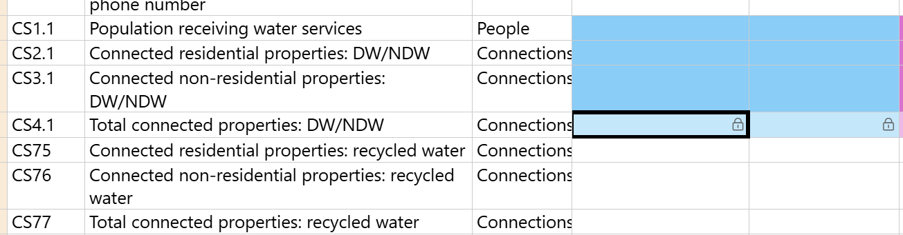
Cells with calculated (i.e., derived) indicators are populated with values as soon as the necessary raw (related) values are entered. Calculated cells are locked, shown by a padlock icon within the cell (calculated cells also are a half shade lighter and resulting number is in italics). You can still add or edit a comment on a calculated cell while it’s locked, the padlock only prevents the value from being changed, not the comment.

It is strongly advised not to change a calculated cell unless absolutely necessary.
If you do need to over-write a calculated value you will need to unlock the cell first. You can unlock a calculated cell by either; right click the cell and select ‘Unlock and edit value’, select the cell and pressing Ctrl+Enter, double-clicking the cell, or clicking the padlock icon.
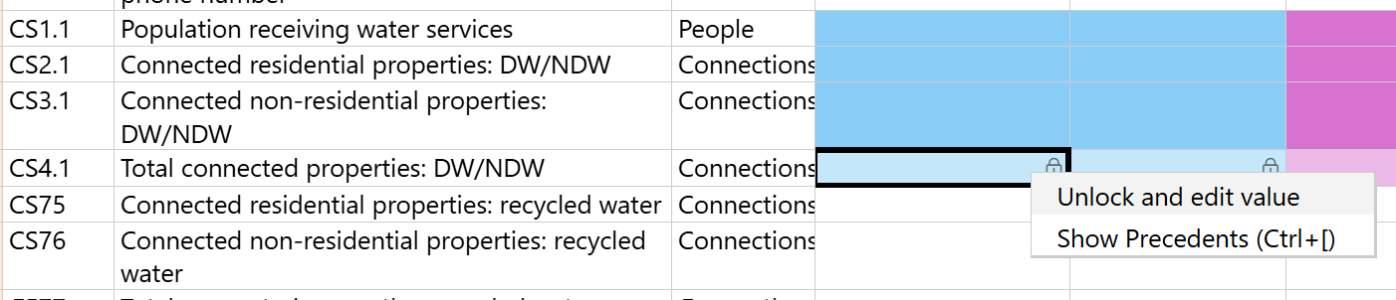

The below popup box will appear, and you must enter the reason for over-writing the calculated cell. Once you have entered a reason, click ‘Unlock For Editing’.
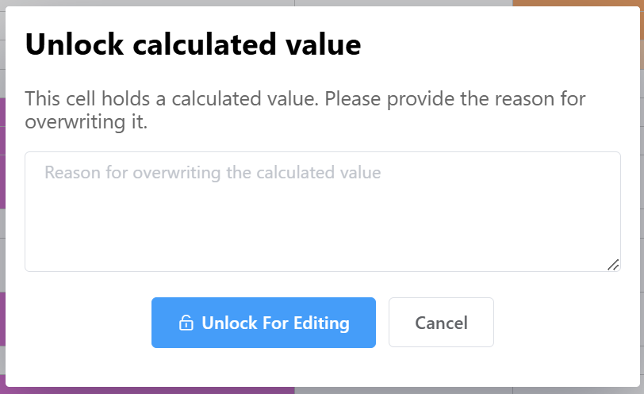
Type in the updated value in the calculated cell (the number entered will not be in italics).

Note over-writing a calculated cell only changes that calculated value – it does not change the raw data cells that the calculation is derived from.
Note once you have over-written a calculated cell, it no longer recalculates automatically. If you later change the raw data values used to calculate it, the over-written cell will keep your typed-in value (the number will not be in italics).
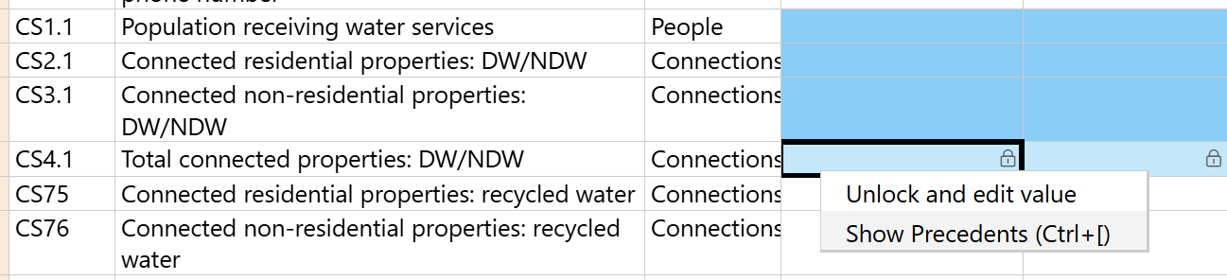
To see where the calculation comes from, either; right click the calculated cell and select ‘Show precedents’ or select the cell and use Crtl+[.

Precedent cells with a valid value are highlighted (purple) – these are fine.
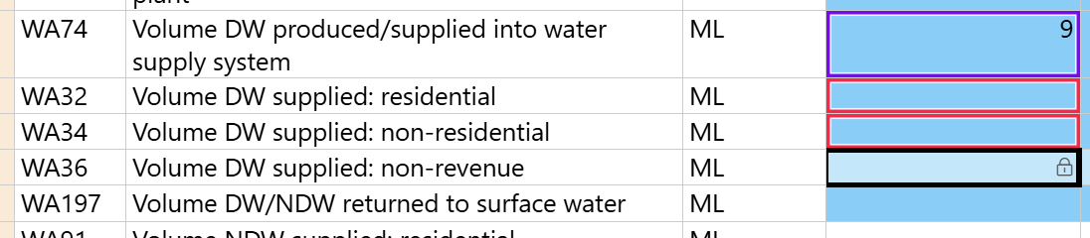
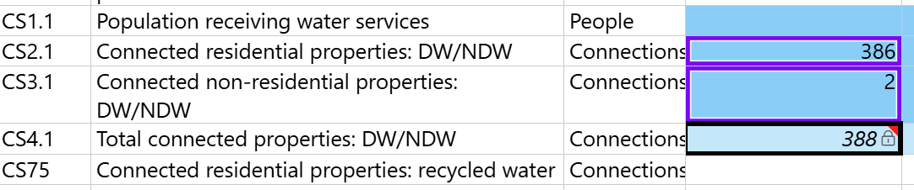
A precedent cell with no value, or another problem is shown with a red box around it. The red box flags that the cell is empty or has an issue that needs to be investigated before the calculation can be relied on.

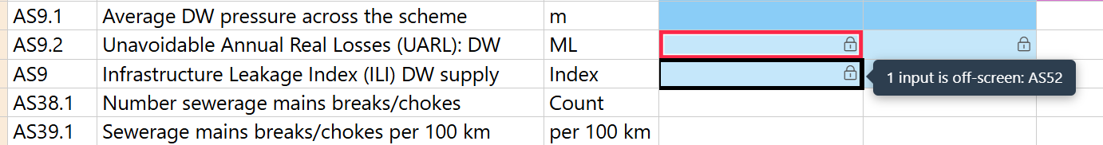
If one of the in-put cells is off-screen, a pop-up box will reference the indicator off-screen, example below. Scroll or use the search function to find the indicator.

Calculated indicator cells are recognised by being a ‘half shade’ lighter than the raw (user entered) data cells and with the calculated value appearing in italics. Note that if a calculated value is over-written then the value will no longer appear in italics. See below – indicator WA45 (7.0) is calculated (light blue background and in italics), while WA7 (20.0) is calculated but has been over-written (light blue background and not italics).
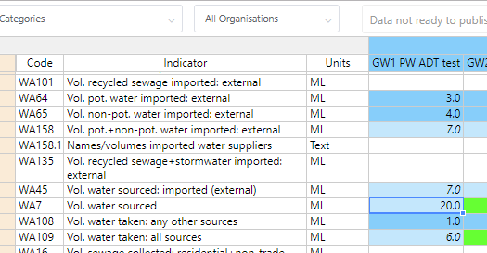

If you have over-written a calculated value you can revert back to a calculated value by right clicking the appropriate cell and selecting ‘Revert to calculated value’. The cell will then recalculate from the raw data and the font will then return to italics.
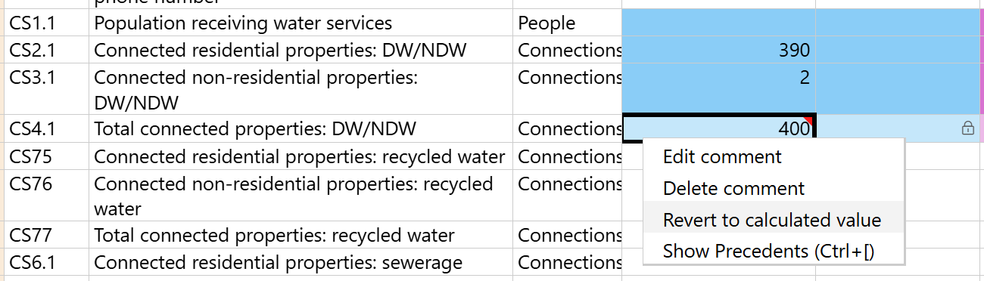
Note: it is very rare that a calculated cell is/should be over-written.
The program can handle ‘NR’ values for raw value indicators from which calculations are derived (it considers it a ‘0’ for calculation purposes).
If there is ‘MD’ (missing data) entered for some of the raw data used in a calculation then the calculated cell will still calculate (the cell will be highlighted green). You will then have two options:
- if the calculated value is appropriate (i.e. the missing value is insignificant) then you would use that value, or
- if the calculated value is not appropriate (i.e. the missing value is significant) then you would either:
  - replace the calculated value with the real value if known or estimated, or
  - replace the calculated value with ‘MD’ (Missing Data).
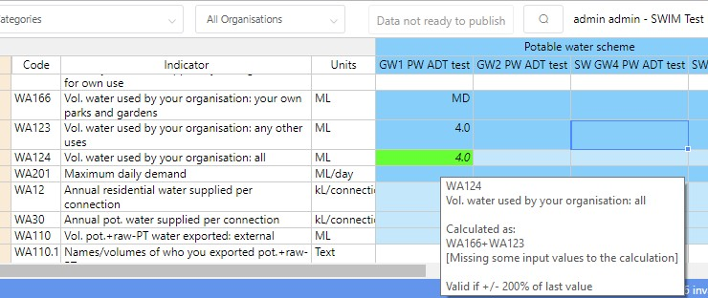
Note that if all the raw/input values are reported as ‘MD’ then a ‘MD’ will appear in the calculated cell.
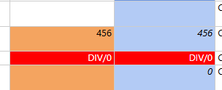
If a ‘MD’, ‘NR’ or ‘0’ is used in a raw data cell for a multiplied or divided calculated cell then a ‘Div/0’ or ‘Error’ will appear in the calculated cell and the cell will turn red. You will need to replace it with either an appropriate value, either an estimate, ‘0’ or ‘MD’.

Invalid (yellow cells) values
A yellow invalid cell is where a value could be true but it needs checking as it breaks the validation rule for the indicator.

The value cannot be published while it is highlighted yellow. If the value is incorrect (e.g., incorrect units used) then enter the correct value and the yellow highlighting should vanish. If the yellow invalid cell is correct, then the user needs to accept the value as true. To do this right click the cell and select the ‘Accept as true value’ option (see below). Once this has been done the cell background colour will return to normal. Please double check all invalid cells, particularly the units.
Note accepting a calculated value as true only clears the yellow for that value. If the raw data behind it later changes, the cell recalculates and the ‘true’ mark is removed and may become invalid again.
It is a good idea to add a comment to all yellow invalid cells that are accepted as true to explain the difference from the previous year’s value.

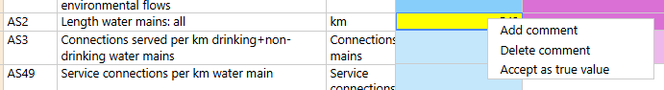

Error (red cells) values
Red error cells are ones that cannot be true, i.e. they are true errors, e.g., text in numeric cells, incorrect text value entered, Div/0, etc. On logout the cell will remain ‘empty’ and no value is saved.
There are 3 reasons for a red error cell:
- The system has done a calculation which has tried to use a ‘MD’ (Missing Data), ‘NR’ (Not Relevant) or ‘0’ in a complex multiplied/divided by calculation. The cell will either contain the text ‘Div/0’ or ‘ERROR’. These error cells are not always immediately obvious as they may be anywhere in the system/screen. They can be found via the search function.
Once you find the red error cells you will need to decide on what has caused it and what to do. Use the mouse hover-over functionality to see how the calculation is done (In general, these calculation errors can be replaced with either MD, NR or 0. (See ‘Calculated indicators’ section and ‘Show precedents’ above).
- The program will not permit any input of non-number values, or values which are not a valid number (for example, containing repeated minus (--), plus (++), symbols). It does allow the use of negative (-), less than (<) and greater than (>) signs. These error cells are easily seen (and found) as they occur in the cell you have just entered data in and you will see them highlighted in red straight away.
- The information entered into a data cell is not in the correct format. For example, text entered into a number only cell. The ‘units’ column will display the appropriate format. It will say ‘text’, ‘yes/no’, ‘1,2,3,4,5,6’, dd/mm/yyyy, etc. If the units are ‘text’ it means that any text/words can be entered. These error cells are easily seen (and found) as they occur in the cell you have just entered data in and will be highlighted in red straight away.
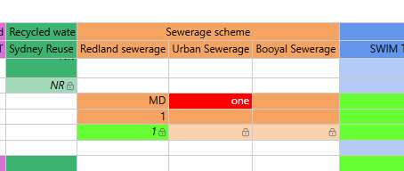
Note: most of the text indicators now have a dropdown box function which will eliminate this last error.

Undoing edits
You can undo recent edits by pressing Ctrl+Z. When you undo, the cursor jumps to the cell that was undone so you can see what changed.
To redo, press Ctrl+Y or Ctrl+Shift+Z, each redo reapplies an undo.
Note undo only applies to edits made in your current session. If you log out or refresh the browser, the undo history is cleared and starts again from that point. Anything entered before then can’t be undone with Ctrl+Z.
Note that reverting a calculated cell (see ‘Revert to calculated value’ under Calculated indicators) acts as an undo barrier, you can’t undo back past the point where you reverted a calculation.

Comments
You can add/edit/delete a comment to any value (cell) that you want to. You do this by ‘right clicking’ on the cell and select either ‘Add’, ‘Edit’ or ‘Delete comment’.
Note that this can only be done if there is a value in the cell.
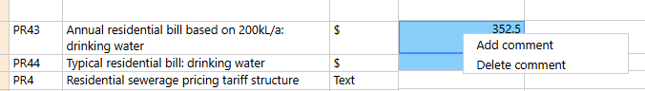

If you click ‘Add comment’ then a comments text box will appear (see below). You can add any text you want (no character limit, can use ‘return’). You can adjust the size of the comment box by placing your cursor on the 2 lines in the bottom right corner. Click ‘Save’ and you will see a red triangle in the top right corner of the cell to indicate that it has a comment. Mouse hover-over the red triangle will show what the comment is.
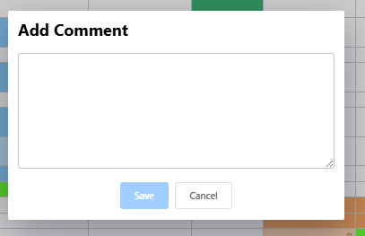
Note that these comments will be sent with the data to the requesting organisation. If you want to add a comment related to scheme(s) for a particular indicator then it is probably best to add this comment to your organisation’s WSP-wide column’s cell, additionally note that some organisations (such as ABS, NPR) only receive the WSP-wide value.
Note that while there is no character limit on a comment you should still try and keep them short but still sufficient to describe the situation.
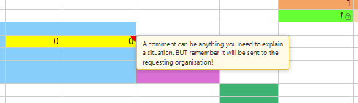
The mouse hover-over (red triangle) function allows you to view/read/edit any comments. Double click the dialogue box to open it.

Mandatory comments
Some indicators require mandatory comments if you enter a certain value/response, e.g., if you have a low confidence in ‘water demand being meet’. The SWIM™ system will automatically open a comments box when this occurs and will contain some text telling you what the comments needs to say/explain (see image below).
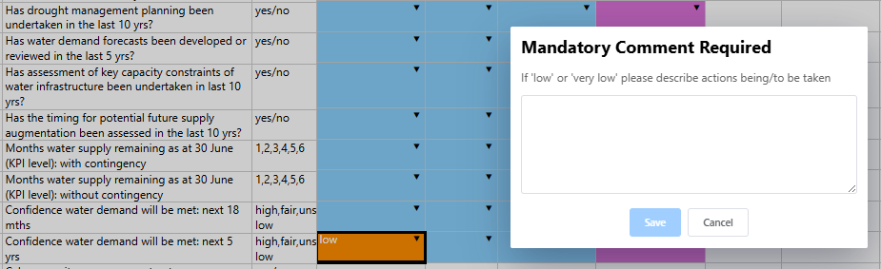
The indicator description will provide details of mandatory comment requirements for the appropriate indicators.

If you don’t add a comment the cell will be highlighted orange and you cannot publish the data. You can return and add a comment at any time (see ‘Comments’ section above). Once a comment is added the cell will return to the normal colour.

Text dropdown boxes
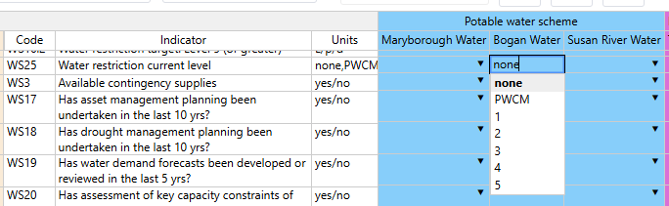
Most text indicators now have a dropdown box function which allows you to select the appropriate response from a dropdown list. A small black triangle in the data cell will indicate if a dropdown list is available, either click the arrow or double click the cell to enable the dropdown list functionality.

Publishing data
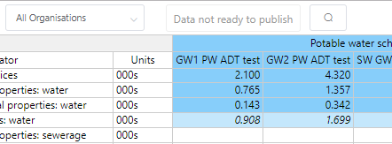
Only a user with a ‘Publish annual data’ role is able to publish the data (i.e., approve the data for release to the organisations requesting the information). These users are the only ones who will actually see the ‘publish data’ button (see image below).

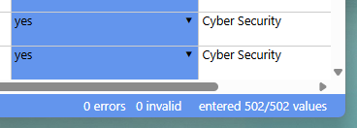
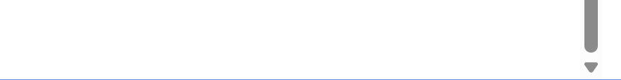
To ‘publish’ your data you must have zero (0) errors (red cells), zero (0) missing comments (orange cells), zero (0) invalid (yellow cells) and entered data for every cell required. This is shown in the bottom right corner of the Web ADT window.

If you still have any empty, invalid, error or missing-comment cells, the ADT will not let you ‘publish’ the data. To find any of these you can use the Search function. Once complete then the ‘Publish’ button at the top right will then become active (blue - as shown below).
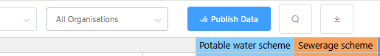

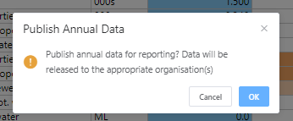
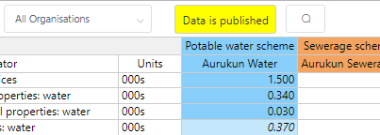
When you are happy with all your data, click the ‘Publish Data’ button and it will ask for confirmation, then it will say that the data is published and the button will now say ‘Data is Published’ and be bright yellow (as shown below).

If you have ‘Published’ your data you can still check and correct/change the data at any time throughout the year but make certain that you check any changes do not result in any error or invalid cells (these will need to be checked/fixed and accepted as true before you re-publish).
When you change any data the system automatically sets the data to ‘unpublished’ and the ‘Publish data’ button will change back to its original plain colour. You will therefore need to click the publish data button again to re-publish it – otherwise no-one will be able to access your updated data. User(s) with an ‘Annual Data Publication’ notification contact for your organisation will receive an email to notify them that this has occurred.
Once your data is ‘Published’ it will be sent to the appropriate organisation, at the appropriate time and in the appropriate format. This will occur just after 5 pm on the date that the data is due to each of the organisations. This means that you will must publish the data prior to 5 pm on the due date. Due dates are communicated to all SWIM™ users each year and may change from time to time depending on business days and public holidays, but mostly it is 1 October each year.
A complete/exact Excel (.xlsx) copy of your published data will be sent to all your User(s) with an ‘Annual Report Dispatch’ notification contact when it is sent off to the requesting organisation.

Quirks and known issues with the ADT

Notes column
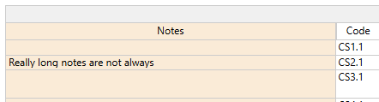
The notes column (light brown left-hand column) doesn’t show the whole sentence in the ADT even when you widen the column (1st image). If you double click the cell, as if you were going to change the data, it does show everything (2nd image).
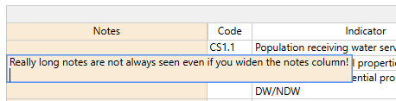
This is a limitation of the way columns are handled in the underlying grid library used to develop the webpage. If the column is dynamic it will always expand to show the full text on the first load of the data which means it takes up too much space. It is not fixable at present.

Search function not showing result
Rarely when searching the screen will not display (jump to) the search result on the current screen view. The ‘found’ cell is usually just lower down. To see the result just scroll or press the ‘down’ (or ‘up’) arrow button on your keyboard and the cell above or below the searched result value will be selected and the screen will now jump to that section and show that cell.

Shortcuts
Shortcut | Function
Ctrl + F | Open Search Form
Ctrl + G | Repeat previous search
Ctrl + + | Increase screen zoom
Ctrl + - | Decrease screen zoom
Ctrl + F5 | Hard refresh the website
Ctrl + Z | Undo edits in your current session
Ctrl + Shift + Z | Redo edits in your current session
Ctrl + [ | Tracks calculation precedents (raw data used for calculation)

Help
Submit an online SWIM™ IT support form here: https://qldwater.com.au/SWIM_Help.

Helpful Websites
qldwater: SWIMTM Help & Information: https://qldwater.com.au/SWIM_Help
OTR: https://www.energymining.sa.gov.au/industry/regulatory-services/office-of-the-technical-regulator/infrastructure-technical-regulation

Contacts

Contacts (Qld SWIMTM)
Dr David Scheltinga (SWIMTM Manager): dscheltinga@qldwater.com.au | 0415 881 195
Ms Jess Dean: jdean@qldwater.com.au | (07) 3632 6852

Contacts (SA SWIMTM)
Emily Lohmann: emily.lohmann@sa.gov.au | (08) 8429 3966
Naomi Struve: naomi.struve@sa.gov.au | (08) 8429 3622

All schemes are controlled via the swimlocalTM Admin Tool.
Note that the background colour of all calculated cells is half strength of the normal colour (i.e., lighter) and has a padlock symbol and italics text.

