

­

**Scoping Paper**

**Parameters of the Review Program and Institutional Models**

**May 2012**

Table of Contents

*Background* 4

*Executive Summary* 4

1 Purported Drivers for Institutional Reform of the Urban Water Industry in Regional Queensland 15

1.1 National Drivers for Urban Water Reform 16

1.1.1 National Water Commission 16

1.1.2 Productivity Commission Inquiry 19

1.1.3 Infrastructure Australia Review 20

1.2 Security of Supply 21

1.3 Drinking Water Quality 26

1.4 Compliance with Regulation 27

1.4.1 Environmental compliance 30

1.5 Financial Sustainability 30

1.5.1 Infrastructure Investment 32

1.5.2 Pricing and Tariffs 33

1.5.3 Cross subsidisation 36

1.6 Skills Shortages 37

1.7 Efficiency 38

1.7.1 Ownership 38

1.7.2 Competition 40

1.7.3 Economies of Scale and Scope 40

1.8 Climate Change 45

1.9 Demographic Change 46

1.10 Planning 48

1.11 Reform Elsewhere 49

1.12 Conclusions 49

2 Institutional Models for the Urban Water Sector. 50

2.1 Review of Institutional Models for Urban Water Services 50

2.2 Formal Mechanisms for Collaboration 54

2.3 Conclusions 56

3 Assessment of Alternative Models. 56

3.1 Assessment Criteria 56

3.2 Assessment Process 60

3.3 Conclusions 62

4 References 65

Appendix 1 - Drivers of Change Raised in Local Government Workshop (2008) on the Future of the Water Industry in Queensland Outside SEQ. 69

Appendix 2 History of the Queensland Urban Water Sector and Water Reform 71

Appendix 3. Models from other Jurisdictions 75

1 The Australian Capital Territory 75

1.1 New South Wales (Metropolitan) 76

1.1.1 Sydney Water 76

1.1.2 Sydney Catchment Authority 77

1.1.3 Hunter Water 77

1.2 New South Wales (Regional) 78

1.2.1 Gosford and Wyong 78

1.2.2 Remaining Regional NSW 78

1.3 The Northern Territory 81

1.4 South Australia 81

1.5 Tasmania 82

1.5.1 Governance and Legislative Framework 83

1.5.2 Function 83

1.6 Victoria 84

1.7 Western Australia 86

1.8 South East Queensland 87

1.9 New Zealand 88

1.10 Auckland - Watercare 90

1.11 Wellington and Hutt Valley - Capacity Infrastructure Services 91

1.12 Greater Wellington Regional Council 91

1.13 Canada 91

1.14 Scotland – Scottish Water 92

1.15 England and Wales 92

1.16 Ireland 93

1.17 USA 95

Appendix 4 – Ten Principles Developed by the Queensland Regional Taskforce to Guide any Institutional Change of the Urban Water Industry. 96

Appendix 5. SWOT Analysis of different structural options 97

# Background

This report was prepared as a scoping paper for the Local Government Association of Queensland for the Queensland Water Regional Alliances Program (Q-WRAP) with the following terms of reference:

The scoping paper will articulate the parameters of the Review Program and provide a detailed description of the various institutional models that exist for the delivery of urban water services sourced from Australian and International experiences. The scoping document will be distributed to Pilot groups to consider a range of possible institutional models that could apply to their areas depending on local issues and key risks to both drinking water and sewerage services (excluding urban drainage). The paper will also provide a base level assessment and evaluation of other external and internal factors (regulatory frameworks, financial management, skills base, etc) which impact on various institutional arrangements.

The report has been prepared with three sections to meet these terms of reference:

1. Rationale (drivers) for considering new industry arrangements for the regional Queensland water industry.
2. Review of potential models for the urban water sector.
3. Assessment of factors impacting on alternative arrangements.

# Executive Summary

Design, construction, operations and maintenance of water and sewerage infrastructure in Queensland has always been a joint activity of local and State Government, but local councils have had the lead responsibility for providing water and sanitation services to communities since at least the 1880s. Local Government institutional arrangements provide a well-understood relationship between community and governance responsible for these essential services and have long been a common model internationally.

Many jurisdictions are changing institutional arrangements for water and sewerage with a common trend towards replacing numerous local government owners with aggregated regional or nationally-owned entities. For example, this form of institutional reform has occurred in England and Wales (1970s), Victoria (1994), Scotland (1996), South East Queensland (2008), Tasmania (2009) and Ireland (2012). The most common drivers for these reforms were poor drinking water quality management, inadequate investment in infrastructure and poor performance against efficiency and sustainability measures.

In Australia, regional Queensland and country NSW are now the only areas where water and sewerage services are still provided by numerous local governments. In NSW a State Inquiry was undertaken in 2008 and recommended that the 104 council water utilities be aggregated into 32 regional groups. During 2011, three concurrent national reviews of the urban water industry were completed by Infrastructure Australia, the National Water Commission and Productivity Commission. While each of the reports provided a different view of urban water services nationally, they all found that the institutional arrangements of the water industry in regional Queensland and New South Wales do not provide an optimal model to adequately manage the risks involved in the provision of urban water services.

As an example, a key recommendation from the Productivity Commission Inquiry was:

*There is a strong case for undertaking aggregation of small water and wastewater utilities in regional areas of New South Wales and Queensland. The precise approach including identification of affected councils and the preferred grouping of councils should be assessed and determined by relevant State Governments, in consultation with Local Governments and affected communities. This process should consider the relative merits of alternative organisational structures, including county councils, regional water corporations and regional alliances (or regional organisation of councils).*

The national reports served to confirm what has been known in Queensland for some time, namely that urban water service providers are facing significant and increasing challenges in the provision of safe, reliable and sustainable water supplies and sewerage services. Population change, changing climatic conditions, degraded and inadequate water supply assets, competing funding priorities, increasing community expectations, drinking water quality standards and insufficient skilled personnel are just some of the challenges that elected officials and officers from Local and State Government as well as private industry face in sustaining planning, operations, management and regulation of urban water and sewerage services.

**Formation of the Queensland Water Regional Alliances Program (Q-WRAP)**

The Local Government Association of Queensland (LGAQ), and ***qldwater*** along with elected representatives and staff from numerous Councils have been cooperating in programs for the development of the Local Government water industry for the past five years. State Government agencies have often partnered in these initiatives but in 2010, cooperation with the water regulator increased markedly as a result of the *“Urban Water Services Memorandum of Agreement”* (MoA) to work collaboratively on issues facing the local government water sector.

In 2011, in response to criticism of the Queensland urban water sector by recent national reviews, Q-WRAP was developed by LGAQ under the MoA as an industry (Council) led initiative to investigate a range of matters including institutional models for urban water services in regional Queensland. The program received seed funding for two years from the State and is developing co-investment from Councils in three pilot regions. This Scoping Paper paper for the Q-WRAP focusing on:

1. the rationale (drivers) for considering alternative industry arrangements for the regional urban water industry,
2. an overview of potential models for the sector and
3. assessment of state-wide factors impacting alternative models.

The aim is that this information will provide background and guidance for the analyses and reviews undertaken by each pilot region.

1. **Drivers for considering different institutional arrangements**

The need for cooperative regional approaches in Queensland’s dispersed urban water industry is clear but it is not obvious that one single type of collaborative approach or that reform of institutional arrangements will be beneficial across all regions and communities. As well as the policy drivers arising from the recommendations of national review discussed above, a number of specific issues and challenges have been promoted as driving the need for institutional change in Queensland. The key issues are summarised below.

*Water Security*

The security of many water supplies was tested severely during the recent drought and Sate concerns over water use efficiency resulted in creation of a raft of new water conservation legislation. Poor demand management and low water security in regional areas has been raised as a driver for institutional reforms (e.g. AECOM 2010, NWC 2011a). While some regional communities are adapted to low or uncertain water sources, residential water use in Queensland is significantly higher than national averages and is also higher than the median water use in inland NSW. High residential water use is often seen as evidence of poor demand management by water utilities.

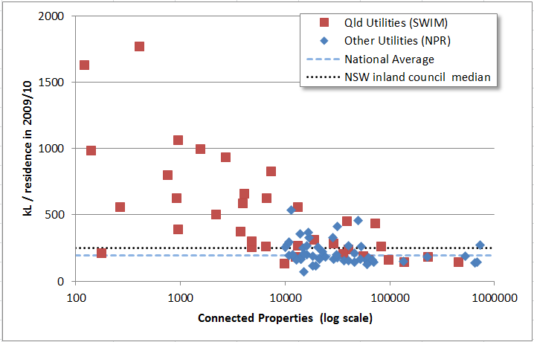

There are a number of mitigating factors for higher-than-average water use in regional Queensland (e.g. extremely low or high seasonal rainfall, high evaporation, a hot ambient temperatures and arid landscapes). Even when these factors are taken into account, it is clear that some communities manage water far more efficiently than others.

This diversity in itself demonstrates that the institutional model is not the sole determinant of water efficiency. Many Queensland councils manage water demand well despite unfavourable climatic conditions. Regionalisation of utilities might foreseeably spread best practice approaches to communities that don’t currently have appropriate practices, but it is more likely that community attitudes are the determining success factor of water efficiency programs and on institutional model will alter current water cultures without significant investment in change management.

Beyond efficiency measures, water security issues must be managed primarily through investment in supply or storage infrastructure. It is likely that planning and design of such augmentation could be done most efficiently and effectively at a broad regional or state level. However, the high cost of such investment has caused significant negative fall-out in South East Queensland and other Australian capitals. Even higher cost would be predicted to ensure water security in remote and unconnected communities in regional Queensland.

*Drinking Water Quality*

Concern over the quality of drinking water in small regional communities has been proposed as a driver for institutional change (Armstrong and Gellatly, 2008; AECOM, 2010; PC Inquiry, 2011) and was one of the key reasons for aggregation of council utilities in Tasmania and other jurisdictions. There is little publically available information on compliance with water quality standards in Queensland but data from the State-wide Water Information Management (SWIM) system suggests that compliance with microbiological guidelines is good though not universal. However, waterborne disease outbreaks are not uncommon in affluent countries and are avoided only through constant vigilance. Regardless of institutional model, this responsibility will fall primarily on the shoulders of local managers of water supply infrastructure.

*Regulatory Compliance*

The ability for the regional water industry to comply with regulatory requirements is sometimes raised as a measure of whether institutional reform is required (see e.g. AECOM 2010, PWC, 2011). Regulatory requirements have increased markedly since 2000 with a raft of legislation created by the Queensland Government with a heavy emphasis on statutory planning. Prior to this date, regulation of the Queensland urban water industry was limited.

It is widely acknowledged that many Service Providers, particularly small councils with limited resources, are struggling to cope with this raft of new legislation. However it is too soon to judge whether this is because the requirements are relatively new and duplicate each other and internal council plans or whether council Service Providers are incapable of compliance because of institutional arrangements. Through the recent Urban Water Services Partnership, the LGAQ, ***qldwater*** and the State Regulator are collaborating on a reform program to review and streamline the regulatory framework while retaining a focus on secure, sustainable and safe services for regional communities.

*Financial Sustainability*

The financial sustainability of water businesses in regional areas has sometimes been called into question (e.g. AECOM, 2010) and the PC Inquiry (2011) called for transparent separation of water businesses from other government matters at all levels (and transparent declaration of cross subsidies). The fact that water businesses are imbedded within general council services means that cross-subsidisation is complex and generally not transparent to customers. However, it is also true that these shared services (e.g. shared staff, common administrative systems and frameworks) can provide beneficial economies of scope and scale for Queensland water businesses.

Over time, low real rates of return indicate sustained under-investment in infrastructure, particularly underground networks which are out of sight and can be repaired reactively. Many of the networks in Queensland were installed over 50 years ago and have reached the end of their operating life. In a similar manner, large, one-off capital costs can be expected for expired water and sewage treatment facilities which must use improved technology to meet regulatory and customer expectations but replace simple systems that cost relatively little to build and operate. Significant investment will be required in the coming decade in communities where infrastructure is aged or has been poorly maintained because of an inability to fund more than basic maintenance in the past.

An important distinction must be made between large water service providers that have a rate base sufficient to achieve cost-recovery and provide a dividend to their council and the smaller towns where this is not possible. The small rate base of many communities means that ongoing capital investment and sometimes even operations and maintenance is not affordable without cross subsidisation from other income. Moreover, communities of very small size will never achieve a positive rate of return or cost recovery regardless of institutional arrangements. The mere cost of operating and maintaining water and sewerage systems to modern standards in these towns makes full-cost pricing impossible to afford in such towns.

The real questions here are about cross subsidisation between communities, appropriate standards of service and who must pay. These questions transcend standard arguments about appropriate institutional arrangements.

*Skills Shortages*

Attracting and retaining skilled people and delivering appropriate training to existing staff in regional Queensland has always been challenging and has been exacerbated in recent years by the resources boom and the looming retirement of the baby boomer generation that forms a large proportion of the industry. Water and sewerage services necessitate on-ground work on a daily basis as well as strategic oversight, planning and monitoring but the industry is relatively small, widely dispersed and competes with industries that pay higher wages than are possible under current industry award structures.

Small communities are further hampered by needing skilled workers to manage systems that require less than a single full-time equivalent person meaning that multi-skilled staff are often responsible for a broad portfolio of work and cannot be appropriately qualified across their entire range. This problem is made worse by the long distance between communities which consumes time and acts against staff and skill sharing arrangements. These are complex problems that will not be easily addressed through institutional change alone.

*Efficiency*

Efficient performance of the water industry and in particular council service providers is often called into question (e.g. PC 2011a; AECOM 2010). However, as noted in the Productivity Commission Inquiry (PC 2011a, p. 28):

in considering the scope for efficiency gains in regional urban areas it should be recognised that factors such as population density, population growth, proximity to metropolitan areas and the endowment of water resources strongly influence the costs and challenges of providing urban water services. These factors vary greatly across regional areas….

It is possible, given the constraints of regional waters service providers, the regulatory structure of the industry and available resources, that the local government water sector is highly efficient. There is no current method determine this and the very lack of formal benchmarking or performance assessment is perhaps in itself an indicator of low efficiency. Comparative (or yardstick) competition has been recommended as a priority for the industry (see e.g. PC 2011a, 2011b) to garner efficiency and continual improvement. This form of competition has been possible in Queensland in the past to only a limited extent with previous Department of Local Government statistical reports but is increasing at present through the comparative reports produced by the State-wide Water Information Management (SWIM) system.

There is a related perception that performance in the water sector can be improved through increasing the size of utilities (WSAA 2010, PC 2011a, and see also several international studies reported in PC 2011b, p. 123). However, the Productivity Commission (PC 2011b) again urges a cautious approach to assessing scale impacts. To properly determine the impact of aggregation the PC Inquiry recommended assessment of:

* the number of discreet schemes managed by the utility,
* network density and length,
* distance between networks and scope/demand and ability for interconnection,
* volume of water/sewage supplied or treated,
* size of the area served,
* geography, geology and topography of the region (to determine cost of connecting networks and pumping costs),
* variability of sewage (wet weather) flows,
* asset life cycles, and
* climate and rainfall variability.

It is likely that these factors will be particularly significant and highly variable in Queensland where large proportions of the population live outside of large cities compared with other jurisdictions.

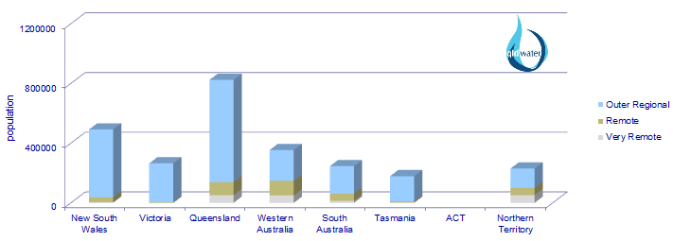

*Other Drivers for Institutional Change*

A number of other factor such as climate change, demographic shifts and the need for better planning to address an uncertain future have been raised as pressures influencing the industry and potentially requiring reform of institutional arrangements. While there is no doubt that these factors are important and complex considerations for the industry, it is not clear which institutional models will be best placed to deal with them in a way that provides most resilience for the urban water sector. Further analysis sensitive to variable local conditions is required.

1. **Potential Alternative Models for the Queensland Urban Water Industry**

The scoping paper includes a review of the broad parameters of models for governance and management of the water sector in Australian jurisdictions and other selected countries. The broad properties of twelve models identified through this review were summarised to enable analysis with respect to Queensland regions.

|  |  |  |  |  |
| --- | --- | --- | --- | --- |
|  | **Model** | **Ownership** | **Governance** | **Examples** |
| 1 | Council owned and operated. | Single Council | LG Councillors. | Most Queensland and NSW regional councils. Most Canadian and NZ water services. |
| 2 | Council owned and operated with arms-length commercialisation of the water business. | Single Council | LG Councillors. | Larger Qld and NSW councils have differing degrees of separation. |
| 3 | Individual council-owned corporation | Single Council | Board which is responsible to owner councillors. | Wide Bay Water. |
| 4 | Regional Alliance | Two or more councils | LG Councillors. | Macquarie regional alliance. |
| 5 | Mandatory (binding) regional Alliance | Two or more councils | LG Councillors. | No Water examples but Davis *et al.* (2008) name the ‘Weight of Loads Groups’ (NSW) as an example of a LG mandatory alliance. |
| 6 | County Council (with service provision only) | Two or more councils | Board of participating LG Councillors. | There are 4 water supply and one water and sewerage county councils in NSW. |
| 7 | County Council (including asset ownership) | Two or more councils via a county council. | Board of participating LG Councillors. | Midcoast Water (NSW). Regional Council model in NZ is similar (e.g. Wellington) |
| 8 | Joint Council-Owned Regional Corporation or Statutory Authority. | Two or more councils | Board which may have appointments by State or local Government. | SEQ distribution and retail entities. Tasmanian water businesses. Gosford Wyong water utility. |
| 9 | State-owned Regional Water Authority. | State Government | State-appointed Board often reporting to responsible Minister(s). | SEQ Water, Gladstone Area Water Board, Victorian Water Utilities, Sydney Water. |
| 10 | Single State-wide agency | State Government | Independent Board often reporting to responsible Minister(s). | WA Water Corporation, SA Water, NT Power and Water. |
| 11 | Government owned with majority of functions outsourced to private contractors.* | Owner organisation. | Governance of owner-organisation plus contractual arrangements. | Linkwater (SEQ), SA Water for Adelaide, Water Corp WA for Perth. |
| 12 | Privatised water utilities.* | Varies – often a private entity owns the assets. | Governance of private entity – usually a corporations law company. | European countries, UK. Australian electricity sector. ActewAGL is publically owned but has substantial private partnership. |

* a degree of outsourcing to private industry is common to all of the listed models including all sizes of council water service providers.

It is not possible to specify a single ideal model because of the range of potential structures, their fitness for diverse local circumstances, variable performance by entities within each type of framework and the resulting difficult of comparing across models. Indeed it is likely that there is no ‘best’ or ‘worst’ model and performance is likely determined by incentives, regulatory frameworks, political support and most importantly, the people driving the industry. It is likely that these key factors along with the resources (both natural and financial) available to any particular utility are the main determinants of performance and it is the purpose of Q-WRAP to allow councils to analyse and respond to these variable challenges on their own terms.

Instead of a regional comparison, in this Scoping Paper the possible models were analysed to short-list the feasible options for the Queensland sector based on general principles and available formal mechanisms within current legislation. The result was a handful of broad options that can be summarised as follows:

1. individual local government water service providers (status quo),
2. alliances among regional groups of councils (varying degrees of formality),
3. regional, joint council-owned corporations,
4. regional, state-owned corporations, or
5. some combination of the above options.

Each of the first four options would have strengths and weaknesses that would be location specific. It is possible that the more flexible approach represented by option “e” could allow the choice of the best model for each area but this also runs the risk of creating a complex urban water sector with concomitant difficulties for regulatory frameworks, compliance and reporting.

1. **Assessment of Alternative Models**

A specific assessment of each models’ relevance at the local level is an element of the broader Q-WRAP project and this Scoping Paper restricted analysis to a high-level assessment of each of the models against broad assessment criteria. The criteria were developed by synthesising generic principles and objectives articulated in several national and Queensland reviews.

*Assessment Criteria*

1. Improved Service and Customer-focus that ensures:

* the long-term interests of communities in the price, quality, safety, reliability and security of supply of fit-for-purpose water and sewerage services with transparent efficiency and accountability, and
* needs of individual communities remain a vital driver of management, policy and planning.

2. Public Health and Environmental accountability whereby:

* operations and investments are managed cost-effectively in accordance with society’s expectations and clearly defined obligations; and
* the organisation contributes to more liveable, sustainable and economically prosperous communities in circumstances where broader social, public health and environmental benefits and costs are clearly defined and assessed.

3. Ongoing Council & Community Sustainability to:

* protect or enhance council revenue streams & capital expenditure, and
* maintain or enhance regional job opportunities and ongoing access to specialised skills within regional communities.

4. Best Practice Governance providing:

* accountability and transparency appropriate to meet the organisation’s objectives, and
* skills/experience-based governance arrangements with appropriate independent water focus.

5. Optimised Management and Planning for:

* efficient operation and maintenance of infrastructure and more effective water system and strategic planning, and
* resilience and capacity to appropriately respond to changing economic, technical, climatic and regulatory drivers (including reporting obligations and benchmarking).

6. Sustainable Staff and Asset Management and Planning to ensure:

* staff are recognised as the most critical assets needing appropriate planning, management and investment,
* efficient deployment of, and investment in, resilient systems, assets (including people) and other resources, and
* cost-recovery that allows for asset renewal with any dividends returned transparently to the community.

7. Improved Articulation with Regional Planning to:

* better manage economic, environmental and social planning consistent with regional communities of interest, and
* coordinate water provision with regional planning and water resource management.

8. Reduction of Transaction Costs for:

* effective partnering with all levels of government,
* horizontal aggregation/collaboration cognisant of geography and distance impacts on network costs, and
* water planning and management linked with statutory and land use planning activities of local government.

The process for scoring each of the feasible models provided a matrix outlining the strengths and weaknesses of each of the institutional arrangements against the criteria. A rank of “1” was assigned to a criteria that are extremely likely to be satisfied by the model, “2” was assigned to criteria when the organisational model may have adverse impacts in some situations that can be addressed through some form of mitigating strategy[1] and “3” was assigned when there is a fundamental flaw with the model that prevents it from meeting the criterion.

|  |  |  |  |  |  |  |
| --- | --- | --- | --- | --- | --- | --- |
| **ASSESSMENT CRITERIA USED IN SWOT ANALYSIS OF EACH OPTION.** | **Option A** | | **Option B** | | **Option C** | **Option D** |
| **STATUS QUO**  **(small Councils)** | **STATUS QUO**  **(large Councils)** | **REGIONAL ALLIANCE (collaboration)** | **REGIONAL ALLIANCE (separate entity)** | **COUNCIL- OWNED REGIONAL WATER CORP** | **STATE- OWNED REGIONAL WATER CORP** |
| Improved service & customer focus | 2 | 1 | 1 | 2 | 2 | 2 |
| Public health & environmental accountability | 2 | 1 | 2 | 2 | 2 | 2 |
| Council & community sustainability | 3 | 2 | 2 | 2 | 2 | 3 |
| Best practice governance | 2 | 2 | 3 | 2 | 1 | 2 |
| Optimised management & planning | 2 | 2 | 2 | 2 | 1 | 1 |
| Sustainable staff, asset planning & management | 3 | 1 | 2 | 2 | 1 | 1 |
| Improved regional planning | 3 | 2 | 2 | 1 | 1 | 2 |
| Reduction of transaction costs | 2 | 2 | 3 | 2 | 1 | 1 |

The small council model scored poorly against some sustainability criteria reflecting the sustainability problems identified with many (but not all) small communities identified in Section 1 of the report. The surprising low rank for community sustainability for this model reflects the lack of investment in water infrastructure. Current towns may be well-serviced but this is being achieved at the expense of future communities.

Large councils scored better but often predicated on the high performance or potential demonstrated by current councils and the assumption that there can be transparent separation of water services as a separate and commercialised business unit. This is seldom achieved at present and would require significant change in most large council water businesses.

Regional collaboration had mixed scores reflecting the ability to provide opportunities to improve many areas of performance, but cognisant of increases in transaction costs including complexity of governance arrangements. The regional alliance model scores lower than the latter two regional integration models on criteria relevant to governance arrangements, transaction costs and integrated planning.

The three regional utility models score similarly and rank highly on most criteria. Lower scores for customer focus reflect the need to manage the risk of centralisation of management away from the communities being serviced. These models also rank lower on council and community sustainability, particularly the State –owned model which would not return dividends directly to local governments and their communities.

It is evident that there is no single best institutional model. Differing local factors, particularly the prevailing culture, network size, distance and predicted population growth will strongly impact the feasibility of various models. The aim of the broader Q-WRAP program is to facilitate review of possible institutional arrangements at a regional scale to allow for greater focus on local factors.

Most importantly, this process will result in greater involvement by the people who actually own, manage and assume responsibility for water and sewerage services across the state. Managerial performance within different models is intrinsically impacted by ownership arrangements because of their influence on patterns of authority, responsibility and economic incentives for those who actually control a business. Strong governance and management structures are possible under any of the models, but rely on individual champions. Sustainable performance over the long term requires processes that seek and support such champions.

# Purported Drivers for Institutional Reform of the Urban Water Industry in Regional Queensland

Approximately one in three Australians live in areas served by local government water utilities and two thirds of the 7.6 million people living outside capital cities rely on local government for water and sewage services (Australian Bureau of Statistics, 2008). These local government utilities operate within an area of over 2.5 million square kilometres meaning remoteness and distance are often fundamental business constraints.

In Queensland urban water and sewage services are provided by local governments or council-owned organisations[2]. The area outside of the 10 local governments incorporating ‘South East Queensland’ is herein called ‘regional Queensland’. Apart from Bulk Water services provided by the Gladstone Area Water Board, Mt Isa Water Board and Sunwater, all urban water services in regional Queensland are delivered within Local Government structures[3] and service over 1.4 million people.

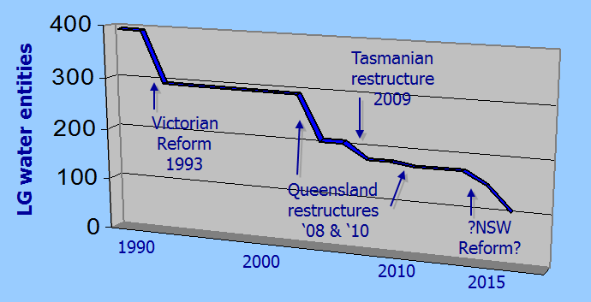

Figure : Decrease in number of council water service providers in Australia since 1990, including the projected reduction if NSW State reforms are implemented.

Outside regional Queensland, institutional arrangements for the urban water sector have changed dramatically over the past 20 years (see Appendix 3). One outcome has been a reduction in the once common model of local government ownership and management of water and sewerage services (Figure 1). Local Governments own and manage water and sewerage services in Tasmania, New South Wales and Queensland but within this structure there is a trend for increased regionalisation and corporatisation of institutional arrangements (Table 1).

Table : Numbers of council water service providers decreased markedly between 2008 and 2010 coinciding with a focus on water services caused by extended, widespread drought and amalgamation of numerous councils in Queensland.

|  |  |  |  |  |
| --- | --- | --- | --- | --- |
|  | **Number of Local Government Water Utilities** | | | |
| Tasmania | NSW | Queensland | TOTAL |
| **2009** | 32 | 102 | 159 | 293 |
| **2010** | 4 | 102 | 73 | 179 |
| **2011** | 4 | 102* | 67 | 173 |

* The NSW Department of Water and Energy Water Inquiry in 2009 recommended amalgamation of LG water providers in NSW to fewer than 32 entities (Armstrong & Gellatly 2008).

Although change has been occurring for some time in other jurisdictions, regional service providers often question the perceived need for further reform in regional Queensland. Internal drivers for change are not strong and the appetite for change has been diminished by the expensive policy reversals occurring in other urban reforms, particularly in South East Queensland.

The following sections summarise the main issues purported to be drivers of reform for regional Queensland. This list is compiled from a range of reviews and the a list of drivers of industry change created in 2008 by a Local Government Taskforce on the Future of the Queensland Water Industry Outside South East Queensland (see Appendix 1). In this section there is no attempt to analyse the applicability, relevance or priority of the drivers (which will vary significantly from place to place). A suggested framework for assessing the need for change against key drivers and considering available institutional models is developed in Section 3.

## National Drivers for Urban Water Reform

There has been increasing pressure from national agencies for reform of urban water nationally and specifically for restructuring institutional arrangements in regional Queensland (and NSW) particularly since 2010. Reform recommendations have arisen from the national water reform framework that commenced in the early 1990s which is described briefly below and placed in context on the Queensland industry timeline in Appendix 2.

Coordination of national water reform crystallised in 1994 when the Council of Australian Governments (CoAG) adopted the Strategic Framework for the Reform of the Australian Water Industry. Although the primary focus was on water resources and rural irrigation urban water was also included with an emphasis on commercial practices and adopting water pricing reforms.

### National Water Commission

Ten years on, in 2004, the National Water Initiative (NWI) and National Water Commission (NWC) were created by COAG to invigorate the framework. Again there was little initial attention to urban water but this began to change towards the end of the decade with the ‘millennium drought’ being and important trigger. The NWC website points to “emerging challenges that create further reform pressures” that “were not as evident when the NWI was signed, including:

* changing and less predictable rainfall and runoff patterns,
* uncertainty about climate change,
* community demands for sustainable water supply options, and
* increases in water prices to pay for new infrastructure.”

In 2009 the second Biennial Assessment of the NWC included the finding “… structural /organisational reforms (for example, aggregation and shared service models) and regulatory reforms may warrant further consideration in some rural and regional areas, particularly where services are currently provided by local government authorities” (NWC 2009).



Figure : NWC Report - Urban Water in Australia. April 2011.

Subsequently, the NWC commissioned a project called “Developing Future Directions for the Australian Urban Water Sector” which resulted in the “Future Directions Report.” The key findings of the report were

* Further change is needed to institutional and policy settings in the urban water sector.
* There are opportunities to improve service delivery and the focus on customers.
* Current regulation of water quality, public health and environmental outcomes is not cost-effective and creates barriers to integrated water management.
* Confusion about the role of the urban water sector in delivering livability outcomes is stalling progress.
* The lack of agreed objectives for the urban water sector is a fundamental barrier to change.

The report stressed (NWC 2011a, p. 4):

Due to the nature of the problems and in the context of the future challenges facing the sector, the Commission is convinced that structural and institutional reform of local council service provision in New South Wales and Queensland is urgently needed. However, the Commission acknowledges that a range of models and transitional approaches may be appropriate, and does not recommend a particular model.”

The recommendations of the report urge action by both COAG and individual jurisdictions including the need to increase incentives, monitoring and evaluation. Specific actions across all jurisdictions are summarised below.

* Governments should ensure that service providers, regulators and other parties have clear objectives and accountabilities.
* Governments, regulators and service providers should ensure a greater voice for customers (including tariff choices and standards of service and pricing trade-offs).
* Governments and regulators should use pricing to promote economic efficiency (including fully independent economic regulation) to better reflect the value of water.
* Governments should encourage supply and demand-side measures, without direct and ad hoc government intervention. Responsible agencies and service providers should adopt risk-based approaches to supply-demand planning. All parties should strive for greater transparency.
* Governments and service providers should reform regional areas to ensure there is sufficient organisational, financial, technical and managerial capacity to meet service delivery requirements and protect public health and the environment, particularly in New South Wales and Queensland.

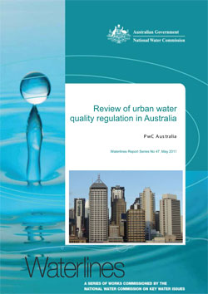

Figure : NWC Report - Review of urban water quality regulation in Australia, May 2011.

* Governments, regulators and service providers should increase market-oriented options to promote efficiency and innovation.
* Governments and regulators should better embed mandatory benefit-cost analysis and community engagement in the regulation of public health and the environment (particularly for investment in sewerage systems) to ensure that obligations are cost-effective and reflect community expectations.
* Governments and service providers should clarify the roles and responsibilities of service providers and other organisations in contributing to more livable communities.

As part of the NWC project a report was also commissioned to review regulatory approvals processes and practices across Australia with a focus on approval pathways for emerging water recycling and reuse technologies. The Review of urban water quality regulation in Australia report identifies problems or challenges and associated options for solutions. It sets out three directions for reform.

1. **Bolster current arrangements** – retain existing structures for urban water quality regulation but provide better resources and incentives to strengthen current arrangements.
2. **Increase cross-jurisdictional coordination** - creating new cross-jurisdictional arrangements to for greater consistency and coordination. Including the recommendation that “councils would play a reduced and clearer role in approving systems through standardised land-use development controls” (PWC 2011, p. 6).
3. **Establish a national water quality regulator** - responsibility for all aspects of urban water quality regulation transferred to a single, national body.

The National Water Commission endorsed its preference of the second option namely, establishing greater cross-jurisdictional coordination. The third Biennial Assessment of the NWC merely notes that “the performance of regional providers varies and the Commission considers that options for reform to address the challenges faced by small water suppliers should be considered” (NWC, 2011b, p. 136).

### Productivity Commission Inquiry

The COAG Water ‘enhanced water reform agreement’ in 2008 (see Appendix 1) resulted in the Productivity Commission Inquiry into the national urban water industry in 2010 and 2011. The three tasks of the review were to:

* identify opportunities for efficiency gains through changes to structural, institutional, regulatory, and other arrangements in the Australian urban water sector,
* provide options to achieve the identified efficiency gains, and quantitatively assess these options (to the extent possible) and
* propose a work program, including priority areas and implementation plans.

The draft discussion paper from the Inquiry was circulated in April 2011 with the final report released in August.

The Inquiry found a “strong case for microeconomic reform of the urban water sector” (PC 2011a, p. xxvii) and made numerous recommendations for efficiency gains that would “maximise net benefits to the community”. The reforms were in two streams: (1) those that were a high priority and universally applicable and (2) structural reforms that should be applied following a case-by-case cost-benefit-analysis.

**Key Universal Reforms**

The universal reforms include a range of issues covering clarification of the role of governments and water utilities, rationalisation of water efficiency and conservation, consistent regulation of pricing and public health outcomes as well as enhanced consumer protection and representation. These reforms are said to be as relevant to regional Queensland as they are for the South East and other jurisdictions.

The recommendations seek a firm delineation of the roles of each stakeholder involved in urban water decisions and propose a framework to achieve this. An important element is the “need for clear delineation between decisions best taken by elected representatives (those regarding ‘public interest’ considerations), utilities (commercial and operating decisions), regulatory agencies and consumers.” (PC 2011a, p. 250). Central to the framework is the independence of water utilities from political intervention in day-to-day decision making and a need to have clear responsibilities and accountabilities for management, governance structures and regulators.

**Structural Reforms Relevant to Regional Queensland**

The specific structural reforms recommended for regional Queensland “are, in general, about tapping efficiency gains through addressing economies of scale issues” (PC 2011a, p. XL). The Inquiry report recognises the factors of distance between communities (and their water sources), the variability in climatic conditions and differing community expectations and thus recommends a case-by-case analysis (p. XLII):

It is the Commission’s view that none of these options should be prescribed. Rather, State and Territory Governments should support local communities to identify the option that best suits them.

The report recommends that State governments assess the benefit of regional communities restructuring as either county councils or regional water corporations, or, if this is not feasible, that existing structures be retained but that aspects of service provision are centralised through regional alliances.

### Infrastructure Australia Review

Infrastructure Australia engaged AECOM in 2010 to identify opportunities to improve Australia's regional water quality and security with a focus on towns with a population between 2,000 and 15,000 people. The review “identified concerns that in many regional towns, water quality does not always meet health standards and that planning for security is often inadequate.” The result was a report in two volumes with recommendations for change at the federal, state and local government levels. Key recommendations were to:

* mandate compliance with Australian Drinking Water Guidelines through legislation or regulation,

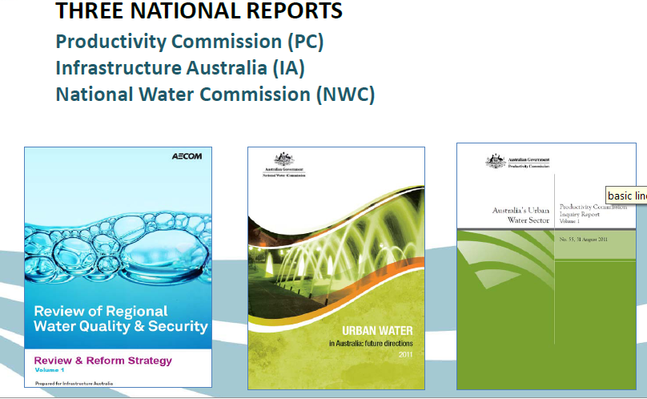

Figure : AECOM review of regional town water quality and security for Infrastructure Australia.

* implement a nationally consistent Best Practice Management Framework for all regional water utilities
* move toward more cost reflective pricing water pricing
* develop a more highly skilled workforce to operate and maintain water systems in regional water utilities by developing a nationally consistent trade qualification
* reform the governance structure of regional water utilities in NSW and Queensland

In regional Queensland three potential institutional models are proposed for the urban water sector namely:

1. **State-owned regional water corporations based (where possible) on catchment boundaries**. Government would be the sole shareholder and appoint expertise-based Boards that would report to the responsible Minister against an operating licence. Dividends could be returned to the State Government (or to local government if local government ownership was selected instead). The reform timeframe recommended was two years with transitional assistance provided for start-up costs, upgrades to neglected infrastructure and to offset loss of revenue to councils.
2. **Mandatory catchment-based regional alliances**. Service Providers would remain within councils but planning would be undertaken on a catchment scale through alliances combining councils, regional catchment management organisations and the relevant state agency. The recommended timeframe for change was one year.
3. **A single State-owned entity servicing regional Queensland (but not SEQ)**. Management would be at a regional scale. This option was thought to be complex and consequently a three-year timeframe was recommended. One-off grants would be required and a temporary dividend payment to councils might be needed to ease the transition.

The first option, with State Government ownership was preferred in the Report and option 3 was recommended with apparent hesitation because “the potential efficiency gains derived from a utility of this size may be outweighed by the considerably higher costs associated with this method of reform.” (AECOM 2010, p. vi).

## Security of Supply

Poor water security in some regional areas is sometimes linked to current institutional arrangements (e.g. AECOM 2010, NWC 2011a). The security of many water supplies was tested severely during the recent protracted drought and concerns over high annual water use were raised for Queensland councils. Some regional communities are adapted to low or uncertain water sources and are experienced and effective in managing this situation through demand management and water efficiency measures. In others, average annual water consumption is traditionally high and the lack of significant restrictions or other measures during times of drought is viewed as a sign of poor performance and a risk to the wellbeing and sustainability of the community.

It can be difficult to determine an appropriate and practical figure for regional consumption. The Productivity Commission (PC 2011a, p. 23) noted “Australia’s per capita water consumption is high by international standards. In 2008, it was amongst the highest of OECD countries.” This is despite a significant decrease in water use over the period of the ‘millennium drought’ when household consumption decreased markedly (Figure 5).

|  |
| --- |
| Figure : Per capita consumption (residential use) in each jurisdiction. Source: PC Inquiry (2011, p. 23). |

These per-capita figures derived from the Australian Bureau of Statistics National Water Account (see ABS 2006, 2010, 2011) do not differentiate water utilities, but data is available for many large utilities (i.e. those with more than 10,000 connected properties) through the Australian National Performance Report. These figures show a declining trend in residential water use since 2004/05 (NWC & WSAA, 2011). Residential water supplied decreased further in 2010/11 “which is consistent with increased rainfall over the most populated areas of the eastern states. Fifty-seven utilities experienced a decrease in residential water supplied, while only two utilities experienced an increase” (NWC & WSAA 2012, p. 28). “Nationally, the average annual volume of residential water supplied per property fell from 228 kilolitres in 2003–04 to 192 kilolitres in 2009–10 (NWC 2011b, p. 133). Using this measure, large Queensland Water Service Providers reported similar water use to other Australian utilities of a similar size (Figure 6).

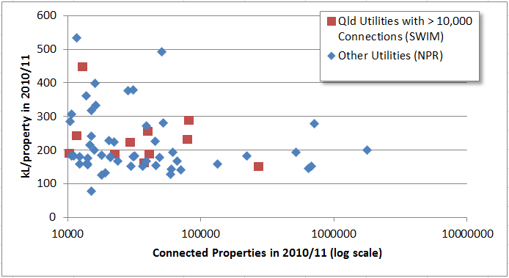

Figure : Annual water supplied to residential properties in 2010/11 comparing Queensland utilities with those in other Australian jurisdictions. (Source NPR & WSAA 2012 and State-wide Water Information Management System, SWIM).

In contrast, utilities in regional Queensland exhibit extreme variation in the volume of residential water supplied. While some regional Service Providers match the residential use of the larger utilities, others, particularly small councils, have much higher levels. In Figure 7 the data for the smaller Service Providers is included in the comparison of large utilities for the past three years. The data included represents only those Providers reporting to the State-wide Water Information Management (SWIM) system and is likely to under-estimate the number of high-water users. For example, only one of the 15 Aboriginal Councils, which often have high per capita water consumption in Queensland, is included in the figure.

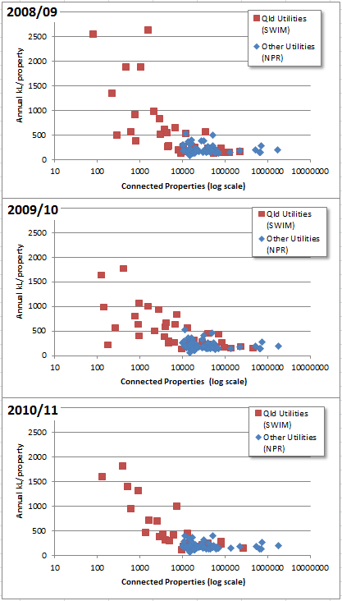

Figure : Annual water supplied to residential properties comparing Queensland utilities of all sizes with the larger utilities in other Australian jurisdictions over three years. (Source NPR & WSAA 2012 and State-wide Water Information Management System, SWIM).

Despite a general trend for reduction in water use over the past three years, the volume of water supplied in small communities can be two to ten times higher than the national average. Volumes were also higher than most utilities in inland NSW which had a median of 252 kL per property on 2009/10 (NOW, 2011). While direct comparison between individual communities is fraught because of diverse and complex drivers in each region, it is clear that consumption in some towns is extremely high by State, national and international standards. But can this water use be linked directly to the institutional arrangements of the Water Service Providers?

Davis et al. (2008, p. 7) found that “institutional and management arrangements are perceived by practitioners as an absolute barrier to the adoption of practices which can enable a ‘water sensitive city.’” This statement is likely to be particularly strongly supported for regional towns in Queensland, but industry structure cannot be an intrinsic ‘absolute barrier’ given the number of councils (even outside of SEQ) with low average water consumption.

The reasons for the high water use in small communities is complex, varying from place to place but some trends are common. For example NWC & WSAA (2011, p. 33) note that “on average, utilities with more than 50 000 connected properties supply much lower volumes of water to individual customers than the smaller utilities. This is likely to be a function of the greater proportion of apartments and units in cities served by the larger utilities”. Demographic and cultural factors are likely to be strong determinants of residential water use.

A common argument provided for high residential water use in regional Queensland communities is that arid conditions and high temperatures mean that more water is required (e.g. to maintain gardens, amenity and to run evaporative air conditioners. A comparison of average residential water use against annual rainfall figures partially supports this contention in that low average rainfall is loosely correlated with high water use. Yet rainfall is clearly not the sole determinant given that many utilities supply less water than similar sized Service Providers regardless of rainfall. However, size is important: within each rainfall category, the higher water users tend to be the smallest Service Providers.

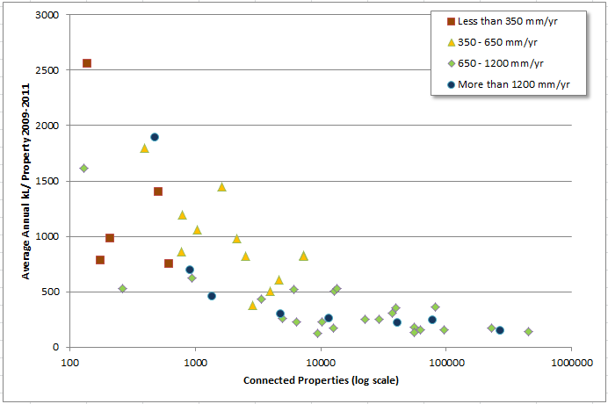

Figure : Average annual water supplied to residential properties between 2009/10 to 2010/11 by Queensland Service Providers between 2009/10 to 2010/11 in four average annual rainfall groupings. (Source: State-wide Water Information Management System, SWIM and Bureau of Meteorology).

Other explanations provided for high residential water use reflect the water culture of the communities involved. For example, many Queensland communities source town water solely from the Great Artesian Basin, some with free flowing urban bores, making domestic water restrictions seem pointless[4]. Similarly, substantial evaporation rates from storages can discourage restriction because of a common community perception that it is ‘better to use the water before it evaporates’. Where water is shared between town and rural use, urban users sometimes question water restrictions and conservation fearing that the significantly larger rate of water use by irrigators will draw down the resource regardless.

An implied but seldom stated reason for poor water use efficiency is that small councils do not introduce adequate policies to create or enforce appropriate water restrictions. While this is likely the case in some areas because of political contingencies, other reasons include the difficulty and cost of enforcing compliance for small communities, cultural perceptions of water use and a lack of incentives for water efficiency. While political aspect of setting water savings targets might be removed through institutional reform, many cultural issues have a high likelihood of being exacerbated.

Water security in regional Queensland is a related but different and even more complex situation than water use efficiency. Security depends on the types of water sources available to each community and the reliability of the supply. As an example, more than 20 regional water service providers rely on the Great Artesian Basin meaning that the immediate threat to water security could be said to be small in many small regional towns. Such communities are exempted from requiring Drought Management Plans under State legislation (Water Supply Safety and Reliability Act 2008, s. 122). This is not to say that efficiency and conservation measures should not be improved.

In some communities located in the wet tropics water security is guaranteed and rainfall is expected to increase under most climate change predictions (see Section 1.8). However, in other tropical communities the seasonality of rainfall means that the storage capacity is inadequate for future (or even current) demand and water efficiency is an essential management measure. Broad-based institutional reform needs to treat these community types differently and few instances of water reform have treated the specific needs of tropical communities in developed countries.

Other small Queensland communities have limited supply options and may depend on unreliable or intermittent surface or sub-artesian water sources. Institutional change in such communities may have an impact on water use efficiency (i.e. if it is poor because of current council policies). However, reform cannot provide greater security for risky water supplies without significant new investment in infrastructure.

Irrespective of the diversity of water supply risks and the validity of assertions defending higher-than-average water use in Queensland, the diversity of factors involved necessitates case-by-case analysis, if only to understand the local risks and prevailing community culture and facilitate change management. The complexity of any state-wide analysis is highlighted by the inter-related nature of many factors (e.g. arid zones tend to support only small communities, small towns tend to be remote and many remote communities rely on the Great Artesian Basin). No single institutional change will overcome the various water supply challenges facing regional communities nor improve community attitudes to water efficiency unless it involves a significant additional investment in the communities.

## Drinking Water Quality

Concern over the quality of drinking water in small regional communities has been proposed as a driver for institutional change. For example, the PC Inquiry (2011, p. 128) found “a significant number of regional water utilities fail to meet the water quality standards of the Australian Drinking Water Guidelines and/or issue ‘boil water’ alerts, whereas this is rare in metropolitan areas.” A similar charge was levelled at the regional council water sector in NSW (Armstrong and Gellatly 2008) and was a likely driver for aggregation of council utilities in Tasmania (See Appendix 3).

AECOM (2010) found that “water utilities servicing regional communities struggle to implement and comply with the Australian Drinking Water Guidelines – this is particularly so for smaller water utilities. This is due to:

* Comparatively fewer human and financial resources, which is being exacerbated by declining population
* Relatively lower availability of technical knowledge and expertise
* Strong competition for skilled employees in regional areas
* Inadequate infrastructure to treat water and preserve water quality
* Poor processes for operation and maintenance of existing treatment infrastructure
* Lack of reporting and insufficient institutional incentive for utilities to comply with guidelines and licence requirements.”

There has historically been limited information collated on drinking water quality in regional Queensland. Summary data available from SWIM indicates that the majority of Service Providers meet 100% compliance with microbiological monitoring standards (Figure 9). Continued vigilance is essential given the risk of waterborne disease even in affluent nations. “Although the literature is filled with reports of waterborne outbreaks, in a number of cases these accounts do not appear to have reached the consciousness of enough of those who are responsible for providing drinking water (Hrudey and Hrudey, 2004, p.3)

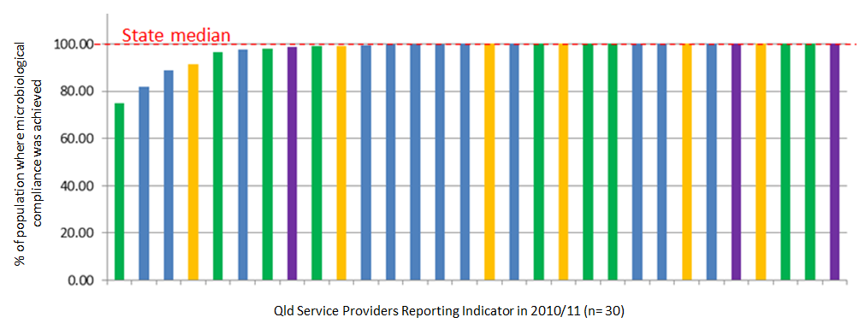

Figure : Ranked values for percent of total population where microbiological compliance was achieved for 30 Service Providers reporting to SWIM in 2010/11. (Orange - < 1,000 connections, Blue - 1,000 to 9,999 connections, Green 10,000 - 50,000 connections and Purple - > 50,000 connections).

The State Government commenced a program of drinking water quality reporting in January 2009. This data is not publically available but anecdotal evidence suggests it is likely that in some areas service providers produce drinking water that does not consistently meet national guidelines. The State Government (through the Department of Environment and Resource Management and Queensland Health) have made an unprecedented investment over the past two years in capacity building and regulatory responses to manage incidents and create Drinking Water Quality Management Plans with service providers in regional Queensland. This activity suggests that the issue has been judged to be serious by those with access to information on water quality risks.

## Compliance with Regulation

The ability for the regional water industry to comply with regulatory requirements is sometimes raised as a measure of whether institutional reform is required (see e.g. AECOM 2010, PWC, 2011). Broad-based regulatory requirements are relatively new in Queensland. Between 2000 and 2009 a raft of legislation was created to regulate the Queensland industry with an emphasis on statutory planning. There were many contributing factors drivers leading up to this period of legislative reform (see Appendix 2) but four concurrent factors were paramount.

1. The Council of Australian Governments developed a Strategic Framework for Water Reform and the National Competition Policy reforms driving change among state regulators.
2. Environmental legislation was drafted in Queensland in 1994 (the Environmental Protection Act 1994) followed in 1997 by the first Environmental Protection Policy dealing with water.
3. The Queensland Government ceased providing formal assistance, advice and consulting services to small council water utilities, a service it had provided previously for over 100 years (see Appendix 2).
4. The protracted ‘millennium drought’ eventually directed policy focus towards water issues and in particular towards water conservation and efficiency.

The outcome was an increasing regulatory focus on water service providers and a dramatic increase in legislative requirements. In particular there was a heavy reliance in the new legislation (particularly the Water Act 2000 and Water Supply (Safety and Reliability) Act 2008) on new mandatory management plans (see Figure 7). For regional Queensland, these included a Strategic Asset Management Plan and Customer Service Standards (2000), Drought Management Plan and System Leakage Management Plan (2005), Outdoor Water Use Conservation Plan (2008), Recycled Water Management Plan and Drinking Water Quality Management Plan (2008), Local Government Asset Management Plan (under Local Government Act 2009), Total Water Cycle Management Plan, and new Sewage Overflow Abatement Plan and Integrated Environmental Management System for large sewage pumping stations (under the renewed EPP Water 2009). There are similar and additional requirements in SEQ where the industry is subject to specific legislation and the Queensland Water Commission in addition to the legislation mentioned above.

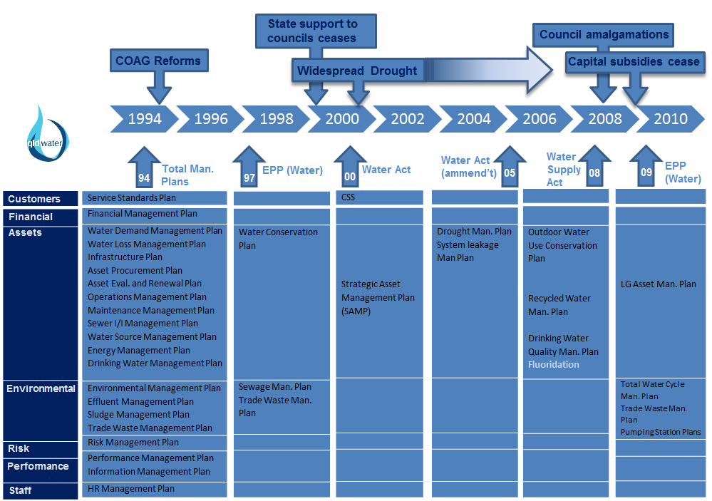

Figure : A dramatic increase in regulation of the Queensland water industry occurred between 2000 and 2009.

The local government water industry has long questioned the prudence of creating numerous overlapping mandatory plans and the limited reliance on other regulatory mechanisms. In terms of the principles for best practice regulation (Table 2) there is strong support within the industry for the need for appropriate regulation to address a number of core industry concerns. However, other aspects of the best practice principles have been neglected, other regulatory options have not been transparently assessed and there was little meaningful consultation including discussion of compliance costs with stakeholders.

Table : Principles for best practice policy and regulation (based on Regulation Taskforce, 2006).

|  |
| --- |
| 1. Governments should not act to address ‘problems’ until a case for action has been clearly established (including clarifying the problem and why additional actions are required). 2. A range of feasible options need to be identified and their benefits and costs, including compliance costs, assessed. 3. Only the option that generates the greatest net benefit for the community, taking into account all the impacts, should be adopted. 4. Effective guidance should be provided to regulated parties and any relevant regulators to ensure that the policy intent and compliance requirements are clear. 5. Mechanisms are needed to ensure ongoing relevance of the policy and regulation time. 6. There needs to be effective consultation with affected parties at all stages. |

The important outcome is that it is unlikely that all Queensland Water Service Providers will be capable of complying with the full raft of new requirements. However, it is too soon to assess the extent of compliance given the recency of the legislation, and the way some requirements are phased-in based on size of the community served. This means that several significant requirements have not yet come into effect for all regional service providers. Through the recent Urban Water Services Partnership, the LGAQ, ***qldwater*** and DERM are collaborating on a reform program to review the regulatory framework for the regional water sector seeking an outcomes-driven and risk-based approach to regulation to achieve secure, sustainable and safe water services for regional communities.

### Environmental compliance

Licensing and approvals processes for discharges of treated sewage and to manage surcharges and overflows were formalised in the *Environmental Protection Act* 1994, particularly through articulation of the General Environmental Duty, and have been developing through successive amendments and policies. The Environmental Protection (Water) Policy enabled under the Act was created in 1997 and significantly revised in 2009. The original Policy included provisions for Water Conservation Plans, and Sewage Management Plans and defined sewage treatment plants as one of many Environmentally Relevant Activities (ERAs).

Specific requirements on water service providers vary markedly across the State because of the age and variation of licences, changes in legislation, assessment of environmental values and location specific nature of environmentally relevant activities. There is no comprehensive review of compliance by the water sector with environmental legislation. Anecdotal evidence suggests that degrees of compliance can vary considerably.

## Financial Sustainability

Financial performance of water businesses in regional areas is often called into question. AECOM (2010, p. 1) note that “less than full cost recovery is a common feature of water utilities servicing regional areas.” The financial performance of most regional water service providers is intricately confounded with the financial performance of the owner councils some of which have been assessed to be financially unstable. Regardless, financial performance of the water sector cannot easily be assessed, and this fact alone can be used as an indictment of the Queensland water industry.

The PC Inquiry calls for transparent separation of the water business from other government matters at all levels and transparent declaration of cross subsidies. In particular, “the Commission strongly encourages the Queensland Government to require that local councils financially ring-fence their water supply and wastewater operations from other council activities” (PC, 2011a, p. 385). The fact that water businesses are imbedded within general council services shows that cross-subsidisation is complex and this complexity is seldom transparent. It should be noted that many elements of this complexity (e.g. shared staff, common administrative systems and frameworks) can be beneficial economies of scope (see section 1.7.3).

An important distinction must be made between the category of (usually large) councils that can be categorised as financially sustainable and can provide dividends to their stakeholders, and the smaller and often remote councils. In the latter, small populations (and thus rate bases) can mean that capital investment in water infrastructure is difficult or impossible and relies on funding assistance and subsidies from other council income. In some cases even operating costs can be difficult to manage (see Section 1.5.1).

One comparator of financial performance is the Economic Real Rate of Return (ERRR) which is available for a number of councils (through the State-wide Water Information Management (SWIM) system). Table 3 lists the median and range of values for Queensland utilities compared with utilities from across Australia.

Table : Economic Real Rate of return (median and range) reported in the PC Inquiry report versus Queensland data.

|  |  |  |
| --- | --- | --- |
| **Number of connected properties** | **Economic Real Rate of Return on water services (%) in 2009/10** | |
| **National Utilities1**  median, (range), number utilities | **Qld Utilities2**  median, (range), number utilities |
| > 100,000 | 3.0  (0 -35.8)  n = 11 | 7.8  (3.2 – 10.3)  n= 3 |
| 50 - 100,000 | 1.2  (-1.0 – 9.1)  n= 10 | 3.5  (0.1 – 11.1)  n= 4 |
| 20 – 50,000 | 1.1  (-2.9 – 4.8)  n = 17 | 4.0  (-3.09 – 4.2)  n = 3 |
| 10 – 20,000 | 1.3  (-2.7 – 6.0)  n = 21 | 2.6  (1.7 – 3.6)  n=2 |
| < 10,000 | no data | 0.1  (-3.4 – 3.9)  n = 9 |

* + 1. Source: PC (2011a, p.39) and NWC & WSAA 2011
    2. Source: SWIM data reported in 2009/10.

The ERRR is the revenue from water business operations less operating expenses for the water business divided by written down replacement cost of operational assets. An appropriate value for ERRR is difficult to determine for water utilities but should be at least positive with a margin to allow for return on capital (NWC, 2011). OTTER (2011) suggested that an ERRR of around 7% was required for full cost recovery in the Tasmanian urban water industry while NWC (2011, p. 386) questioned the reality of NWC and NSW Office of Water definitions of full cost recovery as an ERRR “greater than or equal to zero”.

Conclusive comparisons cannot be drawn because of the range and diversity of service providers listed and the small number of data, but it is clear that there is a broad range in for Queensland utilities with good alignment to the national data in the larger classes. There is no national data for small (<10,000 connections) service providers, many (though not all) of which struggle to provide significant returns from their water business.

Poor economic returns can result from a range of issues including size and remoteness, but presumably is not directly caused by institutional arrangements given the range of values of ERRR in all sizes of regional councils. However, it should also be noted that the PC Inquiry called into question the accuracy of estimates of ERRR even in larger utilities given that it “is based on self-reporting by regional water utilities and not always independently audited” (PC 2011, p. 388).

### Infrastructure Investment

A key determinant of ongoing financial sustainability of regional water service providers is structured investment in infrastructure creation and renewal programs. The PC Inquiry (2011a, p.128) noted that “it would appear that inefficient asset management is particularly prevalent in some regional areas, due to a shortage of staff with appropriate skills and experience and/or lack of financial resources to undertake asset upgrades.” It is difficult to comprehensively address the degree to which this will be the case in Regional Queensland but several factors make it highly likely that at least some councils will struggle with future infrastructure investment.

The most expensive infrastructure of the urban water sector is literally a sunk cost, the distribution and collection networks that remain out of sight in most schemes. In many regional communities, networks were developed rapidly in the decades leading up to 1980, with a large number built in the years immediately before and after the second world war (Appendix 2). Much of this infrastructure is reaching the end of its operating life and the extent of replacement and upgrade programs varies markedly from place to place. Anecdotal evidence suggests that in many small communities network management is limited to reactive maintenance programs and poor data exists on the location and condition of many assets. Low populations and capacity for planning and appropriate depreciation along with the removal of State subsidies contribute further with the result that financial sustainability of some communities will be severely tested by required infrastructure investment in the next two decades.

Another significant capital investment, particularly for small communities, is the relatively large cost of treatment infrastructure for drinking water. This is a common issue across the urban water sector and it is often argued that larger water service providers can spread these “lumpy” capital costs more easily than small organisations (AECOM, 2010; NWC 2011a, PC 2011a). Increasing regulation of water quality (e.g. the new Drinking Water Quality Management Plans that will be mandatory across regional Queensland by 2014 – see Section 1.3 above) is likely to increase the need for expenditure in this area. Even where current systems are adequate, replacement of ageing plants (many of which were installed over 50 years ago – Appendix 2) or expansion to accommodate growth can trigger need for new treatment plants and the resultant need to invest in new skills and capacity.

This form of infrastructure investment is particularly challenging for the many small towns using artesian bore water with little or no treatment. Increased regulation, more stringent national guidelines and increasing community expectations could result in a (relatively very large and unprecedented) need to invest in treatment infrastructure. This issue already hampers efforts to roll-out new mandatory fluoridation equipment across Queensland. In communities using one, or sometimes several, bores and no existing treatment process, installation of fluoride dosing plants is disproportionately costly for both capital and operating budgets.

In a similar manner, ageing sewage treatment plants combined with increased standards for the regulation of treated wastewater discharges have resulted in the need for costly upgrades, or often full replacement, of existing sewage treatment plants. The quality and effectiveness of sewage treatment infrastructure across the state varies but in small towns usually consists of very simple but well-tested and reliable technologies. Where regulatory requirements trigger upgrades to new technology the result is not only a large capital investment, but also significant increases to traditional operations and maintenance costs.

Finally, costs will be increased dramatically by the increased regulation of the water industry over the past decade (see Section 1.4) and particularly by the large number of compulsory management plans. Although the intent of such documents is already achieved through other planning mechanisms (in many councils) the statutory plans entail additional resources for preparation, reporting and review as well as the implementation component. These requirements along with increasing standards and technologies across the industry requires investment in capacity and particularly planning and management skills across councils that are otherwise being encouraged to reduce costs and staff numbers. The common alternative for small councils is to outsource the preparation of compulsory plans to consultants which is a costly process that does not result in ‘ownership’ in the plans.

### Pricing and Tariffs

Pricing policies determined by councils are sometime questioned with respect to sustainability versus political sensitivities. It is recognised that “pricing is a difficult issue, particularly because of community and local government sensitivity to price increases” (AECOM, 2010, p. 2). As a consequence, price setting is directed by a range of agreed principles. The national agreements for determining settings for water prices in Australia are summarised by Cousins (2010, p. 8).

The setting of water prices takes place within the context of a number of intergovernmental agreements. In essence, these agreements seek to have efficient prices set for urban water, in particular through cost reflective price structures and levels. This requires that prices cover operating and capital costs, where the latter covers both a return of capital (depreciation) and a return on capital (interest and rate of return). The agreements include the 1994 Water Reform Framework, which was later incorporated into the 1995 National Competition Policy reforms; the 2004 National Water Initiative; the 2006 Competition and Infrastructure Reform Agreement relating to access terms and conditions; and the 2010 National Water Initiative Pricing Principles. Practice in implementing what governments have agreed to has been variable.

In Queensland, the Queensland Competition Authority issued a Statement of Regulatory Pricing Principles for the Water Sector in 2004. The primary purpose was to guard against water utilities taking advantage of monopolies or abusing public good powers. The principles hold that prices be cost reflective, forward looking, ensure revenue adequacy, promote sustainable investment, ensure regulatory efficiency and take into account relevant public interest matters. These principles align well with the later NWI Pricing Principles that were released in 2010.

Interestingly, while the NWC calls for the need for a national price regulator for the water industry, the Productivity Commission Inquiry found that a lighter role of price oversight, similar to that undertaken in South East Queensland - was a preferable model. The view of the Commission was there should be flexible pricing options that reflect the true cost of providing water services in each community or “location specific pricing” (PC 2011a, p. 163). This could require a move away from universally consistent ‘postage stamp pricing’ where all consumers pay a similar tariff regardless of the cost of their services. A converse argument is that price regulation is required to counter political interference in price setting, particularly in small councils keen to promote population growth, which tends to reduce prices to unsustainable levels. The PC Inquiry finds that this issue could more efficiently be solved through separation of powers and effective price oversight.

The need for location-specific pricing means that it is difficult to compare prices from one utility to the next as many competing and complex factors can affect the appropriate price point. Cousins (2010, p. 33) also warns that “price comparisons in any one year need to be treated with caution as they may not be fully representative of the longer term picture” but provides the following table of comparative charges for residential water and sewerage services.

Table : Annual residential charges based on 200 kL of water and 200 kL sewage provided by major utilities in 2008-09. Source Cousins (2010, p 33.)

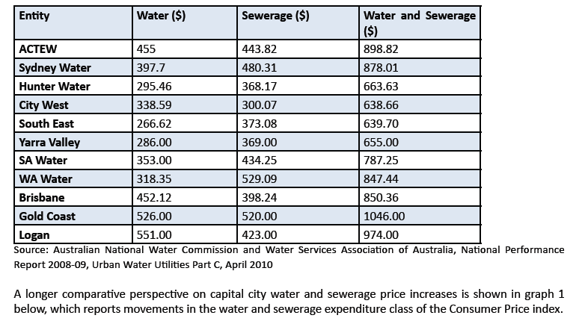

The author notes that Brisbane, Gold Coast and Logan are among the highest water and sewage rates in Australia. This is despite significant recent increases in all capital cities. From 2005 to 2010 price increases were “Sydney 60.3%, Melbourne 59.6%, Brisbane 51.6.%, Adelaide 32.7%, Perth 32.0%, Hobart 34.8.%, Darwin 34.4%, Canberra 69.8%.” (Cousins 2010, p. 33). Prices at Brisbane, Gold Coast and Logan continued to rise and exceeded $1100 (for water and sewage combined) by 2010/11.

Across Queensland, prices tend to be lower in smaller councils (Figure 8). In contrast, WSAA (2010) point out that water and sewerage operating costs tend to increase with decreasing size of water utilities. Anecdotal evidence along with data on the income and expenditure and economic real rate of return of many regional water service providers indicate that prices in some councils are not cost reflective and the utilities do not universally achieve full cost-recovery. This is a charge levelled at the regional industry by Infrastructure Australia (AECOM 2010, p. 2):

…many utilities servicing regional towns are not recouping the costs of supplying water, let alone providing for capital improvements. Many are charging prices significantly lower than in major urban areas, where economies of scale would be likely to mean lower cost. Without pricing reform, at least to cost reflective levels, many regional water utilities – even the larger ones – will remain unsustainable….

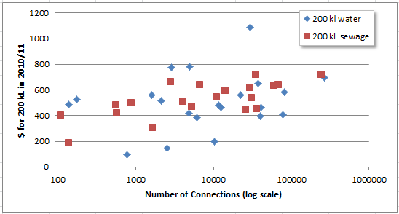

Figure : Annual residential charges based on 200 kL of water and 200 kL sewage in 20 Queensland councils in 2010/11. Source: State-wide Water Information Management (SWIM) system.

In is inevitable that water prices in at least some communities will need to be increased to cover basic costs. Even in many capital cities, water and sewerage prices will continue to rise sharply with real annual bill increases likely to be between 7.7 and 13.2% (Cousins, 2010). Given that prices in some areas of regional Queensland are generally lower than in the capitals and costs are likely higher due to small size, remoteness and age of infrastructure, price increases may be even greater. However, many small councils are, and have for some time, been charging prices equivalent to those in the recently inflated capital cities.

There are a number of very small towns which sophisticated water or sewage treatment technologies that have been installed with State Government grants but which have operating and maintenance expenses greater than the current rate base will cover. In some cases rates do not reflect the cost of operations and by any objective standard true cost-reflective pricing would be unaffordable. To continue with current service standards such towns must be subsidised and a key issue for the future of the water industry is who will bear these costs.

The question of whether the problems associated with low water prices should be solved with institutional change requires a complex solution in regional Queensland. Even in capital cities it has been recommended that “phased implementation is a justifiable policy. Major “overnight” changes to water prices would impose a considerable shock on individuals and businesses, which have only limited short-term capacity to change water-using behaviours” PC (2011a, p. 5). This has been a critical issue in the institutional changes in SEQ (see Appendix 3). In a web article reviewing recent water reform in SEQ and Tasmania, Coe and Harris (2011) note:

The decision to raise prices or impose two-part tariff arrangements during the transition period has proven a hindrance to reform activities. The issues of price increases and transition should have been considered separately to enable the water businesses, political environment and community to evaluate and respond appropriately.

If price increases are needed in regional Queensland undertaking them concurrently with massive institutional reform could present significant risks.

### Cross subsidisation

Cross subsidisation is an important issue on a number of levels but AECOM (2010, p.2) note that it is also “a principle that needs to be acknowledged in the pricing discussion”.

Some utilities that service a larger geographic area spread the cost of water supply amongst all consumers – a solution not always supported by the larger regional or metropolitan communities that ultimately pay more for water to ensure neighbouring towns are serviced by safe and secure water supplies. Cross subsidisation using ‘postage stamp pricing’ is a principle that is applied in virtually all major urban water utilities as one of the costs that comes with the benefits of economic scale. Many regional communities benefit significantly from the application of this principle to the provision of mail and telephone services. Australians have broadly accepted the application of this principle in the water sector and this position needs to be recognised when sections of the community argue that they may be disadvantaged by this approach.

In contrast, some small and remote communities raise the issue of inequities in amalgamating and aligning tariffs across their region. A common argument is that common water tariffs always benefits communities that have not invested wisely in infrastructure, or for which costs of provision are particularly high, over those that have maintained appropriate investment over time. Regardless of whether rates increase or decrease in each community, future investment will be directed to the poorly maintained schemes with less expenditure possible in the other communities. This has already been a common experience through council amalgamations.

Community perceptions play a large role in this impact which is difficult to assess in any case and will vary depending on the size of the region. It is important to note that in those jurisdictions with a single water entity the rate-rich cities where economies of scale are achievable significantly cross-subsidise regional areas. Regardless, the equity of tariff rationalisation must be addressed if prices or institutional arrangements change.

## Skills Shortages

Water Service providers have been facing a shortage of skilled people to adequately plan,

maintain and operate water and sewerage services. This is being exacerbated by an ageing workforce and decline in the available skilled and technical labour pool. The NSW Department of Water and Energy (2008, p. 5) noted that “a significant proportion of engineers currently in the workforce graduated in the 1960s and 1970s and it is estimated that around 30,000 engineers will retire within the next decade.” Retirement of ‘baby boomers’ is also a key issue for the Queensland industry (Figure 9). There is evidence of industry response to this expected shortage including the emergence of “para-professional” roles and commensurate training programs.

Attracting people with appropriate skills and delivering appropriate training to existing staff in regional Queensland has always been challenging and the resources boom has exacerbated this. Water and sewerage services are essential functions for every community, however the industry is relatively small, widely dispersed and service providers are expected to compete with the resources sector without appropriate tools or financial support.

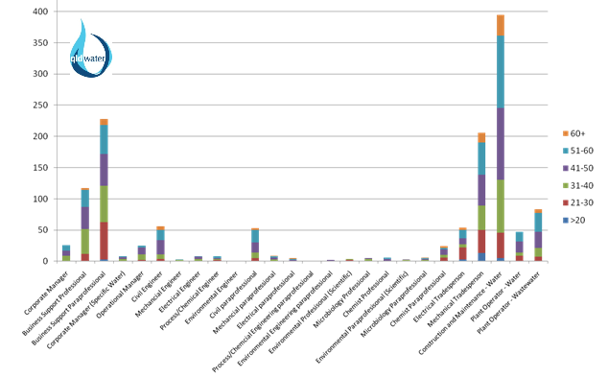

Figure : Age profile by job role across the Queensland urban water sector in 2010 showing high proportions of staff over 50 in many key roles. Source: *qldwater*.

The industry is collaborating (including local government and state-owned bulk water providers) through a skills partnership but much remains to be done. The skills challenges will require substantial investment in human resources over the coming two decades. This is a challenge for small and large utilities alike, however it is clear that small organisations have a far greater exposure.

## Efficiency

Lack of efficiency is a commonly levelled criticism of the water industry and in particular the council-run water sectors in Queensland and NSW (PC 2011a; AECOM 2010). However, as noted by Productivity Commission Inquiry (PC 2011a, p. 28):

In considering the scope for efficiency gains in regional urban areas it should be recognised that factors such as population density, population growth, proximity to metropolitan areas and the endowment of water resources strongly influence the costs and challenges of providing urban water services. These factors vary greatly across regional areas….”

Efficiency is considered here with respect to the three commonly raised issues of public versus private ownership, competition and economies of scale.

### Ownership

In a broad review of efficiency of private versus public owned airports, Tae et al (2005, p.3) note that “a common-sense view is that government-owned firms are less productively efficient than their private sector counterparts operating in similar situations.” However,

“neither empirical nor theoretical evidence presented in the vast management and economics literature is conclusive with respects to the above view despite its general acceptance in the popular press.”

In their review, the authors review productivity levels with respect to:

• Ownership and Governance,

• Management,

• Business Characteristics and Environment, and

• Technical efficiency

and find that 100% or majority private owned airports are slightly more efficient than 100% public (single government) airports, but both are more efficient than public-private-partnership organisations. The authors conclude:

In short, the airports with a government majority and/or with multiple government involvement tend to have significantly lower operating efficiency than all other forms of ownership. Furthermore, airports with majority private ownership (including 100% private ownership) do not achieve significantly higher efficiency than the 100% government-owned airports.

The reasons for these findings are manifold but the transaction costs and lack of clarity in organisations with mixed ownership are given as key factors reducing efficiency. While joint public-private ownership of water utilities is not common (ACTEW AGL in the ACT is a notable exception) the general lessons from this study are likely to be applicable to the water industry. Key among these is that organisation form is not as important as clarity of governance arrangements and the appropriate selection of executives and management.

Another factor to be considered is the community perception of water services and how they should be owned. There is a common argument that water is a particularly essential, common good service. The Productivity Commission (PC 2011a, p. 4) acknowledges this as follows.

Water is sometimes perceived to be different from other utility services (electricity, gas, telecommunications and mail) because it is ‘essential for life’ and/or it exhibits common property characteristics. Understandably, there is also community anxiety about there being insufficient water to meet basic human and industry needs because of prolonged droughts. Consequently, there has been a high degree of political involvement in water issues and pressure to adopt objectives, policies and institutional arrangements that are different from those applied in other utility sectors.

This perception is perhaps emphasised in regional Queensland where numerous communities are regularly threatened by limited water supply or drought, with many alternating with extreme wet seasons and flooding. In western Queensland, as in much of regional Australia, the initiation and development of communities was underpinned by access to reliable water sources (see Appendix 2).

The response of the community to different models of ownership of the urban water sector is important to ensure acceptance, and thus efficiency and sustainability of institutional models particularly in small and remote towns. The political reversals of policy on institutional structure and ownership in South East Queensland, particularly the path taken in repeatedly restructuring the southern entities in the region, provide a particularly telling case study on risks associated with community perceptions of institutional structures and ownership. Such a reaction may be amplified in small communities where links with councillors and council staff are often closer and cultural attitudes to water are more pronounced.

Finally, regardless of institutional arrangement, outsourcing is common across large water service providers for certain functions (Table 5) and is also undertaken to a lesser degree by some regional councils. This means that the private sector is a player in the urban water sector independently of the ownership model. This has ramifications on efficiency measures with respect both transaction costs but also to competition.

Table : Proportion of expenditure outsourced in 2009/10 by large Australian water utilities. Source: PC 2011a, p. 114).

|  |  |  |
| --- | --- | --- |
| **Water utility** | **Operating expenditure (%)** | **Capital expenditure (%)** |
| Water Corporation (WA) | 30 | 93 |
| Sydney Water | 72 | 94 |
| Sydney Catchment Authority | 64 | 99 |
| Melbourne Water | 73 | 100 |
| South East Water (Victoria) | 42 | 90 |
| Yarra Valley Water (Victoria) | 58 | 98 |
| Hunter Water (NSW) | 65 | 100 |
| SA Water | 65 | 94 |

### Competition

Creation of a competitive environment for water utilities was a key driver of reforms in SEQ and the Victorian water sector and is a principle tenet of the microeconomic reform agenda espoused by the Productivity Commission Inquiry. The Inquiry describes the relevance of four types of competition to the water sector (PC, 2011b) as follows.

1. **Competition for the market** – where businesses compete to provide water and sewerage services (e.g. South Australia model in Adelaide, and other outsourcing arrangements practiced by all parts of the urban water sector).
2. **Competition in the market** – where multiple providers compete to provide water or water services to the same group of consumers (e.g. electricity sector and some elements of the non-residential water sector in Scotland and England, see Appendix 3).
3. **Yardstick Competition** – or comparative competition, often recommended for monopolistic industries such as the water sectors where similar utilities are compared and there are rewards and penalties associated with performance (e.g. Victorian water businesses, National Performance Reporting, and regional NSW council utilities).
4. **Competition for the resource** – involves competitive markets for the exchange and charging of water (e.g. rural water market).

The PC Inquiry recommendations generally encourage yardstick competition (between amalgamated regional water service utilities) as the most appropriate form of competition for regional Queensland. It should be noted that this form of competition has been possible in Queensland in the past to a limited extent with previous Department of Local Government statistical reports and in the past two years through the comparative reports produced by the State-wide Water Information Management (SWIM) system. This is currently increasing with the trial of public reporting of some performance indicators by selected utilities though SWIM.

### Economies of Scale and Scope

Many reports have suggested that performance in the water sector can be improved through increasing the size of utilities (WSAA 2010, PC 2011a, and see also several international studies reported in PC 2011b, p. 123). However, the large number and geographical dispersion of service providers in regional Queensland mitigate the benefits of economies of scale. The Productivity Commission (PC 2011a, p. 129) recognises this difficulty: “because of this diversity it is not valid to simply observe differences in costs or service levels between regions and draw conclusions about the performance of regional water utilities”. Regardless, the report goes on to suggest:

There is, however, evidence to suggest that substantial efficiency gains could be achieved by some form of amalgamation or alliance between small regional water utilities, which could be combined with governance reforms (chapter 13). This opportunity exists mainly in parts of New South Wales and Queensland, as other jurisdictions, including Victoria and Tasmania, have already implemented reforms to aggregate small utilities. It is striking that there are 177 urban water utilities that service regional New South Wales and Queensland (chapter 13), and only about 30 that service the remainder of Australia (chapter 2). Many utilities in regional New South Wales and Queensland service fewer than 10,000 connected properties, with some servicing fewer than 1,000.

The relatively large number of service providers in Queensland is associated with the number of small councils and thus part of a larger series of disputes and council amalgamations. Figure 7 is modified from presentations by the Department of Environment and Resource Management in 2010 that referred to the large number of small providers across the state.

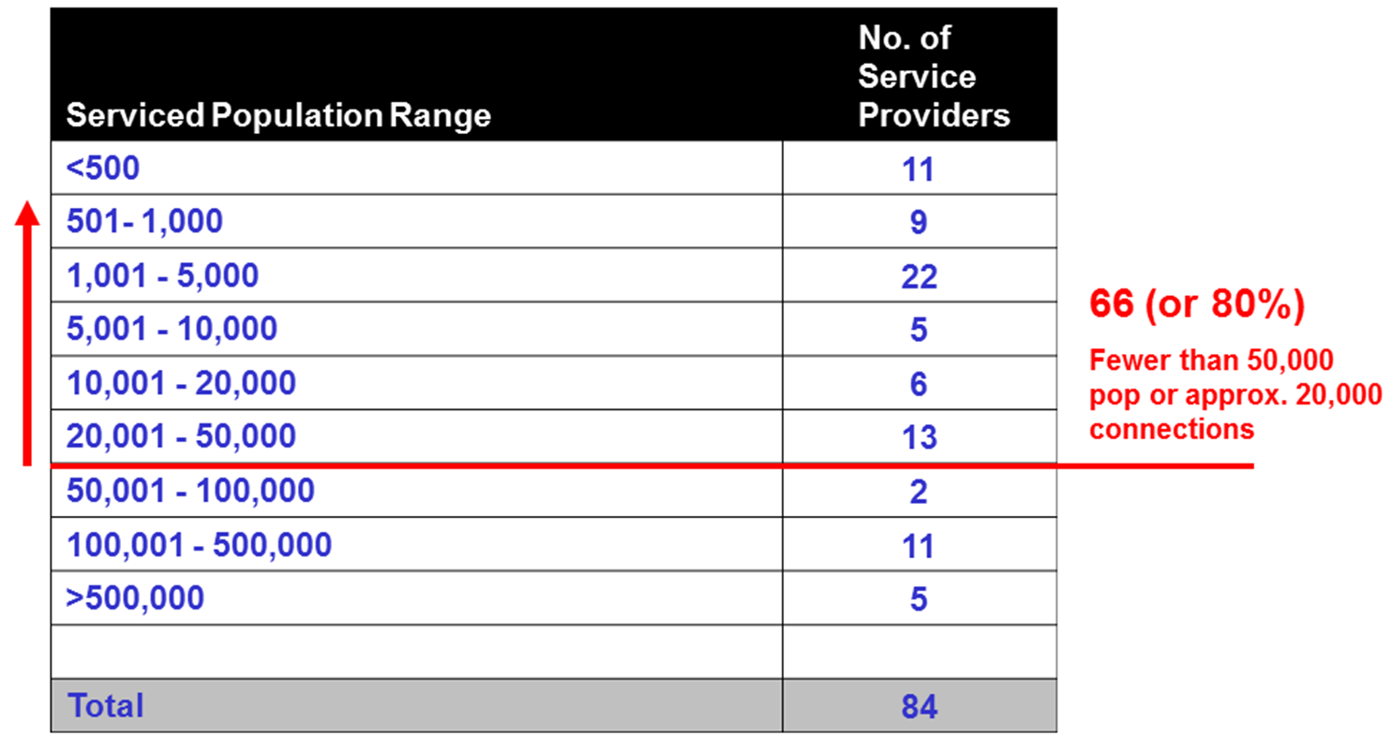

Figure : Number of Water Service Providers in Queensland by Size. Source : DERM presentation 2010.

This situation is unique to Queensland and NSW and results in numerous calls for better understanding of the benefits for economies of scale for these two states (e.g. NWC 2011a).

It is also important to distinguish different types of economies that may be applicable to the urban water sector. PC (2011b, p. 119) distinguishes:

**economies of production density** – where total volume of water produced (or sewage treated) increases but the network size and population served remain constant,

**economies of customer density** – where population served (and thus volume of water produced and sewage treated) increases but the network size remains constant,

**economies of scale** – where population served, size of network and volume treated increase together and wherein two categories are further distinguished:

* **economies at the ‘plant level’ -**  average cost of production decreases as the plant size increases, and
* **economies at the ‘firm level’ –** average cost of production decreases as the number of plants operated by the firm increases.

Numerous studies have recommended the most efficient number of connections, or volume of water treated for urban water service providers in Australia and overseas (see summary in PC 2011b). Other than general agreement that economies of scale are important and larger businesses are more efficient than smaller ones, there is no consistent pattern in the recommended size of the ultimate water utility. This is because of the variation in the water sectors studied and the many factors that will impact the long-run average cost curve of a water business.

It should also be noted that cross subsidies are common in the water industry and “those jurisdictions which have comprehensive water and sewerage agencies (WA, SA, NT & ACT) achieve a positive rate of return by using metropolitan areas to cross subsidise rural and smaller regional communities” Davis et al (2008, p. 5). The author goes on to state that similar cost spreading is not likely in NSW where “metropolitan areas are already serviced by long-established state-owned enterprises”. It is similarly unlikely that the metropolitan providers in SEQ could be restructured (again) to support the rest of the state.

The actual economies of scale that might be achieved through consolidation of small regional entities are not always clearly articulated. The common assumptions are probably reflected by Coe and Harris (2011) on the SEQ and Tasmanian reforms and include:

* elimination of duplicated overheads across small entities,
* ability to attract industry-leading delivery partners,
* rationalisation and alignment of tariffs (resulting in greater equity to consumers),
* centralisation of responsibility for future price planning.
* tariff regulation to help ensure prices are linked to justifiable costs and are supported by the principle of “user pays.”
* improved regulatory and pricing frameworks which in turn:
  + drive higher and more transparent level of service,
  + promote investment into justifiable service outcomes and
  + reduce the long-term risk of price shock and service interruption.

Other suggested benefits of larger utilities over small ones are:

* ability to attract a retain experienced staff (not only due to financial incentives, but because of the interest or challenges provided by a larger organisation) (AECOM 2010),
* the possibility of ‘smoothing’ the inevitably ‘lumpy’ capital investment required of the urban water service providers (AECOM, 2010), and
* in time, Regional Water Corporations may be able to raise capital on wholesale financial markets in their own right, a funding option that is rarely available to local government in Australia (AECOM 2010, p. vi).

While it is not the purpose of this report to assess the validity of each of these claims it should be noted that there are often counter-arguments for the potential benefits of economies of scale, particularly in regional Queensland. For example:

* it has been suggested that overheads are not eliminated, but duplicated in the development of a regional water entity because these structures are already in existence within local governments (e.g. CEOs, senior managers/engineers, office staff and infrastructure). Creating a separate entity duplicates this already existing framework (i.e. there are economies of scope in council entities – see below) without reducing the need for local councils. These additional overheads were in fact used as an argument against shared service arrangements, in favour of amalgamations by the Local Government Reform Commission (LGRC 2007a).
* rationalisation and alignment of tariffs (e.g. postage stamp pricing) can result in cross-subsidisation rather than improved customer equity (see Section 1.5.2).
* councils can have the ability to smooth large investments in capital through their broader activities and the mechanisms by which this is achieved prioritised allow prioritisation based on local needs.
* the ability of large water organisations to attract experienced staff has been criticised on the grounds of increased wage costs for senior staff when councils already recruit senior managers for example.

The Productivity Commission consequently urges a cautious approach to assessing scale impacts and the need for case-by-case analysis is supported by numerous submissions to the Inquiry (though most represent huge water utilities arguing against evidence for diseconomies of scale caused by their large size). To properly determine the impact of aggregation the Productivity Commission (PC 2011b) recommends assessment of:

* the number of discreet schemes managed by the utility,
* network density and length,
* distance between networks and scope/demand and ability for interconnection,
* volume of water/sewage supplied or treated,
* size of the area served,
* geography, geology and topography of the region (to determine cost of connecting networks and pumping costs),
* variability of sewage (wet weather) flows,
* asset life cycles ,
* climate and rainfall variability.

It is likely that these factors will be particularly significant in Queensland where relatively large proportions of the population live in remote regions (Figures 11 and 12).

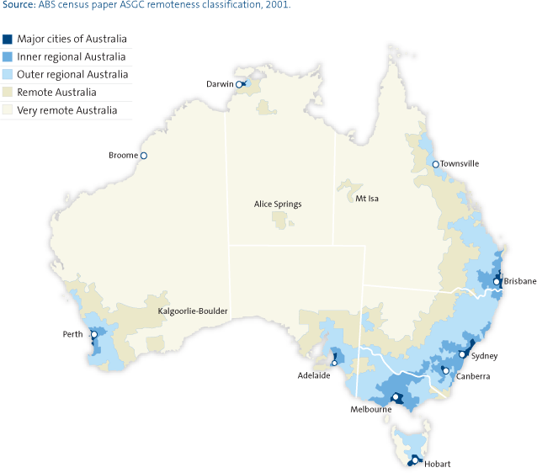

Figure : Map of different statistical regions across in Australia. Source: ABS, 2009.



Figure : Populations in each of the three most remote regions in Queensland.

**Economies of Scope -** where two or more products can be provided by one entity more economically than for each of them to be provided separately.

Economies of scope may be realised in the water industry through vertical integration of the water and/or sewerage service chain and/or through joint provision of water and sewerage services (all of which are the standard case in most regional communities). Economies are also claimed by councils in terms of integration of water services with other functions, particularly town planning, stormwater management and roads provision and for balancing and prioritising a range of public goods and services which may compete for resources in small towns.

There is one other way that economies of scope are important for council water businesses, namely the impact that removal of water functions may have on the rest of council business. The Productivity Commission Review (PC 2011a, p. 129) recognises this as follows.

Many small water utilities, however, are operated by Local Governments and it is possible that their remaining functions would become less efficient if water were separated out into larger regional entities. That is, the removal of water services from Local Governments may reduce their economies of scope. The reform challenge, therefore, is to more fully exploit economies of scale, while recognising possible impacts on the efficiency of Local Government.

Examples of disbenefits are not limited to loss of income that some water businesses transfer to their owner council (e.g. dividend payments). For example, it can also be significantly more difficult to recruit technical staff, particularly senior engineers where the water business is excised from council. Some engineers gain personal satisfaction from working in small communities with a range of technical challenges. This is akin to the case noted above where water businesses have reported greater opportunities for attraction and retention of senior staff because of the broader challenges and experience available in a large business managing many schemes and staff. Impacts on general employment in small communities is a related issue.

## Climate Change

The ability to respond to the threat of climate change is a common cause for concern in reports analysing the issue of regional management of the water sector (e.g. Davis et al. 2008, NWC 2011a). Best estimates of the impacts of climate change to 2070 compiled by the Queensland Climate Change Centre of Excellence, Bureau of Meteorology and CSIRO indicate that average annual temperature increases of 2.5 to 3.5 °C across the state.

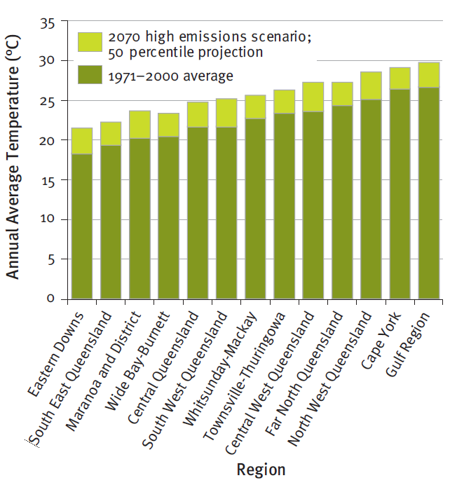As shown in Figure 13, this will result in temperatures in the Maranoa district resembling those in FNQ at present while Central and South West Qld temperatures will resemble those in the North West today. Extreme high temperature days will become more common and evaporation will increase by between 7 and 15% in most areas of the state. There is less certainty about changes to rainfall but the best estimate is that it will decrease by up to 10% across the entire state (Figure 14).

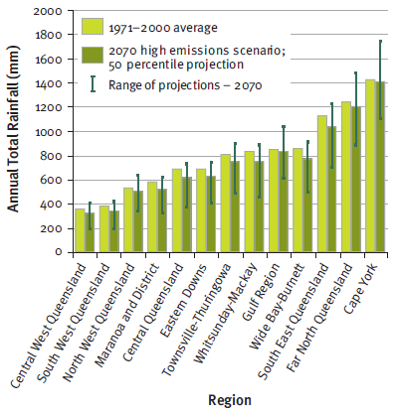These predicted changes will clearly have significant impacts on the urban water sector. Direct impacts include reduction of water supplies or their reliability and difficulty in forecasting supplies using traditional methods.

Figure : Average annual temperature (1971-2000) with projected changes by 2070 for a high emissions scenario. Source: Qld Government 2009.

Hotter weather and reduced rainfall will also have a marked impact on the level and intensity of demand and water use. In some areas extreme events (cyclones, flooding and droughts) will increase in intensity if not frequency. This will have ongoing impacts due to infrastructure damage and reduce asset life.

It is clear that climatic change will require a different approach from urban water service providers and a need for long-term planning. Whether institutional change is required to generate such responses depends on the ability of current structures to manage this change. There is little available information on how or whether this is being achieved by local government water service providers, which in itself indicates a lack of transparent planning (see Section 1.10).

Figure : Annual total rainfall (1971-2000) with projected changes and range of changes by 2070 for a high emissions scenario. Source: Qld Government (2009).

## Demographic Change

Population growth is seen as a driver for water industry reform and it is true that Queensland does contain some of the fastest growing local government areas in Australia. These areas will experience increased demand for water and waste water services and likely changing customer expectations as populations age. However, it should also be noted that a large number of councils will experience low growth or even population decline in coming years. These councils face increasing regulatory requirements and infrastructure replacement programs with a static or decreasing rate base which may be small to begin with.

Predictions of population change are complicated in parts of Queensland by complexities such as the ephemeral booms caused by the resource sector and coastal towns with large population change during holiday periods. Figures 15 and 16 provide projections compiled by the Office of Economic and Statistical Research and ABS for Queensland for the next twenty years. Areas of high growth are generally restricted to coastal councils and few Aboriginal councils. In stark contrast, many councils in the centre of the state will have low growth or population decreases. All indigenous councils except Hopevale are predicted to have growth in excess of 0.9%. These and other demographic changes, particularly ageing population structures will have significant impacts on urban water service providers but will be very different from those in areas of high growth.

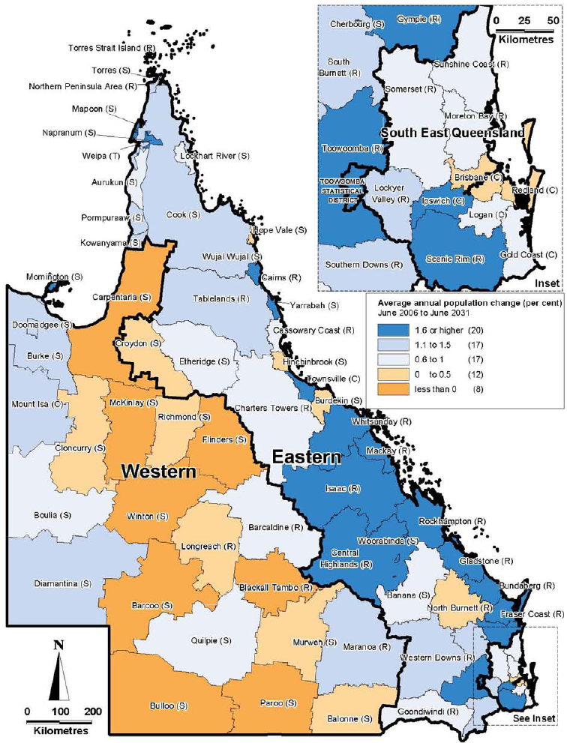

Figure : Average annual population change (%), 2006 to 2031. Source: OESR 2011, p. 10.

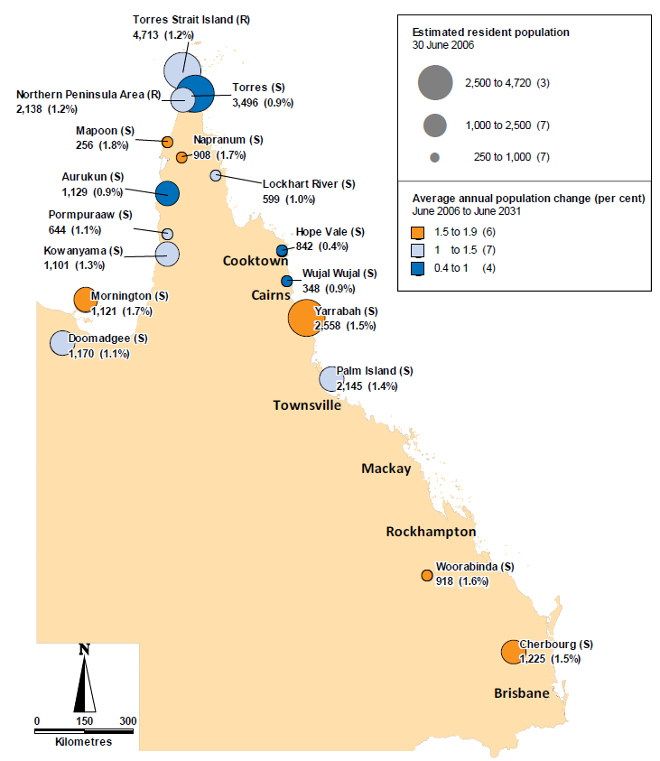

Figure : Population and projected annual population change (rates) in Queensland indigenous councils from 2006 to 2031. Source: OESR (2011, p.27).

## Planning

AECOM (2010) suggests that “water business related planning is not performed well in regional areas compared with the planning undertaken for metropolitan utilities and larger regional centres.”

*Planning practices also differ between States, and as a result, the management of factors such as drought, demand, water quality, climate change and capital infrastructure is not achieved in a consistent manner and more importantly, not performed adequately in some parts of the country.*

The productivity places this issue in a historical context (PC 2011a, p. 6):

*Historically, water provision has been concerned with supplying water at the lowest cost by utilising passive, surface water dominated collection methods. Until recently, a mixture of demand and supply management techniques has ensured the reliable provision of water for the Australian community. However, there is an emerging need to adopt more holistic strategies, which encourages efficiency improvements in network performance, in usage and in establishing alternative, non-conventional supply options like desalination and recycling. This represents a shift from demand-driven planning to a more supply-constrained, integrated planning approach.*

There is an acknowledged need for better and more integrated planning approaches for the water sector. The ability of different institutional forms to embrace these changes requires further research. Paradigm shifts can be laborious regardless of the institutional model, particularly when statutory planning forms a large part of the landscape as it does for the Queensland urban water sector.

## Reform Elsewhere

The institutional arrangements and reform program occurring in South East Queensland (SEQ) is described in Appendix 3. The existence of broad institutional change in the south east of the state often raises questions about application to regional Queensland. In contrast, the dysfunctional political reversals of policies and legislation driving the changes (Appendix 3) have also been used in argument against the advisability of institutional reform across the rest of the state. However, successful reforms of urban water sector from local government ownership to regional organisation have occurred in the past two decades in Victoria, Tasmania, Auckland and Scotland, often for similar reasons as those proposed as drivers for change in regional Queensland.

It is likely that these other drivers will be the key determinants of the need for regional reform in Queensland but lessons may still be learnt from the (ongoing) SEQ experience. An important learning is that the rate and magnitude of change must be carefully managed. Coe and Harris (2011) note that “the cumulative risk of price increases, structural change, ownership transfer, consolidation, and crisis response can prove too much. Successful reforms should recognise and weigh these risks in advance, and develop a practical, consistent and supportable approach to managing these risks through communication, engagement and where necessary, staged implementation.” Initiating reform in response to key drivers may be easier to justify politically but a measured change program is more likely to be sustainable and meet the varied needs of the diverse regional water sector.

## Conclusions

The operating environment of local water utilities has changed dramatically over the past two decades and is likely to continue with rapid change over the next twenty years. A lack of transparent data and reporting means that it is difficult judge whether the current industry has coped well with these changes or how well prepared the sector is to face the new challenges in the coming decades. There are clear case studies of both poor and industry best-practice performance within regional Queensland. In other regions both good and bad performers have been treated the same way when sweeping institutional reforms have been introduced. An industry is often judged on the perceived performance of its weakest links.

Although the real or perceived strength of the drivers discussed above vary considerably, it is clear that the issue of institutional change in regional Queensland cannot be ignored. Rather, it is essential that it be considered carefully and resolved appropriately by the current urban water service providers on a case-by-case basis to ensure that any future reform is not solely politically motivated and is regionally appropriate. The next Section will consider the potential models for institutional arrangements for the Queensland urb industry.

# Institutional Models for the Urban Water Sector.

The Queensland urban water sector is often compared with other jurisdictions within Australia and internationally. The institutional models for the urban water sector vary as does the number of utilities servicing a given population. All water service providers in Australia are owned by either state or local governments (Figure 17). In other countries, government ownership is the norm but private ownership and management has also been trialled in some countries with mixed success. The next section summarises the available institutional models based on a high level scan reported in Appendix 3.

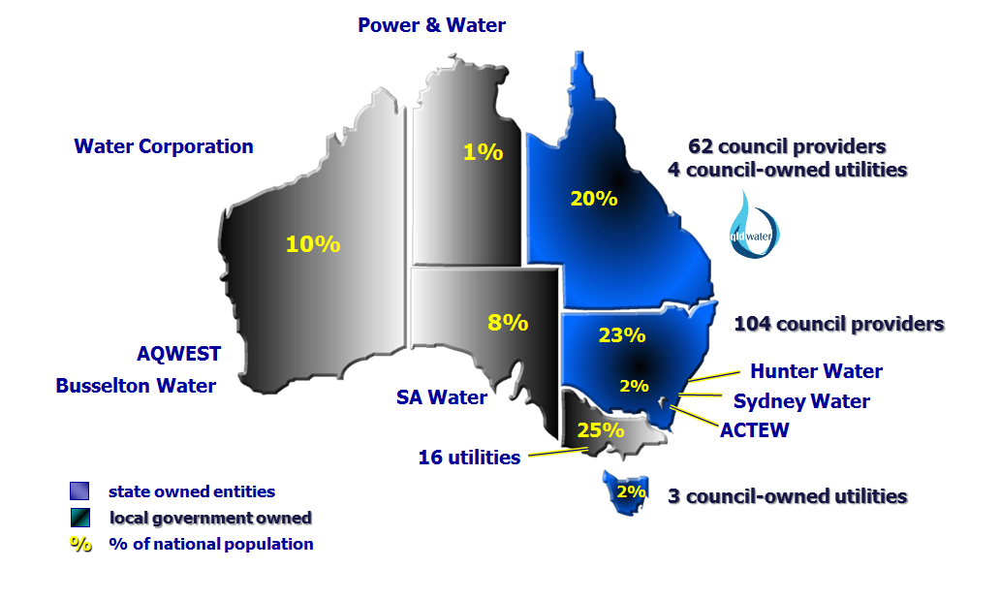

Figure : Ownership and number of water service providers across Australian jurisdictions.

## Review of Institutional Models for Urban Water Services

One purpose of this report is to provide a summary of the various models for governance and management of the water sector in Australian jurisdictions and other selected countries. Details of this scan are provided in Appendix 3 and include an overview of the urban water sector in:

* Australian Jurisdictions
  + Australian Capital Territory
  + New South Wales (Metro)
  + New South Wales (Regional)
  + Northern Territory
  + South Australia
  + Tasmania
  + Victoria
  + Western Australia
  + Queensland (South East)
* Other Countries
  + New Zealand (Auckland & Wellington)
  + Canada
  + United Kingdom (England and Wales, Scotland)
  + Ireland
  + USA

Some of the fundamental parameters of the institutional models identified in the high-level scan are summarised in Table 6. The difficulty is specifying the ideal model results from the range of potential structures, their fitness for diverse local circumstances, variable performance by entities within each type of framework and the resulting difficult of comparing across models because of these factors. Indeed it is likely that there is no ‘best’ or ‘worst’ model and performance is often determined by the key factors of incentives, regulatory frameworks, political support and most importantly, the people involved in the industry. It is likely that these key factors along with the resources (both natural and financial) available to any particular utility are the main determinants of performance.

Table : Summary of some properties of major institutional models for water service providers*.

|  |  |  |  |  |  |  |
| --- | --- | --- | --- | --- | --- | --- |
|  | **Model** | **Ownership** | **Legal Structure** | **Staff** | **Governance** | **Examples** |
| 1 | Council owned and operated. | Single Council | Councils under LG Act. | Council staff. | LG Councillors. | Most Queensland and NSW regional councils. Most Canadian and NZ water services. |
| 2 | Council owned and operated with arms-length commercialisation of the water business. | Single Council | Councils under LG Act. | Council staff. | LG Councillors. | Larger Qld and NSW councils have differing degrees of separation. |
| 3 | Individual council-owned corporation | Single Council | Corporation. | Staff employed by corporation. | Board which is responsible to owner councillors. | Wide Bay Water. |
| 4 | Regional Alliance | Two or more councils | Individual councils under LG Act. | Employed across two or more councils. | LG Councillors. | Macquarie regional alliance. |
| 5 | Mandatory (binding) regional Alliance | Two or more councils | Councils under LG Act with additional contract, MoU, or legislative agreement. | Employed across two or more councils with some pooled resources. | LG Councillors. | No Water examples but Davis *et al.* (2008) name the ‘Weight of Loads Groups’ (NSW) as an example of a LG mandatory alliance. |
| 6 | County Council (with service provision only) | Two or more councils | Model under NSW LG Act. | Employed by county council. | Board of participating LG Councillors. | There are 4 water supply and one water and sewerage county councils in NSW. |
| 7 | County Council (including asset ownership) | Two or more councils via a county council. | Model under NSW LG Act. | Employed by county council. | Board of participating LG Councillors. | Midcoast Water (NSW). Regional Council model in NZ is similar (e.g. Wellington) |
| 8 | Joint Council-Owned Regional Corporation or Statutory Authority. | Two or more councils | Incorporation under the Cwth Corporations Act or State legislation. | Staff employed by corporation/ authority. | Board which may have appointments by State or local Government. | SEQ distribution and retail entities. Tasmanian water businesses. Gosford Wyong water utility. |
| 9 | State-owned Regional Water Authority. | State Government | Statutory Authority or Corporation | Employed by the water utility. | State-appointed Board often reporting to responsible Minister(s). | SEQ Water, Gladstone Area Water Board, Victorian Water Utilities, Sydney Water. |
| 10 | Single State-wide agency | State Government | Statutory Authority or Corporation | Employed by the water utility. | Independent Board often reporting to responsible Minister(s). | WA Water Corporation, SA Water, NT Power and Water. |
| 11 | Government owned with majority of functions outsourced to private contractors.* | Owner organisation. | As above but with contractual arrangements with private industry. | Mix of staff employed by owner and contractors. | Governance of owner-organisation plus contractual arrangements. | Linkwater (SEQ), SA Water for Adelaide, Water Corp WA for Perth. |
| 12 | Privatised water utilities.* | Varies – often a private entity owns the assets. | Varied – often contractual arrangements or charter with government. | Private industry staff. | Governance of private entity – usually a corporations law company. | European countries, UK. Australian electricity sector. ActewAGL is publically owned but has substantial private partnership. |

* a degree of outsourcing to private industry is common to all of the listed models including all sizes of council water service providers (see Section 1.7.1).

While there is no way of analysing the different possible models to determine which would be best for the entire regional water industry, it is possible to analyse the application of relevant models at individual regional levels. Indeed, this is a primary aim of Q-WRAP. To assist in this process, this report seeks to indicate broadly which models may be most relevant to regional Queensland.

An immense amount of public resources have been invested in reviewing appropriate models for the Australian urban water industry in the past few years. There were three concurrent, well-resourced public reviews by national bodies in 2010/11 (AECOM 2010, NWC 2011a, PC 2011a). These national reports followed a comprehensive state-wide review in NSW (Armstrong and Gellatly, 2009) as well as significant institutional change in SEQ and Tasmania with their accompanying studies and reports. The outcomes and recommended models from each of these reviews are tabulated below along with the models considered by the Queensland Taskforce on regional urban water reform (LGAQ and ***qldwater*** 2008).

Table : Favoured Institutional Models for Council Water Service Providers in Recent Reviews.

|  |  |  |  |  |  |  |
| --- | --- | --- | --- | --- | --- | --- |
|  | **Model** | **Productivity Commission (PC 2011a)** | **National Water Commission (NWC 2011a)** | **Infrastructure Australia (AECOM 2010)** | **NSW Review (Armstrong & Gellatly 2008)** | **Qld Taskforce (LGAQ &** *qldwater* **2008)** |
| 1 | Council owned and operated. | Existing structures to be retained if they are assessed to be the most efficient. | Council service providers considered inappropriate. No alternatives offered. | Council service providers considered inappropriate. | Some large council businesses or county councils to be retained. | 3 broad models were assessed but not ranked. State regional entities were associated with the most disadvantages. |
| 2 | Council owned and operated with arms-length commercialisation of the water business. |
| 3 | Individual council-owned corporation |  |  |  |
| 4 | Regional Alliance |  |  |  |  |  |
| 5 | Mandatory (binding) regional Alliance |  |  | As interim stage in transition to corporations. |  |  |
| 6 | County Council (with service provision only) |  |  |  |  |  |
| 7 | County Council (including asset ownership) |  |  |  | As above for councils. |  |
| 8 | Joint Council-Owned Regional Corporation or Statutory Authority. | No differentiation between state or council ownership. |  |  | Corporation preferred. |  |
| 9 | State-owned Regional Water Authority. |  |  |  |  |
| 10 | Single State-wide agency |  |  | only outside SEQ, described as marginal |  |  |
| 11 | Government owned with majority of functions outsourced to private contractors. |  |  |  |  |  |
| 12 | Privatised water utilities. |  |  |  |  |  |

|  |  |  |  |  |  |  |  |  |  |
| --- | --- | --- | --- | --- | --- | --- | --- | --- | --- |
|  | preferred option(s) |  | secondary option(s) |  | acceptable option(s) |  | unacceptable option(s) |  | not discussed |

Table 7 shows that there is disagreement among the many reviews of the urban water industry but there is convergence on the potentially workable institutional models. In general the favoured models for the regional industry can be divided into three categories:

1. status quo (i.e. single council service providers),[5]
2. aggregation of small service providers into larger regional groupings,[6] or
3. a combination of the above where large or highly-efficient council service providers are retained while others are regionally aggregated.

## Formal Mechanisms for Collaboration

Within Australia, the county council model favoured by some reviewers is peculiar to NSW in the provision of water services. It is defined by the Productivity Commission (PC 2011a, p. 380) as follows:

County councils operate independently of local councils, with boards of management appointed by constituent councils. County councils own all relevant assets, and are responsible for service delivery, operation and maintenance of assets, and investment. There are four water supply county councils and one water supply and wastewater county council in New South Wales. County councils are established by proclamation under the Local Government Act 1993 (NSW), and any change to the constitution of a county council must be approved by the minister.

In Queensland, the Local Government Act 2009 Act provides councils with the power to formally cooperate with 1 or more other Local, State or Commonwealth Governments to conduct a “joint government activity”. This includes providing a service, or operating a facility, that involves those other governments. The cooperation may take any form, including entering into an agreement or creating a joint Local Government entity, or joint government entity, to oversee the joint government activity. The joint activity may be set up for more than one purpose and the following example is provided:

Three local governments may create a joint local government entity to manage an aerodrome that services each of their local government areas, and may also enter into an agreement to sell water in bulk to 1 of the local governments.

In previous incarnations of the Local Government Act, there was the ability to form Joint Local Governments which would have similar powers and responsibilities as local governments. Only two are recognised under the current Act, namely the Esk-Gatton-Laidley Water Board and the Nogoa River Flood Plain Board (s. 273). Other joint local government water boards (e.g. NQ Water and Aquagen) were removed during the 2008 local government amalgamation process and their functions assumed by new regional councils (see LGRC, 2007a&b). For example, the previous Townsville-Thuringowa Water Supply Joint Board (NQ Water) was dissolved (s 89B of the Local Government Regulation 2005) and during the amalgamations the separate legal entity was “abolished and its functions assumed by the amalgamated local government”, namely Townsville Regional Council LGRC 2007b, p. 338).

The Local Government Reform Commission raised a number of arguments against the establishment of multi-purpose joint local government (MPJLGs) though they were commended by the LGAQ and other stakeholders. Their concerns were that in contrast to council amalgamations, MPJLGs:

* essentially create an additional tier of local government administration,
* duplicate costs of compliance auditing and reporting requirements,
* likely would not be fully supported by local councillors “for fear they would be removed from the ability to directly influence decisions for which their constituents hold them accountable” (LGRC, 2007a, p. 46),
* might raise disputes with their regional councils requiring a separate dispute resolution process,
* remove accountability for proper management, and particularly debt, from the community that consumes the services.

Indeed the LGRC (2007, p. 45) supported the findings of an earlier review by the Electoral and Administrative Review Commission in the early 1990s, particularly concerns that (1) conflict could arise between parties to joint arrangements and (2) “any system that removed accountability away from local government to an unelected board or committee.” This review was supporting council amalgamations and not the special case of joint organisations for specifically managing water services but the findings reflect some of the barriers to the formation of joint local government services in Queensland. Although many of these concerns could be overcome with carefully drafted legislation and appropriate service charters and agreements among participating councils, it is clear that it would be a complex process to create county councils in Queensland.

The ideal structure is the one that meets the communities’ sustainable financial and performance expectations within the framework of the prevailing culture and preferences. Central to this context is the independence of water utilities from political intervention and regulators in day-to-day decision making and to have clear responsibilities and accountabilities for management and governance in order to meet the prescribed objectives and policies of the elected representatives. Council ownership and a role for nominated members are likely to be essential to maintain public confidence and trust particularly in the face of likely increasing rates.

The LGRC (2007a, p. 47) also commented on the use of shared services models and did “not discount shared services as a valid method of performing certain functions cost effectively.” However, the Commission did raise a concern about the impacts of shared services models on local employment:

Councils outsource the delivery of certain services (to the LGAQ and other providers) on the basis they can be performed at a lower cost. This is a function of scale resulting from the aggregation of work from a number of councils which enables the provider to achieve efficiencies. …… The efficiencies provided by the shared services provider come about because dispersed functions are centralised to a single or limited number of locations. Loss of jobs in remote areas is the inevitable result.

The Reform Commission was more supportive of alliances (including integrated services) with respect to employment. These models were advocated to the Commission by the LGAQ as “a mechanism that delivers cost efficiencies to councils in the provision of infrastructure and utility services, thus assisting their financial sustainability” LGRC (2007a, p.48. The report goes on to suggest that complexity of alliances may vary but:

A simple alliance model is essentially a contracting methodology that enables:

* a more formalised and coordinated approach to the planning and programming of significant infrastructure for roads, water and a range of other services;
* a more efficient use of resources in the delivery of that infrastructure; and
* longer term commitments to be entered into for contracting work. This improves the prospects of sustaining jobs and retention of skills (which is a particular issue for rural and remote communities).

It is apparent that shared services and alliance models have a heritage in Queensland and widespread support. While not necessarily simple to gain an agreement that can be formalised through contractual arrangements, alliances have the advantage of not requiring new legislation.

## Conclusions

The models for future institutional arrangements for the regional water industry favoured in numerous recent reviews in Australia can be reduced to a handful of broad options. These are summarised here as:

1. individual local government water service providers,
2. alliances among regional groups of councils (varying degrees of formality),
3. regional, joint council-owned corporations,
4. regional, state-owned corporations, or
5. some combination of the above options.

Each of the first four options would have strengths and weaknesses but these would be location specific. It is possible that the more flexible approach represented by option “e” could allow the choice of the best model for each area but this approach has the potential disadvantage of creating a complex urban water sector with concomitant difficulties for regulatory frameworks, compliance and reporting.

# Assessment of Alternative Models.

## Assessment Criteria

In order to compare the broad costs and benefits of the available models a set of objective assessment criteria were developed. No specific criteria have previously been developed for guiding the future structure of the Queensland regional water industry, but a number of reviews have developed clear objectives, principles and criteria that should inform or guide any structural change in the Queensland urban water sector.

These include the national review by the Productivity Commission (2010), the Objectives for the Australian water industry developed by the National Water Commission in 2011, the NSW review of regional water service providers (2008, the Queensland Local Government Reform Commission (2007) and the Principles developed by the Local Government Taskforce on the Future of the Urban Water Industry (2008 – see Appendix 4). The relevant factors listed in each of these reviews are summarised in Table 8.

The common elements from these reviews are proposed as eight criteria for assessing regional reform options in Queensland, as follows:

**1. Improved Service and Customer-focus**

* meet the long-term interests of communities in the price, quality, safety, reliability and security of supply of fit-for-purpose water and sewerage services with transparent efficiency and accountability.
* needs of individual communities remain a vital driver of management, policy and planning.

**2. Public Health and Environmental accountability;**

* operations and investments are managed cost-effectively in accordance with society’s expectations and clearly defined obligations.
* the organisation contributes to more liveable, sustainable and economically prosperous communities in circumstances where broader social, public health and environmental benefits and costs are clearly defined and assessed.

**3. Ongoing Council & Community Sustainability**

* council revenue streams & capital expenditure protected or enhanced.
* maintain or enhance regional job opportunities and ongoing access to specialised skills within regional communities.

Table : Summary of objectives, principles and criteria guiding urban water reform from five recent reviews.

|  |  |  |  |  |
| --- | --- | --- | --- | --- |
| **NSW 20081** | **PC Inquiry 20112** | **Qld 20073** | **Qld 20084** | **NWC 2011a5** |
| Any new model must: | appropriate aggregation of regional water utilities to give rise to productive efficiencies. | structural changes to ensure strong, effective and financially viable councils capable of: | Institutional change should provide for | A successful Australian water sector will |
| * protect or enhance councils’ revenue stream; * protect or enhance councils’ capital expenditure; * maintain or enhance job opportunities; * provide ongoing access to specialised skills; * adopt an independent an sustainable pricing mechanism; * must have best-practice governance, that is, the structure must be appropriate to meet the organisation’s objectives. * water and sewerage services must meet tests of viability, expertise, efficiency, and effectiveness * assess economies of scope, planning integration, employment and impact on regional communities. | * realisation of economies of scale efficiencies; * reduce impact of skills shortages; * efficient investment in and operation of infrastructure; * increase compliance with public health and environmental regulations; * improve standards of services delivered to customers; * provide scope for yardstick competition; * support more effective water system planning; * reduce transaction costs. * consider network costs, geography and distance factors; * coordination of water provision with planning and resource management; * account for costs on legacy local governments and their communities. | * facilitating optimum service delivery to Queensland communities; * effectively contributing to and participating in Queensland’s regional economies; * better managing economic, environmental and social planning consistent with regional communities of interest; * effectively partnering with other levels of government to ensure sustainable and viable communities. | * Efficient and effective service delivery and resource use; * Equitable and transparent water sharing across and between regions; * Needs of individual communities as vital driver of management, policy and planning; * management to deliver returns that allow for appropriate asset renewal with a dividend on assets returned to the community through Local Government (with no cross-subsidisation of other council services); * No community to be substantially disadvantaged (reasonable price for basic access); * Water planning framework to be consistent across the state; * Water planning and management needs to be directly linked with statutory and land use planning activities of local government; * Long-term sustainable asset management (taking into account, for example, Water Sensitive Urban Design, System Supply Losses, Integrated Water Cycle Management and maximising the benefits of vertical integration); * Local Government to retain ownership; * Creation of autonomously governed and managed sustainable water businesses to ensure among other things: * Accountability; * Management and technical capacity to appropriately respond to changing economic and technical regulatory frameworks (including reporting obligations); * Capacity to provide for ongoing training, skills enhancement and development needs of staff; and * Skills/experience based, independently appointed board/governance with minority representation by local councillors. | * provide secure, safe and reliable water-related services to urban communities in an economically efficient and sustainable manner; * understand and meet the long-term interests of all water consumers in the price, quality, safety, reliability and security of supply of fit-for-purpose water and sewerage services through the efficient use of, and investment in, systems, assets and resources. * protect public health and the environment by ensuring that the impacts of the sector’s operations and investments are managed cost-effectively in accordance with society’s expectations and clearly defined obligations. * enhance its effective contribution to more liveable, sustainable and economically prosperous cities in circumstances where broader social, public health and environmental benefits and costs are clearly defined and assessed, or where customers or other parties are willing or explicitly obliged to pay for the outcomes. * will meet these objectives and future challenges in a resilient, flexible, efficient, transparent, accountable and customer-focused manner. |

1. Criteria used by the 2008 Independent Inquiry into secure and sustainable urban and water supply and sewerage services for non-metropolitan NSW (Armstrong & Gellatly 2008, pp. 9 and 49).
2. Productivity Commission Inquiry into examining the case for microeconomic reform in Australia’s urban water sector accepted most recommendations of the 2008 NSW review but rejected the need for independent price setting. The criteria are developed from the discussion of potential benefits and assessment factors for institutional change in regional Queensland and NSW (PC 2011a, p. 408).
3. Objectives of the Local Government Reform Commission examination of local government area boundaries, classes, names and electoral arrangements (Queensland Government, 2008).
4. In 2008 the Taskforce considering the Future of the Water Industry Outside South East Queensland determined 10 principles that should guide any institutional reform in regional Queensland (Appendix 4).
5. The 2011 NWC report *Urban Water in Australia: Future Directions* list the common objectives recommended for the urban water sector.

**4. Best Practice Governance**

* must be accountable and transparent and appropriate to meet the organisation’s objectives.
* Skills/experience-based governance arrangements with appropriate independent water focus.

**5. Optimised Management and Planning**

* efficient operation and maintenance of infrastructure and more effective water system and strategic planning.
* resilience and capacity to appropriately respond to changing economic, technical, climatic and regulatory drivers (including reporting obligations and benchmarking).

**6. Sustainable Staff and Asset Management and Planning**

* staff recognised as the most critical assets needing appropriate planning, management and investment.
* efficient deployment of, and investment in, resilient systems, assets (including people) and other resources.
* cost-recovery that allows for asset renewal with any dividends returned transparently to the community.

**7. Improved Articulation with Regional Planning**

* better management of economic, environmental and social planning consistent with regional communities of interest.
* coordination of water provision with regional planning and water resource management.

**8. Reduction of Transaction Costs**

* effective partnering with all levels of government.
* horizontal aggregation/collaboration cognisant of geography and distance impacts on network costs.
* Water planning and management linked with statutory and land use planning activities of local government.

## Assessment Process

A two-stage process was used to assess each of the broad models considered in Section 2 against these criteria. The first stage involved a SWOT analysis of each of the models considering each criterion in turn. This analysis was undertaken considering the issues raised in recent reviews (including those from which the criteria were developed, and industry feedback. They have not been tested with the industry and this essential consultation should be undertaken to determine any gaps in the analysis.

The second stage follows the methodology of Armstrong and Gellatly (2008, p.59) to summarise the outcomes of the analysis. This ranking procedure is summarised in Table 9 which compares each of the models against the eight criteria using the following ranks:

* “1” is assigned to a criteria that are extremely likely to be satisfied by the implementation of the organisational model,
* “2” is assigned to criteria when the organisational model may have adverse impacts in some situations that can be addressed through some form of mitigating strategy (note that for status quo options, this rating implies that change is required),
* “3” is assigned to a criterion when there is a fundamental flaw with the model that prevents it from meeting the criterion.

Table : Summary of ranking of assessment criteria against governance models

|  |  |  |  |  |  |  |
| --- | --- | --- | --- | --- | --- | --- |
| **ASSESSMENT CRITERIA USED IN SWOT ANALYSIS OF EACH OPTION.** | **Option A** | | **Option B** | | **Option C** | **Option D** |
| **STATUS QUO**  **(small Councils)** | **STATUS QUO**  **(large Councils)** | **REGIONAL ALLIANCE (collaboration)** | **REGIONAL ALLIANCE (separate entity)** | **COUNCIL- OWNED REGIONAL WATER CORP** | **STATE- OWNED REGIONAL WATER CORP** |
| Improved service & customer focus | 2 | 1 | 1 | 2 | 2 | 2 |
| Public health & environmental accountability | 2 | 1 | 2 | 2 | 2 | 2 |
| Council & community sustainability | 3 | 2 | 2 | 2 | 2 | 3 |
| Best practice governance | 2 | 2 | 3 | 2 | 1 | 2 |
| Optimised management & planning | 2 | 2 | 2 | 2 | 1 | 1 |
| Sustainable staff, asset planning & management | 3 | 1 | 2 | 2 | 1 | 1 |
| Improved regional planning | 3 | 2 | 2 | 1 | 1 | 2 |
| Reduction of transaction costs | 2 | 2 | 3 | 2 | 1 | 1 |

This analysis suggests that the small council model is not sustainable reflecting the problems identified with many (but not all) small regional councils identified in Section 1. The surprising low rank for community sustainability for this model reflects the lack of investment in water infrastructure. Current communities are often supported by council-managed service providers but this arrangement is clearly not sustainable in the long term.

Large councils score more highly, but this is predicated on the high performance/potential of some councils and transparent separation of water services as a separate and commercialised business units. This is seldom achieved at present and would require significant change in most large council water businesses.

Regional collaboration provides opportunities to improve many areas of performance, but increases transaction costs including complexity of governance arrangements.

The three regional utility models score similarly and rank highly on most criteria. Lower scores for customer focus to reflect the need to manage the risk of centralisation of management away from the communities being serviced. These models also rank lower on council and community sustainability, particularly the State –owned model which would not return dividends to local governments. The regional alliance model scores lower than the other two regional organisations on criteria touching on governance arrangements, transaction costs and integrated planning.

## Conclusions

This report provides an overview of the various structural models used for the delivery of water services and a description of the drivers for institutional change. The different models are reviewed and a transparent assessment process is presented.

The key drivers for change listed in the various reports are to:

* meet community demands for sustainable and improved water service delivery,
* maintain or enhance revenue streams,
* facilitate improved asset management and affordable capital expenditure,
* recruit experienced staff and develop organisational and technical capacity,
* identify opportunities for efficiency gains,
* clarify objectives and decisions best taken by elected Councillors (those regarding governance and public interest) and management’s business and operating decisions.

In regional Queensland, water and sewage services are provided by local governments with the larger Councils having commercialised water businesses. However, for many small and medium sized water service providers, distance and a smaller rate base remain major issues and there is little support for further institutional change.

Even after the Local Government amalgamations of 2008, and SEQ institutional reform there are still 68 Service Providers with approximately 50 small regional councils each servicing fewer than 10,000 people. However, the geographical separation of the 50 or so inland regional Councils, their small population and low growth projections limit the opportunities for efficiencies based on increasing customer density, economies of production and economies at business or plant level.

Economies of scale through amalgamation have potential benefits of eliminating duplicated overheads, a greater ability to attract and retain experienced staff and the possibility of smoothing ‘lumpy’ capital investments. However, there are also strong counter-arguments for integration and centralisation. For example, overheads are not eliminated but rather duplicated in the development of a separate regional water business; economies of scope will be lost from existing structures through separation of water and sewerage services from other council activities and functions such as town planning, stormwater, waste management and road engineering.

The financial performance and sustainability of water businesses in regional areas is often called into question. The main issues are: stability of council revenue streams, existing and future asset management and transparent pricing mechanisms. The reviews from other jurisdictions generally advocate separation of the water business from other council functions and transparent declaration of cross subsidies. This has also been an increasing trend overseas.

A key determinant of ongoing financial sustainability of regional water service providers is the ability to invest in new and replacement assets. The Productivity Commission noted:

*“it would appear that inefficient asset management is particularly prevalent in some regional areas, due to a shortage of staff with appropriate skills and experience and/or lack of financial resources to undertake asset upgrades.”*

It is difficult to determine the degree to which this applies in regional Queensland. However several factors make it highly likely that the financial sustainability of many small communities is currently severely stressed:

* ageing infrastructure approaching the end of its useful life,
* higher government standards – particularly for wastewater treatment,
* low council rate bases,
* removal of state government subsidies, and
* limited asset management capability.

All water service providers in Australia are owned by either state or local governments. It is impossible to specify the best business model due to the range of options, relevance to different local circumstances and variable performance by entities. Indeed it is likely that there is no ‘best’ or ‘worst’ model and performance is often determined by choice and a number of factors and trade-offs. Assessment criteria have been used in the report in an attempt to determine which would be best the best model for the regional water industry. This needs to be assessed on a case-by-case basis.

There are strengths and weaknesses in all of the feasible institutional models but these are location specific. Some models have strengths that can be achieved only through careful management of potential risks. For example, in the assessment process, large councils rate well against the criteria, but this is predicated on the high performance and transparent separation of water services to independent, arms-length commercialised units. These criteria are not always achieved at present and would require significant change in many large council water authorities.

The Productivity Commission recommends an assessment of the benefit of regional Councils restructuring their water businesses as regional water corporations compared with retaining existing structures but including aspects of service provision that can be centralised through regional alliances:

It is the Commission’s view that none of these options should be prescribed. Rather, State and Territory Governments should support local communities to identify the option that best suits them.

The ideal structure is the one that meets the communities’ sustainable financial and performance expectations within the framework of the prevailing culture and preferences. Council ownership and a role for elected members would be essential to maintain public confidence and trust.

It is evident that there is no single best institutional model because of the different local factors, particularly the prevailing culture, network size, distance and predicted population growth. The aim of the broader Q-WRAP program is to facilitate review of potential models on a regional scale to allow for greater focus on local issues. Importantly, this process will result in greater involvement by the people who actually own, manage and assume responsibility for water and sewerage services across the state.

The literature in corporate governance indicates managerial performance within different models is intrinsically impacted by ownership arrangements because of their influence on patterns of authority, responsibility and economic incentives for those who actually control a business. Strong governance and management structures are possible under any of the models, but rely on individual champions. Sustainable performance requires institutional structures and processes that support and develop such champions.

# References

ABS (Australian Bureau of Statistics) 2006 *4610.0 Water Account Australia, 2004-2005* Web Publication accessed 20 December 2011 (<http://www.abs.gov.au/AUSSTATS/abs@.nsf/Lookup/4610.0Main+Features12004-05>).

ABS (Australian Bureau of Statistics) 2010 *4610.0 Water Account Australia, 2008-2009* Web Publication accessed 20 December 2011 (<http://www.abs.gov.au/AUSSTATS/abs@.nsf/DetailsPage/4610.02008-09?OpenDocument#Data>).

ABS (Australian Bureau of Statistics) 2011 *4610.0 Water Account Australia, 2009-2010* Web Publication accessed 20 December 2011 (<http://www.abs.gov.au/ausstats/abs@.nsf/Latestproducts/CAE301277A675941CA257956000E646E?opendocument>).

AECOM 2010, *Review of Regional Water Quality and Security.* Report prepared for Infrastructure Australia.

Amato, A. and Conti, M. 2005, *The Economics of the Water Industry: Technology, ownership and Efficiency*. Franco Angeli, Italy.

Armstrong, I. and Gellatly, C. 2008, *Report of the Independent Inquiry into Secure and Sustainable Urban Water Supply and Sewerage Services for   
Non-Metropolitan NSW*, Sydney.

Brown, R., Farrelly, M. and Keith, N. 2007 *Summary Report: Perceptions of institutional drivers and barriers to sustainable urban water management in Australia*. Report No. 07/06, National Urban Water Governance Program, Monash University.

Coe, A. and Harris, P. 2011 *Reform – What we have learnt. Insights from water reform in South East Queensland and Tasmania.* Web Article accessed January 2011 ( <http://www.marchmenthill.com/qsi-online/2011-06-22/reform-what-have-we-learnt-insights-from-water-reform-in-south-east-queensland-and-tasmania>).

Commonwealth of Australia 2002 *Towards A Truly National and Efficient Energy Market.* Commonwealth of Australia, Canberra.

Cousins, D. 2010 *Review of Water Prices. Final Report Prepared for the Council of Mayors (SEQ)*. Monash University centre for Regulatory Studies.

Cox, R. 2010 *Water Reform in Queensland*. Web Report accessed 18 December 2011 (<http://www.irrigation.org.au/assets/pages/75D4C8BD-1708-51EB-A6816CD6992AC045/39%20-%20Cox%20-%20Paper.pdf>)

Davis, B. 2010 *A brief history of drinking water supply in Queensland. The relationship between State and Local Government*. Department of Environment and Resource Management. Unpublished, Brisbane.

Davis, C., Paddon, M., and Chong, J. 2008 O*ptions paper on the Inquiry into secure and sustainable urban water supply and sewerage services for non-metropolitan NSW Prepared for the Local Government and Shires Associations New South Wales & NSW Water Directorate By the Institute for Sustainable Futures University of Technology, Sydney*. Local Government and Shires Associations of NSW and NSW Water Directorate.

DECLG (Department of Environment, Community and Local Government) 2012 Position Paper: Reform of the Water Sector in Ireland. Dublin.

Department of Water and Energy 2008 *Inquiry into secure and sustainable urban water supply and sewerage services for non-metropolitan NSW. Discussion paper*. Department of Water and Energy, NSW Government, Sydney.

Forest, P. and Forest, S. 2006 *Engineering the outback. A history of the western Queensland consulting engineers, George Bourne and Associates.* George Bourne and Associates, Barcaldine.

Hrudey, S.E. and Hrudey, E.J. 2004 Safe Drinking Water. Lessons from Recent Outbreaks in Affluent Nations. IWA Publishing, London.

ICEWaRM (International Centre of Excellence in Water Resources Management) 2008 *National Water Skills Audit.*  Commonwealth of Australia, Canberra.

LGAQ and *qldwater* 2008 *Future of the urban water industry outside SEQ . Report on LGAQ/qldwater Workshop, Mackay – 20 August 2008*. Queensland Water Directorate, Brisbane.

LGRC (Local Government Reform Commission) 2007a Report of the Local Government Reform Commission. Volume 1. State of Queensland July 2007.

LGRC (Local Government Reform Commission) 2007b Report of the Local Government Reform Commission. Volume 2. State of Queensland July 2007.

LGSA (Local Government and Shires Association of NSW) 2008 Local Government Association of NSW and Shires Association of NSW Submission to NSW Inquiry into secure and sustainable urban water supply and sewerage services for non-metropolitan NSW. LGSA, Sydney.

McKay, J. 2005 Water institutional reforms in Australia. *Water Policy* **7**: 35-52.

Ministerial Council on Energy 2003 Report to the Council of Australian Governments on Reform of Energy Markets. Commonwealth of Australia, Canberra.

NOW (New South Wales Office of Water) 2011 *2009-10 NSW Water supply and sewerage Performance monitoring report.* Department of Trade, Industry, Regional Infrastructure and Services. Sydney.

NWC (National Water Commission) 2009, *Australian water reform 2009: Second biennial assessment of progress in implementation of the National Water Initiative.* NWC, Canberra.

NWC (National Water Commission) 2011a *Urban Water in Australia: Future Directions.*  NWC, Canberra.

NWC (National Water Commission) 2011b, *The National Water Initiative—securing Australia’s water future: 2011 assessment.* NWC, Canberra.

NWC and WSAA (National Water Commission and Water Services Association of Australia) 2011, *National Performance Report 2009–10: Urban Water Utilities*, NWC, Canberra.

NWC and WSAA (National Water Commission and Water Services Association of Australia) 2012, *National Performance Report 2010-11: Urban Water Utilities*, NWC, Canberra.

OESR (Office of Economic and Statistical Research) 2011 *Queensland Government population projections to 2031. Local Government areas.* 2011 Edition, Version 1.4. Queensland Treasury, Brisbane.

OTTER (Office of the Tasmanian Economic Regulator) 2011 *Tasmanian Water and Sewerage State of the Industry Report 2009‑10*. Tasmanian Government, Hobart.

PC (Productivity Commission) 2011a, *Australia’s Urban Water Sector*, Report No. 55, Final

Inquiry Report, Volume 1, Canberra.

PC (Productivity Commission) 2011b, *Australia’s Urban Water Sector*, Report No. 55, Final

Inquiry Report, Volume 2, Canberra.

Powell, J. 1991 *Plains of Promise,* *Rivers of Destiny: Water Management and the Development of Queensland 1824-1990*. Boolarong Publications, Brisbane.

Pullar, I. and Cook, M. 2001 *Watery Sauces: A people’s history of the water resources commission (Queensland) and its predecessors 1881-1995.* Department of Natural Resources and Mines, Brisbane.

PWC (PricewaterhouseCoopers)  2010 *Review of urban water security strategies*, Report prepared for Infrastructure Australia. Infrastructure Australia, Canberra.

PWC (PricewaterhouseCoopers)  2011 Review of urban water quality regulation in Australia, *Waterlines Report Series no. 47*, National Water Commission, Canberra.

Queensland Government 2009 ClimateQ: Toward a greener Queensland. Queensland Government, Brisbane.

Regulation Taskforce 2006, *Rethinking regulation: Report of the taskforce on reducing regulatory burdens on business*, Report to the Prime Minister and Treasurer, Canberra.

SEACI (South Eastern Australia Climate Initiative) 2011. The millennium drought and 2010/11 Floods. *Factsheet 2*. CSIRO, Canberra.

Tae, H., Adler, N. and Yu, C. 2005 Privatisation, corporatisation, ownership forms and their effects on the performance of the world’s major airports.

USEPA (United States Environmental Protection Agency) 2009 Water on tap. What you need to know. USEPA, Washington.

USEPA 2010 Factoids: Drinking Water and Ground Water Statistics for 2009. USEPA. Washington.

Vine, E., Hamrin, J., Eyre, N., Crossley, D., Maloney, M., and Watt, G. 2003 Public policy analysis of energy efﬁciency and load management in changing electricity businesses. *Energy Policy* **31**: 405-430.

Whitmore, Raymond L. 1997. *Queensland’s Early Waterworks*. Department of Natural Resources, Brisbane.

WSAA 2010, Implications of population growth in Australia on urban water resources. *Occasional paper no. 25*, WSAA, Canberra.

# Appendix 1 - Drivers of Change Raised in Local Government Workshop (2008) on the Future of the Water Industry in Queensland Outside SEQ.

The local government taskforce examining the ‘Future of the Water Industry Outside SEQ’ met for the first time in Mackay in August 2008 (LGAQ and ***qldwater***, 2008). The following drivers for change in regional Queensland were summarised by the group prior to agreeing on common principles (see Appendix 4). The key drivers are summarised below:

**Summary of the drivers common across the whole industry**

* Customer service and base-level standards of supply.
* Security of supply (short and long term – includes financial sustainability).
* Pricing (efficient, equitable and not over-inflated).
* Water quality and health standards.
* Environmental sustainability.
* Local input and ‘’ownership’’.
* Political imperatives.
* Communication break-down and misunderstandings.

**Customer Drivers - Top 5**

* Pricing (lowest)/ greatest value for money.
* Security of supply (certainty).
* Accountability.
* Perception of ownership.
* Quality

**Other Customer Drivers**

* Customer service and customer service standards.
* Increasing expectations (environmental responsibility, quantity, quality,
* lower price, service, efficiency, perception of sustainability e.g. greywater and effluent reuse).
* Customer choice in service (3rd party access, tariffs).
* Trust in service (need to prove we know what we are doing).
* Related social issues (e.g. climate change and sustainability, potable substitution).
* Community apathy and lack of knowledge of water management.
* Fluoride forced on community.

**Local Drivers - Top 5**

* Security of supply.
* Affordability and capacity to pay.
* Impact of State Planning Initiatives (misalignment between local and regional plans).
* What are the “best practice” principles for water supply management (and what are the State’s expectations and timeframes).
* Community education on water issues varies from council to council.

**Other Local Drivers**

* Potential loss of water income to local government.
* One size won’t fit all.
* Ability of local government to fund and renew infrastructure.
* Varying views of officers and elected members post amalgamation.
* Redundancy of storage capacity and ability to create storages.
* Differing water strategies.
* Town planning issues and regional plans.
* Loss of control by local government.
* State directives that affect local planning.
* Pace of growth (water and waste water can limit growth).
* Local Governments bogged down in legislative process.
* Environmental Sustainability.
* Financial sustainability.
* Prioritisation of water supply (primary industry vs industry/commerce vs residential).
* Water reuse (e.g. partnering for reuse is difficult for local government).

**State and Federal Drivers - Top 5**

* Pricing Reform and Demand Reduction (consistency, sensible use of water, and oversight for greater regulatory scarcity-based pricing).
* Long-term planning and capacity to deliver asset management and maintenance (including funding asset renewals).
* Water efficiency.
* Regional water supply strategies – ramifications for local government.
* Self-sustaining business.
* Security of supply.

**Other State and Federal Drivers**

* Federal legislation for raising taxes.
* State legislation for savings grants and subsidies.
* Complexity of getting approvals and doing business.
* Business/industry needs for development.
* Structural reform.
* Regional Water Supply Strategies
* Ownership of raw water – cost.
* Water trading.
* Catchment boundaries (across states).
* Water is a saleable commodity for States.
* No state water policy.
* Whole-of-state solutions, ability to control assets/planning.
* National control/solutions.
* Limit local political influence.
* Encourage investment into state debt.
* Privatisation of water providers/supply
* Competition (State objective).
* Short-term political thinking based on election cycle instead of long-term planning.

# Appendix 2 History of the Queensland Urban Water Sector and Water Reform

This timeline was compiled from a range of sources including Powell (1991), Whitmore (1997), Pullar and Cook ( 2001), Forest and Forest (2006), Davis (2010) and NWC (2011a).

|  |  |  |  |  |  |  |  |  |
| --- | --- | --- | --- | --- | --- | --- | --- | --- |
|  | Queensland |  |  | National |  |  | Other Jurisdictions |  |

|  |  |  |  |
| --- | --- | --- | --- |
| **2012** |  | | Confluence of Local Government and State Government elections in early 2012 has significant impact on water industry, policy development and legislation. |
| **2011** |  | | Decision by council-owners of Unity Water and Queensland urban Utilities to remain joint council-owned ventures but Allconnex owner-councils elect to return to three local government run water service providers. |
| **2011** |  | | July – Water Secure is merged into SEQ Water reducing the three new SEQ bulk entities to two within three years of their formation. |
| **2011** |  | | NWC *Future Directions Report* is released suggesting that “structural and institutional reform of local council service provision in New South Wales and Queensland is urgently needed” (NWC 2011, p.4). |
| **2011** |  | | ‘Allwater’ is awarded a 10 year contract to operate and maintain SA metro water services. |
| **2011** |  | | Central Coast Water Corporation is formed to take over services of the Gosford-Wyong councils joint water authority. |
| **2010-11** |  | | Widespread flooding across Queensland followed by cyclone Yasi that crosses the coast between Cairns and Townsville causing widespread destruction. |
| **2010\*** |  | | Queensland has 345 drinking water schemes with 277 water treatment plants (78 service providers of which 66 are local governments). There are 559 water supply schemes of all types but many are not urban. 287 sewerage schemes with 298 sewage treatment plants. |
| **2010** |  | | Creation on 1 July 2010 of three joint council-owned statutory authorities (Unity Water, Queensland urban Utilities, Allconnex Water) to manage distribution and retail services in three sub-regions of SEQ. |
| **2009** |  | | Mandatory quarterly reporting and incident reporting on Drinking Water Quality commences. Drinking Water Quality Management Plans are required for Large, Medium and Small service providers by 2011, 2012 and 2013 respectively. |
| **2009** |  | | Second NWC Biennial Assessment calls for structural (aggregation and shared service models) and regulatory reforms where services are currently provided by local government authorities (NWC 2009). |
| **2008-13** |  | | Mandatory fluoridation of all communities with more than 1000 people. |
| **2008** |  | | Bulk water assets in SEQ transferred on 1 July from 10 (recently amalgamated councils) to three state-owned statutory authorities (SEQWater, LinkWater and Water Secure). Creation of SEQ Grid Manager. |
| **2008** |  | | Report on the Independent Inquiry into Secure and Sustainable Urban Water Supply and Sewerage Services for Non-metropolitan NSW recommends aggregating 106 local government service providers into 32 regional utilities. No actions had been taken in response to this Inquiry by the release of the current report in 2012. |
| **2008** |  | | Local Government Amalgamations in March reduce 125 councils many of which had water and sewerage services to 73 Local Governments each with one or more water supply and sewerage schemes. In SEQ, 17 council water service providers are reduced to ten each with water and sewerage responsibilities and many managing bulk water supplies. |
| **2008** |  | | 28 Local government organisations in Tasmania hand over their water and sewerage assets to four new corporations. |
| **2008** |  | | 2008 COAG enhanced national urban water reform framework to improve the security of supply for urban water. |
| **2004** |  | | Queensland Water Directorate Commences operations. |
| **2004** |  | | 2004 COAG *National Water Initiative* and the establishment of the *National Water Commission* to progress reforms in listed the 1995 agreement |
| **2000-09** |  | | State Regulation of the water and sewerage providers increases dramatically within introduction of the. Water Act 2000 and Water Supply (Safety and Reliability) Act 2008. Numerous statutory plans are introduced including Strategic Asset Management Plans and Customer Service Standards (2000), Drought Management Plans (2005) System leakage management Plans (2005), Outdoor Water Use Conservation Plan (2008), Recycled Water Management Plan (2008), Drinking Water Quality Management Plan (2008), Local Government Asset management Plan (under Local Government Act 2009), Total Water Cycle Management Plan (EPP Water 2009), Sewage Overflow Abatement Plan and integrated Environmental Management System for large sewage pumping stations (EPP Water 2009). |
| **2000** |  | | Planning and implementation of infrastructure is deemed to be no longer core business of the State government which instead focuses on Total Management Planning to determine allocation of subsidies and statutory plans and regulation. |
| **2000** |  | | Formation of ACTWEW AGL partnerships to provide water and power services to the ACT. |
| **1997-2009** |  |  | Widespread Drought (‘Millennium Drought’ - see SEACI 2011). |
|  |  |
| **1997** |  | | Environmental Protection (Water) Policy 1997 introduced under the Environmental Protection Act 1994 requiring first statutory plans of the industry (Water Conservation Plan, Sewage Management Plan, Trade Waste Management Plan). |
| **late 90’s** |  | | In the late 1990’s driven by the National Competition Policies of the Federal Government a number of large Local Governments commercialised their water and sewerage services. Wide Bay Water Corporation (Australia’s first council-owned water corporation) created by the then Hervey Bay City Council in central Queensland. |
| **1996** |  | | United Water is awarded 15 yr contract to service Adelaide. |
| **1995** |  | | SA Water was established as a statutory corporation providing water and sewerage services to Adelaide and regional SA. |
| **1995** |  | | 1995 COAG National Competition Policy and Related Reforms, which included payments to jurisdictions that effectively implemented the strategic framework for water reform in the 1994 agreement |
| **1994** |  | | Introduction of Total Management Plans which are voluntarily undertaken by local governments and submitted to the State. A accepted TMP is required to access State subsidies. |
| **1994** |  | | 1994 COAG strategic framework for water reform of the Australian water industry, developed by the Working Group on Water Resource Policy |
| **1994** |  | | Kennett Government amalgamates non-metropolitan water authorities in Victoria into 15 state-owned authorities (210 councils were amalgamated to 78 at a similar time). |
| **1993** |  | | Over 400 local council owned water authorities in Victoria are decreased to 140 through amalgamations. |
| **1992** |  | | 1992 - Hunter District Water Board becomes the first major urban water authority in Australia to be corporatised. |
| **1992** |  | | 1992 - Industry Commission inquiry into water resources and sewerage disposal |
| **1990\*** |  | | 385 water and 195 sewerage schemes |
| **late 1980s** |  | | Creation of Asset Management Unit based in Cairns to provide operation and maintenance services to remote aboriginal and Torres Strait communities. |
| **1988** |  | | Water Resources Commission finally absorbs the Town and Water branch and regionalises it in alignment with the regional water resources (irrigation) framework. |
| **1980** |  | | Water Resources Commission formed. Town and Water Branch of Lands Department which had provided advice consultancy services to councils for many decades is taken over under protest from LGAQ and Chief State Engineer, John Turnball and 18 months later is returned to Department of Local Government. |
| **1980\*** |  | | 382 water and 188 sewerage schemes. |
| **1977** |  | | Gosford-Wyong Council’s Water Authority established. |
| **1974** |  | | Widespread flooding including inundation of much of the Brisbane flood plain. |
| **1970** |  | | 315 water and 121 sewerage schemes |
| **1960** |  | | 210 water and 53 sewerage schemes statewide. |
| **1945-50** |  | | Increase in development of water and sewerage schemes. Department provides design and constructions services on a consultancy basis and prepares guidelines, codes and specifications. Continuation of loan subsidy scheme. By 1950 there were 123 water and 22 sewerage schemes across the State. |
| **1941-45** |  | | Department of Local Government created and takes responsibility for town water supply, sewerage and drainage works. Supplies created during the second world war are focussed on new or augmented schemes for the armed services. |
| **1940** |  | | Branch undertakes 18 water supply and 14 sewerage schemes (employing 2,232 men). |
| **1936-37** |  | | The Water Supply Branch is involved in 23 water supply and eight sewerage schemes across the state employing 839 men on construction work. |
| **1932** |  | | Lands Administration Board took over responsibility for water resources with Water Supply and Sewerage supplied by Town Water Supply Branch. Establishment of subsidy for capital works with a high labour content. |
| **1929** |  | | First Queensland sewerage scheme. |
| **1922** |  | | Irrigation Act 1922 established the Commissioner of Water Supply and Sewerage. |
| **1916** |  | | Thirty two towns had reticulated water supplies, half of them supplied by artesian bores. |
| **1912** |  | | First drinking water treatment, slow sand filters installed at Enoggera. |
| **1898-1903** |  | | Severe drought across Queensland. |
| **1891** |  | | Charters Towers Water Supply completed |
| **1881** |  | | Water Supply Department of Queensland formed to centralise the portfolio. Responsibility for design, constructions and commissioning of water works was transferred to Local Government with John Henderson as head. The State provided advice, assistance and funding as technical consultants. |
| **1878-1982** |  | | Second Brisbane reservoir completed (next to original on Wickham terrace). Ipswich, Toowoomba, Warwick, Maryborough and Townsville water supply schemes completed. Responsibility and debt for the schemes were to be transferred to local governments but Toowoomba and Warwick refused because of cost overruns. This resulted in the Local Works Loan Act 1880 which forced councils to take responsibility for servicing the loans. Warwick still refused and the State shut down the supply with the dispute finally resolved in 1883. |
| **1879** |  | | Torres Strait became part of Queensland under the Queensland Coast Islands Act 1879. |
| **1878** |  | | Local Government Act 1878 allows councils to impose water rates in reticulated areas. |
| **1878** |  | | Re-establishment of Department of Harbours and Rivers (as sub-department) and appointment of John Baillie Henderson and engineer for Northern waterworks, initially focussed on Townsville. |
| **1874** |  | | State Public Works Department assumes control for all State-funded waterworks under William Highfield. |
| **1874-75** |  | | First water supply for Rockhampton (financed by loan to the Council from the State) but was undersized and needed substantial upgrades. |
| **1872** |  | | First Brisbane service reservoir (Wickham terrace) |
| **1867** |  | | First water storage for Maryborough (Ululah Dam) |
| **1866** |  | | Completion of Enoggera dam and gravity main |
| **1865-1868** |  | | Water supply surveys for Ipswich, Toowoomba, Warwick, Maryborough, Rockhampton, Gladstone, Mackay, Bowen, Townsville and Dalby by Thomas Brady and William Highfield. |
| **1863** |  | | Brisbane Waterworks Act forms the Brisbane Waterworks Commission who use estimates of engineer Thomas Oldham to commission engineer Joseph Brady to build the first Brisbane water supply. |
| **1859** |  | | Separation and proclamation of Queensland. |
| **1842** |  | | Moreton Bay region opened to free settlement. Urbanisation increases. |
| **1829** |  | | Brisbane’s first water storage (Roma St and Tank St) |
| **1820s** |  | | First white settlement and start or urban development in Brisbane. Individual wells, rain water tanks and water carriers. Earthen water closets and cesspits. |
| **50,000 BCE** |  | | Aboriginal occupation of Australia including Queensland where archaeological sites 15-30,000 years old are common. Given the estimated 90 aboriginal languages in Queensland prior to white settlement there were likely many aboriginal camp sites near reliable surface water supplies. Some sites could become the gathering place for hundreds of people during certain ceremonies. The Brisbane region is thought to be home to 5000 people prior to white settlement. |

* Note that the total number of water and sewerage schemes has remained relatively stable since 1980 despite population growth in many areas because of augmentation and sometimes integration of existing schemes with only a small number of new schemes developed each year.

# Appendix 3. Models from other Jurisdictions

All Australian water distribution and bulk supply utilities operate under one of the following institutional arrangements:

1. State or Territory owned corporations or statutory authorities

2. Local Government owned corporations or statutory authorities

3. Local government owned “Business Units”

4. Local government integrated service operating as a normal department of council

Originally each state and territory was uniform in its approach to the provision of water and the public sector local government model was preferred (McKay 2002). Reform in the 90s and first decade of this century resulted in the majority of states having state government-owned water corporations or statutory authorities.

# The Australian Capital Territory

ActewAGL is the sole provider of water and sewerage services in the Australian Capital Territory. It is a multi-utility business formed in October 2000 as two partnerships, Distribution and Retail. The partners in the ActewAGL Distribution partnership are currently ACTEW Corporation Ltd and SPI Assets (Australia) Pty Ltd (Singapore Power International). The partners in the ActewAGL Retail partnership are AGL Energy Ltd and ACTEW Corporation Ltd. At the time of writing discussions were underway to dissolve this partnership in preference of a fully Government-owned model.

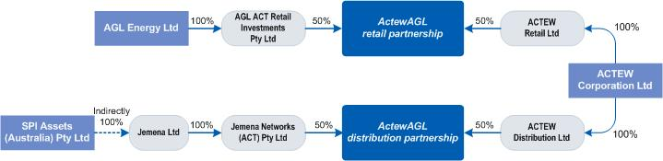

**Figure A3.1** Diagram illustrating ownership of ActewAGL. *source:* [*http://www.actewagl.com.au*](http://www.actewagl.com.au)*.*

ActewAGL:

• owns the electricity network in the ACT

• owns the gas network in the ACT and parts of the capital region

• provides retail services for gas and electricity across the capital region

• operates ACTEW’s water business

• provides management services to TransACT, Neighbourhood Cable and Ecowise

**Governance and Legislative Framework**

ACTEW Corporation is owned by the ACT government. ACTEW has a Board of Directors appointed by the Chief Minister and Deputy Chief Minister of the ACT. It retains 100 per cent ownership of the ACT’s water assets. The Utility Services Licence issued by the Independent Competition and Regulatory Commission (ICRC) under the Utilities Act 2000 constitutes the regulatory framework under which ACTEW operates.

The ICRC also determines water and sewerage prices and recommends the method for setting and calculating the water abstractions charge. Drinking water quality is regulated under the Public Health Act 1997 (ACT) which mandates a drinking water utility licence and compliance with the Drinking Water Quality Code of Practice 2007. Sewage treatment and discharge as well as recycled water is regulated under the Environmental Protection Act 1997 (ACT) with the latter being subject to ACT Heath and the EPA.

**Function**

ACTEW provides the ACT with reticulated and bulk water supply, bulk storage and waste water collection and disposal services. It operates and maintains the water and sewerage networks under contract to the owner of the networks, ACTEW Corporation. These networks do not form part of ActewAGL’s assets. In addition to major projects related to ACTEW’s water assets ActewAGL undertakes work to rehabilitate and augment ACTEW’s sewer mains.

## New South Wales (Metropolitan)

New South Wales has a range of different models for water service providers in the large metro centres which service around 70% of the State population:

• Sydney Water Corporation (State Owned)

• Hunter Water Corporation (State Owned)

• Gosford Water Supply Authority (Local Government Owned) and

• Wyong Water Supply Authority (Local Government Owned)

### Sydney Water

**Governance and Legislative Framework**

Sydney Water is a statutory corporation, wholly owned by the New South Wales Government created under the Sydney Water Act in 1994 and governed by the State Owned Corporations Act 1989 (NSW). The Board is appointed by the NSW Government which may direct the Board under special circumstances. The Board may adopt policies of the NSW Government that otherwise do not apply to Sydney Water, provided that such policies are (1) relevant; and (2) beneficial, to Sydney Water. Under the legislation, the Board is responsible to the Shareholding and Portfolio Ministers.

The utility is licenced by the Independent Pricing and Regulatory Tribunal (IPART) which also determines water prices.

**Function**

Sydney Water is the largest water utility in Australia providing drinking water, recycled water, sewerage services and some stormwater services to more than four million people in Sydney, the Illawarra and the Blue Mountains. Water is sourced from a network of dams managed by the State-owned Sydney Catchment Authority (see below) and from a desalination plant owned by Sydney Desalination Plant Pty Ltd (a subsidiary of Sydney Water) and treated and distributed by Sydney Water. The majority of Sydney Water’s capital expenditure and three quarters of operational expenditure is outsourced (see Table 5), a dramatic change from the large internal workforce of the organisation prior to the 1990s.

### Sydney Catchment Authority

A state-owned bulk water supplier for the Sydney region. Bulk water prices are determined by the Independent Pricing and Regulatory Tribunal (IPART) which also licences the utility.

### Hunter Water

Hunter Water provides water sewerage and stormwater services to the Newcastle and wider hunter region.

**Governance and Legislative Framework**

Hunter Water is a State-owned Corporation governed under the State Owned Corporations Act 1989 (NSW) and in 1992 the Hunter District Water Board was corporatised under the Hunter Water Act 1991 and began trading as the Hunter Water Corporation. The Board comprises nine members including the Managing Director together with a Chairperson and seven independent Directors appointed by the Voting Shareholders of the

Corporation. The Corporation has two nominated shareholders, being the NSW State Government Treasurer and Premier of NSW. The Corporation is the parent entity in a group which includes a subsidiary – Hunter Water Australia (HWA) which is governed by an independent Board of Directors.

All Non-executive Directors are appointed for their expertise across a range of fields, with the Managing Director the only Non-independent Director, appointed in accordance with our Constitution and State Owned Corporation Act 1989 upon the recommendation of the Board. Pricing is determined by the Independent Pricing and Regulatory Tribunal (IPART)

**Function**

Hunter Water provides water and sewerage services to over half a million people in the lower Hunter region. Their total assets are valued at approximately $3.5 billion across an area of 5,366km2. A population of 560,603 is serviced in the local government areas of Cessnock, Lake Macquarie, Maitland, Newcastle, Port Stephens, Dungog and small parts of Singleton delivering on average 184 megalitres of water per day.

## New South Wales (Regional)

### Gosford and Wyong

**Governance and Legislative Framework**

The Central Coast has the third largest urban water supply system in NSW, after Sydney and Hunter Water which was established in the 1930s by Gosford and Wyong Councils. The two councils have been working together on water supply since 1977 when the Gosford-Wyong Councils’ Water Authority (GWCWA) was formed to provide water, sewerage and stormwater services. The Water Authority Board is made up of 10 members being the Mayor, two Councillors, General Manager and a Director from each Council. The Water Authority works through the existing resources of the Councils and where necessary engages external consultants for specialist input. Pricing is determined by the Independent Pricing and Regulatory Tribunal (IPART) which also licences the utility.

The two Councils currently jointly manage the system and share the cost of construction, operation and maintenance but are working to establish the Central Coast Water Corporation (CCWC). All Council water and sewerage assets and functions may be transferred to the Corporation by July 2013 following a cost benefit analysis.

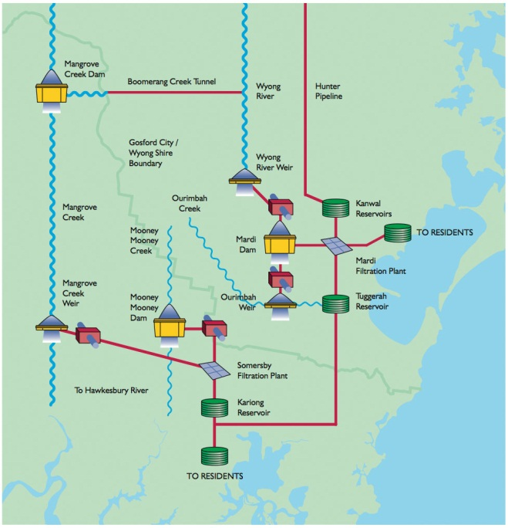The CCWC was created by the NSW Government under an Act of Parliament in 2006 and amendments passed in 2010. The CCWC was formally established in July 2011 and initially, replaces the functions of the Water Authority and provides strategic advice to the Councils. In 2013, if a complete transfer takes place the CCWC would combine the services currently provided by the Councils into a new organisation servicing the entire Central Coast. On December 15 2011 the NSW Governor endorsed the appointment of the Board of Directors to the Corporation.

**Function**

The entity provides water supply services to an urban population of 285,000 people. Water can be transferred between the two Council areas and the combined services consist of three dams, three weirs, two water treatment plants, 40 reservoirs, and 1900 km of pipelines.

**Figure A3.2** Schematic of the Central Coast water supply system. source: http://gwcwater.nsw.gov.au

### Remaining Regional NSW

In the remainder of regional New South Wales communities, comprising nearly 2 million people or approximately 30% of the population, receive water and sewerage services from Local Government. Some water operators are integrated parts of councils while others operate as independent business units which provide a measure of separation from the parent council. Water, sewerage and stormwater drainage services are provided by 106 local water utilities including:

* + 96 ‘general purpose’ local government councils,
  + four water supply ‘county councils’,
  + one water supply and sewerage ‘county council’, and
  + three water supply authorities (in addition to Gosford and Wyong – see Section 5.2.4), namely Essential Water and Fish River Water Scheme (State-owned) and Cobar Water Board (owned by Cobar Shire Councils and three mining companies).

The obligations of council and county council owned water utilities are set out in the Local Government Act 1993 (NSW) while the obligations of water supply authorities are in the Water Management Act 2000. The Local Government Act establishes the operating areas of local water utilities with 106 utilities between 200 and 65,000 connections. Local water utilities are not subject to operating licences but strive to meet the NSW Government’s Best-Practice Management of Water Supply and Sewerage Guidelines and must report on various state performance and health benchmarks to the state regulator.

Pricing is determined by the local governments informed by state guidelines. Drinking water quality is monitored by NSW Health as well as by the utilities which are encouraged to create risk-based water quality management plans under State guidelines which mention the National guidelines. Recycled Water schemes require Ministerial approval and are administered under a range of legislation.

**NSW Institutional Review**

In 2007/08 the NSW state government undertook an inquiry into sustainable urban water supply for non-metropolitan NSW. The unsatisfactory performance of some of the smaller utilities in meeting the standards of the guidelines and the high levels of investment required for future growth or capital replacement programs were two of the major drivers for reform.

Terms of Reference for the Enquiry were (Armstrong and Gellatly (2008, p. 7):

• To identify the most effective institutional, regulatory and governance arrangements for the long term provision of water supply and sewerage services in country NSW; and

• Ensure these arrangements are cost-effective, financially viable, sustainable, optimise whole-of-community outcomes, and achieve integrated water cycle management.

The enquiry found that under-performance by a number of local water utilities was a concern for economic, environmental and public health reasons and it contends that reform is necessary due to the following factors;

• the difficulties in attracting and retaining skilled staff - many areas of NSW are unable to attract skilled staff owing to declining populations and the associated reduction in the provision of community services;

• lack of effective regulatory incentives and sanctions to achieve a high level of compliance with standards and guidelines and to encourage innovation and continuous improvement;

• an absence of functional separation – water supply and sewerage are two of many functions performed by councils and compete with other functions for attention and resources; and

• lack of commercial focus – the multifunctional structure of councils may tend to inhibit the establishment of commercially focused business units.

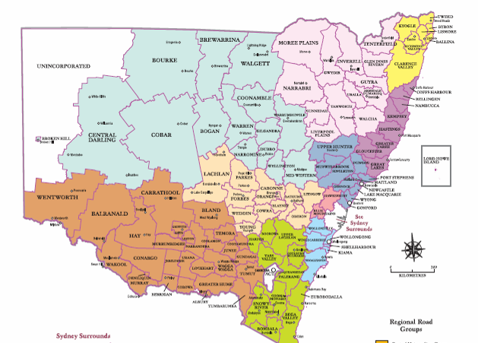

**Figure A3.3 Existing Local Government Areas in NSW.**

The review concluded that larger utilities generally perform better in meeting performance benchmarks such as the National Water Initiative’s Best Practice Management of Water Supply and Sewerage Guidelines, and often were better able to access specialist skills and facilities compared with smaller utilities. Small and more remote service providers in particular struggled to attract and retain skilled staff

The report recommended two options for aggregation (1) amalgamate 104 existing water utilities into 32 regional “groups” or (2) aggregate the 104 utilities into 15 “groups” based on regional catchments. Option (1) was the preferred recommendation and best reflected submissions from NSW councils. Three potential organisation structures were recommended for further investigation:

1. Binding Alliance - individual councils retain ownership of assets and responsibility for service delivery under a compulsory Alliance ‘umbrella entity’ which directs asset management strategy and service levels. for the constituent councils in its “group”, or
2. County Council - aggregation based on County Councils to act as umbrella organisations with full transfer of ownership, or
3. Council-owned Regional Corporations

Importantly, the ‘status quo’ option was considered to be inappropriate.

Other recommendations from the report included the need for improving regulation, external price setting, increasing consumer protection and addressing skills shortages. The latter Productivity Commission Inquiry reviewed the NSW Report and agreed with all but two of the recommendations. The first exception was the need for price setting: PC (2011a) preferred location-dependent pricing with regulatory oversight. The second was the specific recommendation for the number of aggregated water service providers. In contrast PC (2011a) recommended a case by case assessment for all regions and councils based on the long-term costs and benefits of aggregation. The New South Wales Government is currently considering the results and recommendations of the Inquiry Report and will presumably be influenced by the later national reports including PC (2011a).

## The Northern Territory

Power and Water Corporation is a government-owned corporation with the NT Treasurer as the single shareholder and the NT Minister for Essential services as the responsible Minister. Indigenous Essential Services Pty Ltd is a subsidiary of the corporation and supplies water and sewerage services in remote indigenous communities.

Water and sewerage prices are set by the NT Treasurer via an Order which is then monitored and enforced by the NT Utilities Commission. All water and sewerage services must be licenced under the Water Supply and Sewerage Services Act 2000 (NT) and this also includes service standards and drinking water quality. Minimum standards for drinking water quality are set by the Minister for Health to be the same as the Australian Guidelines along with reporting requirements. Recycled water schemes must be approved and is managed under at least two Acts.

The Power and Water Corporation provides water and sewerage services across the Northern Territory. Darwin is the only major population centre with a surface water impoundment providing supply. Other NT towns and communities rely primarily on bore water supply.

## South Australia

**Governance and Legislative Framework**

South Australian Water Corporation (SA Water) was established on 1 July 1995 under the SA Water Corporation Act 1994. SA Water is a statutory corporation subject to the provisions of the SA Public Corporations Act 1993. A Board of Directors reports to the responsible Minister and the Treasurer (the shareholders) who own the corporation on behalf of the people of South Australia. Some small local government provide services in remote areas of the state.

In 1996 the SA Government awarded United Water (made up of Veolia Water, 95% and Halliburton KBR, 5%) a fifteen year contract to manage and operate the metropolitan water and sewerage systems in Adelaide. In July 2011 the Allwater Joint Venture (made up of Transfield Services, 50%, Degremont, 25% and Suez Environment Australia, 25%) was awarded a 10-year contract for operations and maintenance of the metropolitan water and sewerage systems with KBR responsible for project management and procurement. A key competing alliance was ‘Metroaqua’ made up of United Utilities Australia, Acciona and Thiess Services.

Under these arrangements SA Water owns all infrastructure and remains responsible capital expenditure along with the collection of revenue, managing customer relationships, managing catchments and setting service standards.

In 1996, SA Government awarded Riverland Water a 27-year contract to finance, design, build and operate 10 new water treatment plants to service 90 rural communities with a total population of 100,000. The communities include Adelaide Hills, Barossa Valley, Mid-North, Upper South-East and the larger towns along the River Murray with plants at Barmera, Berri, Loxton, Mannum, Murray Bridge, Renmark, Summit Storage, Swan Reach, Tailem Bend, Waikerie. In 2025 ownership of the plants will revert from Riverland Water to SA Water.

**Function**

SA Water provides water supply services across the State (1.5 million people) including reticulated (about 16,616 kilometres of water mains) and bulk supply, water treatment and water storage facilities. SA Water is also responsible for the collection and disposal of sewerage extending through country areas with 1321 kilometres of sewers, 23 sewerage treatment plants and collecting and treating 90 billion litres of sewage annually. In Adelaide, this system includes 8,900 kilometres of water mains as well as six treatment plants (including the large Christies Beach, Glenelg and Bolivar plants). Their work

will also cover operations and maintenance of 7,200 kilometres of sewer mains, six sewage treatment plants along with various recycled water schemes.

## Tasmania

Tasmania introduced a regional water industry model in July 2009 with the aims of securing the long term sustainability of the State’s water resources amid concerns over the state of assets and adverse public health and environmental outcomes coinciding with a need for major capital investment and predicted price increases. Twenty eight local governments and three bulk water authorities (Hobart Water, Esk Water and Cradle Coast Water) were aggregated into three local government-owned utilities covering the northern, north-western and southern areas of the State. A fourth corporation provides “common services” to the regional three corporations.

|  |  |  |
| --- | --- | --- |
| tassie councils base |  | tassie councils3 copy |

**Figure A3.4.** Previous local government water service providers and regions for the new regional utilities in Tasmania.

### Governance and Legislative Framework

The Water and Sewerage Corporations Act 2008 (Corporations Act) and the Water and Sewerage Act 2008 (Industry Act) were created to form the three new corporations, namely Southern Water (based in Hobart), Ben Lomond Water (based in Launceston) and Cradle Mountain Water (in Ulverstone). The Governing Boards for the organisations have 4 common members (including the Chair) and two regional members and were responsible to the State Treasurer and the Minister for Primary Industries and Water.

### Function

The new regional corporations provide reticulated and bulk water supply and sewerage collection services across Tasmania to a population of over 400,000 or around 200,000 connections. The total value of the combined water and sewerage infrastructure in 2010 was calculated to be $2.7. billion (OTTER, 2011) Some statistics of the three new corporations are compared in Table A3.1.

|  |  |  |  |
| --- | --- | --- | --- |
| **Corporation** | **Cradle Mountain Water** | **Ben Lomond Water** | **Southern Water** |
| **No. FTEs 09/10** | 166 | 137 | 320 |
| **Prev. bulk provider** | Cradle Coast Water | Esk Water | Hobart Water |
| **Connections**  **(water)** | 43,000 | 58,000 | 95,000 |
| **Net Assets & Liabilities transferred in 2008** | 319 million | 523 million | 883 million |
| **Assets** |  |  | 2,817 km mains  60 treatment plants |
| **Area covered (sq km)** | 22,500 |  | 25,000 |
| **Council owners** | 9 | 8 | 12 |
| **Council Areas** | Burnie City  Central Coast  Circular Head  Devonport City  Kentish  King Island  Latrobe  Waratah-Wynyard  West Coast | Break O’Day  Dorset  Flinders Island  George Town  Launceston City  Meander valley  Northern Midlands  West Tamar | Brighton  Central Highlands  Clarence City  Derwent valley  Glamorgan Spring Bay  Glenorchy City  Hobart City  Huon Valley  Kingborough  Sorell  Southern Midlands  Tasman |
| **Returns to council owners 09/10 ($‘000)** | 1,364 | 3,442 | 13,167 |

**Table A3.1**  Comparison of the three new Tasmanian water Utilities. Source: OTTER 2011, and interviews with staff.

The first year review of the three new corporations was completed in 2009/10 and found a number of ongoing issues, for example:

* Water usage in unmetered areas (primarily in Hobart and the southern areas) was high with average consumption of 460 kL per property annually. In the north and north-west water consumption is 20 to 30 per cent lower.
* “the industry is characterised by substandard environmental and public health outcomes that have resulted from sustained under investment across the State”.
* “at current levels of revenue, the corporations are not financially sustainable in the long term as they will be unable to fund the replacement and maintenance of their assets over time, let alone be able to fund the significant investment required to address the current health and environmental performance issues.”
* “pricing structures continue to reflect previous council practices where customers across the State are required to pay a range of costs for the same service, which is inherently inequitable”

Further discussion about the structure of the industry were underway at the time of writing.

## Victoria

The current structure of the Victorian Water Industry resulted from micro economic reform undertaken by the Kennett Government in 1994. This saw the removal of water sewerage responsibilities and assets from 120 water boards and Local Governments across the state to four Metropolitan (City West Water, Yarra Valley Water and South East Water) and 13 state-owned regional urban water businesses. Prior to the reform metro water, sewerage and stormwater services were provided by a single, vertically integrated authority called Melbourne water which was state owned.

In regional Victoria, the reform process was underpinned by a decade of local government reform reducing the 400 council water authorities (in 1982) to 140 by 1993, which were then transferred to 15 state-owned entities in 1994. Three of these regional entities merged in 2005 leaving 13 regional urban water utilities.

Regional businesses may provide a range of services to their customers including urban (water and sewerage services to regional towns) or rural services (manage large headworks and/or bulk supplies to regional towns and farms). The amalgamation of urban and rural businesses in 2005 resulted in two businesses (Grampians Wimmera Mallee Water and Lower Murray Water) providing both urban and rural services.

|  |  |
| --- | --- |
| **Urban Water Corporations**  Barwon Water  Central Highlands Water  Coliban Water  East Gippsland Water  Gippsland Water  Goulburn Valley Water  North East Water  South Gippsland Water  Wannon Water  Westernport Water  Western Water | **Rural Water Corporations**  Goulburn-Murray Water  Southern Rural Water  **Urban and Rural Water Corporations**  Grampians Wimmera Mallee Water  Lower Murray Water |

**Table A3.3** Victorian water businesses.

**Governance and Legislative Framework**

All Victorian water utilities are subsumed under the portfolio of the Minister for Water and are either statutory authorities or corporate entities. The Metropolitan water utilities are governed by a Board of Directors, and operate under the Corporations Act 2001 (Cth). The companies are state-owned and regulated and licenced under the Water Industry Act 1994.

Melbourne Water Corporation, established by Melbourne Water Corporation Act 1992, is owned by the Victorian Government. An independent Board of Directors is responsible for the governance of Melbourne Water Corporation and the responsible Minister is the Minister for Water.

The regional water utilities are each governed by skills-based Board of Directors, who are responsible to the State Minister for Water, and regulated under the Water Act 1989.

Performance regulation is administered through the State Government via the Essential Services Commission (ESC) which regulates both the water and electricity sectors on behalf of the Government of Victoria. Prices are also set by the ESC and the authorities pay dividends to the Victorian State Government. Drinking water quality is regulated by the Victorian Department of Health under the Safe Drinking Water Act 2003 (Vic) which also sets out requirements for water quality risk management plans which reference the national guidelines. Recycled water is regulated by the Victorian EPA under the Environment Protection Act 1970 (Vic).

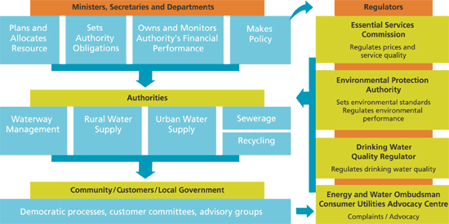

**Figure A3.5** Victoria’s Water Governance Framework (source: <http://www.water.vic.gov.au/governance>).

**Functions**

The metropolitan water utilities provide water services to the Greater Melbourne Area. Melbourne Water manages the metro area water supply catchments, sewerage network and manage rivers and creeks and major drainage systems throughout the Port Phillip and Westernport region. They are responsible for managing $8.4 billion in water supply, sewerage and drainage assets. The regional utilities may provide a mixture of urban and rural services which include water supply to urban areas and farms, sewerage services to towns and the management of head works and bulk water supplies.

## Western Australia

**Governance and Legislative Framework**

The Water Corporation services the majority of the two million WA customers in over 300 towns and communities. Other industry participants include the Bunbury, Busselton, Rottnest Is state-owned water authorities. Sewerage services in many areas are provided by local government councils.

The regulatory framework including economic regulation, licencing and monitoring is governed by the Water Services Licensing Act 1995. Other regulatory agencies include

the Department of Water and the Health Department. The Water Corporation is governed by a Board of Directors who report to the shareholders - the responsible Minister and the Treasurer - who own the corporation on behalf of the people of Western Australia.

**Functions**

The Water Corporation is chartered to provide reticulated and bulk water supply, storage, drainage, and waste water collection and disposal services across the state of Western Australia (an area of 2.5 million square kilometres).

## South East Queensland

Reform in South East Queensland has followed a complex path since the late 2000s when the severe drought and the large expenditure on infrastructure (e.g. Desalination plant, water grid) triggered reform of the water sector. Some of the key changes are summarised below.

**Local government reform process completed in March 2008**.

Amalgamation affected the seventeen existing SEQ council Water Service Providers to form ten water service providers within the ten new local governments. For bulk water, this structure was short lived (3 months).

**Transfer of bulk water infrastructure in July 2008**

Water retail and sewerage services remained with councils but all former bulk water functions were transferred mandatorily to the state. Nominal compensation for these assets was made by the State Government to Local Government, however strong concerns about the level of compensation were raised by local government at the time. The institutional reforms administered under the South East Queensland Water (Restructuring) Act 2007 and created four new State-owned Statutory Authorities:

* + The Queensland Manufactured Water Authority (WaterSecure), a bulk water “manufacturer” managing the SEQ Desalination Plant and Western Corridor Recycled Water Project including advanced wastewater treatment plants.
  + The Queensland Bulk Water Supply Authority (Seqwater), an entity that manages water sources (dams, weirs and aquifers) and water treatment.
  + The Queensland Bulk Water Transport Authority (LinkWater) responsible for major transport infrastructure.
  + The SEQ Water Grid Manager which manages contracts with the Bulk Supply and Transport Authorities and the retailers, and manages the flow of water around the SEQ Water Grid.

**Establishment of an SEQ Distribution Entity and initiation of 3 retail entities in 2009.**

While distribution and retail components of the reform framework continued to be delivered by the 10 new local governments in SEQ a single Distribution Entity, owned by the ten local governments was created to assume control of these functions on 1 July 2010. The organisation was very large relative to most national water utilities with assets in the order of $10bn, annual revenues of $1bn, and 2600 employees. Retail services were to be divided into three sub-regional entities owned by local governments.

**State reveres decision on single entity and forms three distribution-retailers in 2010.**

In May 2010 the state reversed its decision, disbanded the single entity and established (on 1 July 2010) three new local government-owned distributor-retailers, namely:

* Unitywater (servicing Sunshine Coast and Moreton local government areas)
* Queensland Urban Utilities (servicing Brisbane, Ipswich, Somerset, Lockyer Valley, Scenic Rim local government areas).
* Allconnex Water (servicing Gold Coast, Redlands, Logan local government areas).

**State reverses decision on bulk water disaggregation and combines two bulk water entities in 2010.**

In December 2010 the state announces its decision to merge two of the new bulk entities (WaterSecure and Seqwater) in July 2011 after only three years of operation.

**State reverses decision on council-owned distributor retailers in 2011.**

In April 2011 the State Government announced that legislation requiring local government distribution retail entities is to be repealed to allow councils to choose the ongoing structure of their water utilities. This results in July 2011 decision by council owners of QUU and Unity Water to continue with the new common water utilities. In contrast Allconnex owners decided to return to individual local government management of urban water services.

**Impact of pricing**

The series of changes were underpinned by strong disagreements, media coverage and public attention over rising water prices in SEQ. This is summarised well by Cousins (2010, p. 43):

New infrastructure investment to drought proof the region had a cost which had to be paid for and this has meant significantly higher bulk water prices. Water pricing reform, which has been on the agendas of all governments in Australia for many years, has also suddenly become more urgent. Consumption and investment decisions need to be guided by efficient price signals to ensure the overall welfare of the community is maximized……… There has been a tendency for governments in SEQ to try to shift blame on to others rather than to work constructively together to ensure efficient pricing is implemented. Ultimately, whatever the perceived short term political gains from this blame game, it is likely that no party will benefit. Most importantly, the effect of this disputation will be to undermine community confidence and support for reforms to be maintained.

These disputes, the political reversals and the speed of the changes have been the subject of much commentary. Coe and Harris (2011) note that:

Hindering the success of the change programs in SEQ and Tasmania has been the management of the cost impact of reform on consumers. In both jurisdictions, the same change program – which aims to promote greater efficiency – has coincided with an upward step-change in price. Whilst justified in terms of expenditure – $9 billion investment in supply security in SEQ – the cost to consumers is significant and ill-timed…..In both SEQ and Tasmania, the process of asset valuation and transfer has exposed a legacy of underinvestment by some local governments in their infrastructure, with corresponding upgrade programs needed to bring the asset base to a sustainable standard.

The complexities of rapid and sweeping reforms must be taken into account and weighed up with the costs and benefits, particularly in terms of impact on staff in an industry that is already struggling in attracting and retaining appropriate skills. “Major “overnight” changes to water prices would impose a considerable shock on individuals and businesses, which have only limited short-term capacity to change water-using behaviours” (PWC, 2010).

## New Zealand

The majority of water and sewerage services in New Zealand are provided by Councils. Local Government in New Zealand is divided into regional and territorial (city or district) councils. Regional councils cover larger areas and may include several territorial councils within their boundaries. Regional Councils manage natural resources and their use because of they often cross local boundaries. In some areas, issues such as transport planning and regional strategies are also carried out by Regional Councils.

In terms of Governance, Councillors decide the overall policies while management decide how the activities should be carried out. Various Acts of Parliament such as the Local Government Act 2002 (NZ) and the Resource Management Act 1991 (NZ) provide the framework to enable Regional councils to undertake their activities.

City and district councils are responsible for essential community services within their own areas, such as road maintenance, land-use and subdivisions, community health, and community services (libraries, swimming pools and recreation areas). The Wellington Regional Council provides a good example of how the two levels of local government cooperate on water supply (see 6.13 below).

Most large communities are serviced by City and District Councils as shown in Table A3.2 which lists the entity responsible for water supplies for all communities with more than 10,000 people. This represents around three quarters of the New Zealand Population. Details of the three largest New Zealand Water Service providers are given below as they represent three important local government models.

|  |  |  |
| --- | --- | --- |
| **Community** | **Local Authority** | **Population** |
| Ashburton | Ashburton District Council | 16,000 |
| Auckland | Watercare Services Ltd | 1,297,393 |
| Papakura | 47,216 |
| Blenheim | Marlborough District Council | 24,028 |
| Cambridge | Waipa District Council | 13,500 |
| Te Awamutu & Pirongia | 10,665 |
| Christchurch Central | Christchurch City Council | 311,000 |
| Northwest Christchurch | Christchurch City Council | 83,000 |
| Dunedin City | Dunedin City Council | 101,354 |
| Mosgiel | 10,176 |
| Hamilton | Hamilton City Council | 132,471 |
| Feilding | Manawatu District Council | 13,000 |
| Gisborne City | Gisborne District Council | 30,600 |
| Hastings City | Hastings District Council | 46,015 |
| Havelock North | 11,623 |
| Invercargill | Invercargill City Council | 50,456 |
| Kaiapoi | Waimakariri District Council | 10,843 |
| Rangiora | 13,346 |
| Levin | Horowhenua District Council | 20,000 |
| Lower Hutt | The Hutt City Council | 95,469 |
| Masterton | Masterton District Council | 19,000 |
| Napier | Napier City Council | 49,910 |
| Nelson | Nelson City Council | 43,000 |
| New Plymouth | New Plymouth District Council | 59,072 |
| Oamaru | Waitaki District Council | 11,919 |
| Palmerston North City | Palmerston North City Council | 67,653 |
| Porirua | Porirua City Council | 46,444 |
| Queenstown | Queenstown Lakes Distr Council | 18,000 |
| Richmond | Tasman District Council | 10,500 |
| Rotorua Central | Rotorua District Council | 42,500 |
| Rotorua East | 10,330 |
| Taupo - Lake Terrace | Taupo District Council | 17,105 |
| Tauranga | Tauranga City Council | 103,783 |
| Te Puke Eastern Districts | Western Bay of Plenty D.C. | 12,960 |
| Timaru City | Timaru District Council | 26,832 |
| Tokoroa | South Waikato District Council | 13,300 |
| Upper Hutt | Upper Hutt City Council | 34,650 |
| Wellington Region Bulk Water | Upper Hutt City Council Water and Wellington Reg. Council | 350,000 |
| Waikanae/Paraparaumu/Raumati | Kapiti Coast District Council | 35,800 |
| Wanganui | Wanganui District Council | 39,000 |
| Wellington City | Wellington City Council | 165,126 |
| Whakatane | Whakatane District Council | 21,020 |
| Whangarei | Whangarei District Council | 56,530 |

**Table A3.4** New Zealand water supply utilities servicing populations greater than 10,000 people supply water to more than 3.25 million people.

## Auckland - Watercare

**Governance and Legislative Framework**

Watercare is a council organisation, wholly owned by the Auckland Council which appoints the company’s board of directors. Before the current arrangements which commenced in 2010, Watercare existed but was responsible for bulk water supply to six territorial councils in the Auckland Region which provided retail services. Sewage collection, treatment and disposal was undertaken by Watercare in some areas and by councils in others. Aligned with local government realignment, Watercare was expanded to be a single, vertically-integrated water entity. Drivers for the need for reform included

* age and condition of network infrastructure,
* fragmented industry resulting in poor regional planning and decision-making,
* significant governance issues and failure to act on previous reviews,
* clear scope for improved cooperation and coordination.

**Function**

Watercare draws water from around 30 sources, treats it and delivers it to homes and businesses in six of Auckland’s seven regions. In Papakura, the company provides bulk services to United Water who manages the local network and retails services to the local community. It also collects, treats and disposes of wastewater, including trade waste from industry. The company supplies around 370 million litres of drinking water to around 1.3 million people in the Auckland region and treats around 350 million litres of sewage and trade waste.

## Wellington and Hutt Valley - Capacity Infrastructure Services

**Governance and Legislative Framework**

Capacity Infrastructure Services Limited (Capacity) was established in April 2004 to maintain water, sewerage and stormwater infrastructure for the Wellington and Hutt City Councils. It is managed on a not-for-profit basis and governed by a Board of independent Directors and Councillors. The organisation is a Council Controlled Trading Organisation.

**Function**

The organisation purchases water from the Greater Wellington Regional Council and maintains the reticulation network supplying over 165,000 people. The reticulation network includes 121 reservoirs and tanks, 5,086 km of pipes and 174 pumping stations. Water for Wellington, Porirua and most of the Hutt Valley comes from the headwaters of the Hutt River at Kaitoke and from the catchment east of Wainuiomata. The organisation also manages the sewerage network consisting of 1022km of pipes, 62 pump stations and 3 treatment plants with a total replacement value of $580 million.

## Greater Wellington Regional Council

**Governance and Legislative Framework**

Greater Wellington Regional Council is a statutory body made up of 13 regional councillors, representing six constituencies. The Council is responsible for developing policies that direct the activities of the Regional Council. Legislation including the Local Government Act 2002 (NZ) and the Resource Management Act 1991 (NZ) dictate what activities the Council should, or may, be involved with.

**Function**

Greater Wellington collects and treats all tap water used in Lower Hutt, Porirua, Upper Hutt and Wellington. Water is distributed to reservoirs owned by the four city councils, from where the water is distributed to customers. The council operates four water treatment plants, 15 pumping stations and just over 180 kilometres of large-diameter pipelines supplying around 150 million litres of water each day.

## Canada

Regulation of water and sewerage systems in Canada is under provincial/territorial jurisdiction. Similar to Australia, under the Constitution Act, 1867 (Canada), Provinces "own" all water resources and have responsibilities and their own legislation for water resource management, supply and the environment. Service provision is the responsibility of about 4,000 municipalities which are equivalent to local governments. While municipalities provide water and sewerage services directly, some outsource to private or public companies. There are approximately 9,000 service providers with 2,500 of these, or nearly 90% of the population being urban areas serviced by municipalities.

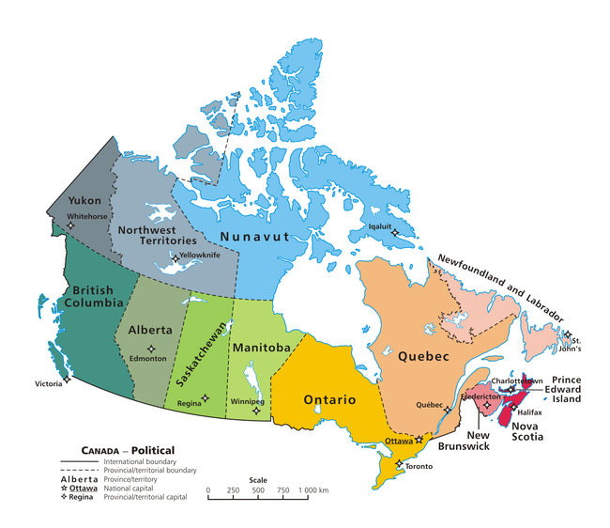

**Figure A3.5** Canadian provinces

## Scotland – Scottish Water

Scottish Water was established in 2002 provides water and sewerage services as a publically owned company responsible to the Scotland parliament. Prior to establishment of the single entity these services had been provided by three central government-owned water authorities which had been established in 1996 to replace the previous 12 regional and island council service providers. In 2008 Scotland commenced the first water and sewerage retail market in the world to increase competition in an effort to lower prices. Five business entities are licensed to compete in the market which allows non-residential customers to negotiate for better prices and standards of service.

## England and Wales

Water and sewerage services in England and Wales are provided by 11 water and sewerage companies and 11 water supply only companies. Performance targets and prices are highly regulated by the Water Services Regulation Authority (OFWAT), the Drinking Water Inspectorate (DWI) and the Environment Agency (EA). All companies are privately owned following full privatisation of the industry in 1989. Prior to this time, ten government owned regional water authorities provided total water total water cycle services some of which were outsourced to 28 privately owned, water supply only service providers since 1974.

This was the culmination of decades of amalgamations of 2,160 water undertakings and 1,370 and sewage treatment authorities. There had been under-investment in infrastructure with ageing leaking water distribution pipes, polluting discharges and out of date and overloaded wastewater treatment works. The rationale used by the Thatcher government supporting privatisation included:

• the private sector would be more efficient,

• private companies would be better able to finance the large investments needed , and

• privatisation would create competition.

The newly privatised water companies were initially unpopular with a reputation for increasing prices, high profits and poor performance. Profit margins were high by international standards, consumers who couldn’t pay had their water cut off or pressure reduced and there were major staff redundancies with job losses and increased outsourcing. Between 1974 and 1989 the number of employees was reduced from 80,000 to 50,000. In the 10 years after privatisation, employment fell by a further 40% to 31,000.

The privatised water companies were perceived poorly by the public and in the decade following privatisation, the industry was strongly subjected to the media spotlight, e.g.

• In 1992, a landslip of sewage sludge engulfed a sewage works at Huddersfield. Almost 20,000 tonnes of sewage slipped on to the plant. It completely blocked 150 m of the River Colne and forced closure of the nearby ICI manufacturing plant.

• In 1995, Sir Gordon Jones, the £189,000 a year chairman of Yorkshire Water quit after a year of drought which required water to be supplied by a convoy of up to 700 tankers with 3,500 deliveries per day which cost £3 million a week.

• In 1997, there was a serious outbreak of cryptosporidiosis in North London which affected about 400 consumers. As a consequence, the Three Valleys Water Company owned by Vivendi had to pay compensation to affected residents.

• Between 1989 and 1997 all water companies were heavily prosecuted for environmental offences and between 1997 and 1998 all ten water and sewerage companies were found guilty of a total of 260 water pollution offences.

• In 1998, the Drinking Water Inspectorate (DWI) reported that there were still weaknesses in companies’ performance. Less than 80% of zones complied with five key parameters; nitrite, iron, lead, poly-aromatic hydrocarbons and pesticides. The number of ‘serious incidents’ did not decline in the first 6 years of privatisation.

• Yorkshire Water's largest fine, of £119,000 (reduced to £80,000 on appeal), with costs of £125,598, was received in December 2000 after pleading guilty to seventeen charges of supplying water unfit for human consumption.

• North West Water was required to invest £3bn from 2000 to 2005, mainly to reduce the number of sewer overflows with around 2,000 properties at risk of sewer flooding at least once every 10 years.

## Ireland

The Irish Government intends to take a national approach to water according to a position paper released in January 2012 (DECLG, 2012). It will establish Irish Water, a State company that will take over the water investment and maintenance programmes of the 34 County and City Councils, characterised by a few large systems and many smaller, widely scattered ones. The key aim is to accelerate the pace of delivery of planned investments needed to upgrade the State’s water and sewerage networks and to install water meters in households.

An independent assessment was undertaken with an assessment of the existing structures for the provision of water services and making recommendations in relation to how services might be modernised and re-structured. The current weaknesses were broadly categorised as:

• Variability of service – absence of consistent policies, processes and standards and variable performance standards

• Inability to realise economies of scale, duplication of management and absence of/limited industry standard IT and management information systems

• Long term under-investment in assets and limited asset data to support strategic planning

As part of the study, a range of key performance indicators from the Irish water sector were compared with the UK water companies, Northern Ireland Water and Scottish Water.

The evidence indicated that:

• An operating expenditure per connection up to two times more expensive than the UK,

• Leakage levels were double the UK average (41% as compared to 20%),

• The number of employees involved in water services is 25% higher than the UK median,

• The number of employees per water connection and per customer served are significantly higher than the UK median, and

• Scottish Water achieved operational savings of 40% over a five year period.

International models for water service provision were also reviewed to identify trends and lessons to be learned for water sector reform in Ireland. Relevant models for water service provision in a number of countries, including Scotland, England, Wales, Northern Ireland, Germany, France, Netherlands, South Africa and Australia were reviewed. The study showed that the fragmented nature of water service provision in most countries has been or is being addressed by the amalgamation of municipal water services, the creation of utilities or the use of inter-communal structures.

Irish Water will have both a regional and local focus which will be achieved by organising operational regions based on river basin districts. In addition to the primary goal of ensuring compliance with statutory quality standards, other objectives are:

• Ensure security and quality of supply

• Consistent and transparent service quality

• More efficient cost base and lower unit cost of delivery

• Critical employment mass to attract key talent

• One decision making authority with a more coherent and integrated structure

• Clear lines of accountability, authority and responsibility

• Meeting the investment needs and rising operational costs.

From a staffing perspective, Irish Water was said to able to present opportunities not otherwise available to staff who wish to pursue a career in water services. Increased specialisation will provide routes for career development as well as enhancing job satisfaction. An increased emphasis on training and development and the introduction of new systems at an accelerated pace will provide both challenges and opportunities.

## USA

Public Water Systems in the USA are defined as those supplies having 15 or more connections or servicing at least 25 people for 60 days of the year. There are over 160,000 such systems, but the majority of the population (approximately 268 million) are serviced by 54,000 Community Water Systems (USEPA, 2009). Around 32% of these systems draw water from aquifers and the remainder rely on surface waters and the quality of drinking water is regulated nationally under the Safe Drinking Water Act 1974 (USA). The Act requires providers to report to their customers, State agencies and the USEPA on water quality, but in 2001, “one out of four systems did not conduct testing or report the results for all of the monitoring required” (USEPA, 2009, p. 3).

Water utilities may be publically or privately owned with private utilities involved in servicing around one quarter of the population (National Association of Water Companies website 2012). In most metro areas with populations greater than 100,000 people (nearly half of the population or 130 million people) services are provided by city or regional water and sanitation utilities that may be publically or privately owned. In fact 8% of the community water systems service over 82% of the population (USEPA, 2010). In regional areas most utilities are publically owned by a city or county level of local government or by utility cooperatives jointly owned by customers including local governments.

# Appendix 4 – Ten Principles Developed by the Queensland Regional Taskforce to Guide any Institutional Change of the Urban Water Industry.

In 2008 the Local Government Taskforce considering the “Future of the Water Industry Outside South East Queensland” determined 10 Principles that should guide any institutional reform in regional Queensland. These principles were subsequently endorsed by the Executive Committee of the LGAQ and presented to the State Government to inform future discussions on institutional reform of the urban water sector. The Principles are listed below.

1. Efficient and effective service delivery and resource use.
2. Equitable and transparent water sharing across and between regions.
3. Needs of individual communities to remain a vital driver of management, policy and planning.
4. Management of water businesses needs to deliver returns that allow for appropriate asset renewal with a dividend on assets returned to the community through Local Government (with no cross-subsidisation of other council services).
5. No community to be substantially disadvantaged (reasonable price for basic access).
6. Water planning framework to be consistent across the state.
7. Water planning and management needs to be directly linked with statutory and land use planning activities of local government.
8. Long-term sustainable asset management (taking into account, for example, Water Sensitive Urban Design, System Supply Losses, Integrated Water Cycle Management and maximising the benefits of vertical integration).
9. Local Government to retain ownership.
10. Creation of autonomously governed and managed sustainable water businesses to ensure among other things:

* Accountability;
* Management and technical capacity to appropriately respond to changing economic and technical regulatory frameworks (including reporting obligations);
* Capacity to provide for ongoing training, skills enhancement and development needs of staff; and
* Skills/experience based, independently appointed board/governance with minority representation by local councillors.

# Appendix 5. SWOT Analysis of different structural options

**Table A5.1 - Option A: Individual local government water service providers**

This option is considered to include the no-change (or status quo) situation and to recognise that reviews allowed for individual council (or council-owned) water service providers in the case where this could be shown to be the most efficient and effective solution.

|  |  |  |  |  |
| --- | --- | --- | --- | --- |
|  | **Strengths** | **Weaknesses** | **Opportunities** | **Threats** |
| **1. Improved Service and Customer-focus** | * Service standards are generally accepted by individual communities. * Communities can influence water services through well-known council processes. * There is a strong perception that customers are comfortable with local ownership of water services. * As this represents the status-quo, any change would incur costs and increase prices. * There are economies of scope across the various customer services provided by councils. * Some large councils have strong customer service focus and policies. | * Pricing policies are influenced by politics more than efficient and sustainable delivery of water services (particularly in small councils). * Water quality can have a low priority in small councils some of which do not adopt the national guidelines. * Important reforms that are not universally popular can be delayed by political pressure. * Many customers are unaware or indifferent assuming the council manages water efficiently and effectively. * Historically, low levels of collaboration among councils act against economies of scale. | * Prices could be set at individually-appropriate cost-recovery levels. * Councils could work towards maximising customer service based on their intimate knowledge and links with the community. * Benchmarking or yardstick competition could be achieved (e.g. through SWIM). * Economies of scale to improve customer service could be accessed through greater regional and state-wide knowledge-sharing. * Economies of scope could be quantified to demonstrate the utility of council services. | * Instances of poor service can trigger widespread top-down reform insensitive to local needs & conditions. * Small councils lack capacity to keep pace with external drivers (technology, broad community expectations, climate change). * Reliability and security of supply can be unachievable on a small scale despite the best efforts of council. * Expectations of economies of scale can be over-emphasised due to the large distances between communities in Qld. * Inadequate pricing and under-investment will result in extreme price-hikes. |
| **2. Public Health and Environmental accountability;** | * Local councils can have better access to specific knowledge of local environmental and public health issues. * Small councils/ communities may have a small environmental footprint due to the distributed and simple (yet effective) small-scale water and sewerage systems. * ‘Liveability’ factors sought for large cities can be more accessible in small communities. | * Water quality management does not follow national guidelines in all small councils. * Many councils lack capacity to address increasing societal expectations for managing public health and environmental risks. * Some small councils do not meet best-practice wastewater discharge standards. * Small councils lack the capacity to optimise their systems to reduce greenhouse impacts. | * Local councils can develop fit-for-purpose risk management and compliance protocols and procedures. * With greater investment and appropriate controls, some small councils (particularly those using bores) could be mostly self-sustainable with a small environmental footprint. | * Increasing expectations of larger metro areas drive regulation and policy focus in smaller communities despite the local community’s desires. * Some of the strengths and opportunities recognised for small councils could also be achieved easily under alternative institutional arrangements. |
| **3. Ongoing Council & Community Sustainability** | * Current perceptions of community sustainability will not be challenged by status-quo. * Water income provides a much-needed income source for a great number of councils. * Local WSPS can maintain local employment and skills. * Rates are generally maintained at affordable levels. | * Some councils are financially unsustainable even with current water income. * Cross subsidies are not always transparent. * Under-investment and pricing that does not cover costs creates a debt that will be borne by future communities. * Small communities have a small skill-base and often cannot recruit internally. | * Community growth and liveability could be enhanced through whole-of-council planning involving the council’s water service provider taking advantage of economies of scope. * Skills and training programs can be developed within local communities. | * Forced reform could negatively impact council or community sustainability. * Small communities are losing skills regardless of the water industry. * Reform of LG WSPs into regional organisations has occurred in SEQ, Tasmania, Victoria, Auckland, Ireland and Scotland despite council protests. |
| **4. Best Practice Governance** | * Some council’s processes can reflect best-practice governance and community involvement. * Some councils manage their water units in a transparent manner that is easily accessible to the community because of the standard and well-understood local government model. * Councillors can be easily accessible and accountable to their communities particularly in small communities. | * Some councils (particularly small) are not transparent in managing their water business. * In many councils, water services have low priority compared with other functions. * Councillors generally lack skills and experience in governing a water business. * Council response to community issues can favour vocal groups overlooking broader interests. | * Good governance processes within a council framework have the potential to provide the most accountable and transparent governance approach for small community water businesses. | * Increasing emphasis on commercialisation and privatisation of water businesses increase the expectations of best practice governance. * Increasing responsibilities and regulation of local government is increasing pressure on council management of their water business. |
| **5. Optimised Planning and Management** | * Water operations and management in many councils is cost-effective due to low resourcing and a culture of efficiency. * This can also be a driver for innovation. * Water planning is aligned closely with council and community planning. * Councils bring together broad resources in the face of crisis and often have planned redundancy with neighbours in emergency response situations. * Councils are best placed to understand local conditions and this is particularly important in remote areas and communities where drought and/or flood cycles are key drivers. | * some small councils lack capacity to undertake effective strategic planning focussed on water services. * low capacity councils can struggle to undertake effective management and planning. * the above two issues mean that resilience and capacity to respond to change can be low. * the large number of council WSPs and their remoteness can mean that innovative/ new responses are slow to spread. * water businesses have limited influence on total funding levels or strategic planning over the medium-long term. * political decision making means that some issues are put aside until crises galvanise public opinion. | * economies of scope provide opportunity for councils to optimise planning in line with broader community needs. | * Increasing external challenges and decreasing internal capacity in many small councils mean that risks to regional water services are increasing in number and magnitude. |
| **6. Sustainable Staff and Asset Management and Planning** | * There are economies of scope within councils allowing assets to be incorporated within a broader infrastructure portfolio. * This broad scope also improves attraction and retention of staff (e.g. engineers attracted to the diverse portfolio of work and community service). * Some staff resources (e.g. administration, call centres) can be shared across council activities. * Any income reserves from a water business are automatically returned to the community through council activities. | * Water assets, including skilled staff, are part of a broader set of priorities and do not receive strong focus, particularly in small councils. * Cost recovery and appropriate depreciation and investment is not always achieved particularly in small councils. * In some councils staff skills do not receive priority and staff numbers are determined by broad council HR policies rather than business needs. * Small size and limited water resource options mean that infrastructure is not resilient in the face of change. * Asset management in isolation across numerous small providers increase the risk of inefficiencies. | * Collaboration on joint skills initiatives and training can increase staff skills and morale and provide for internal succession programs. * Some councils have developed strong training partnerships with training providers using best-practice training and technology. | * Increasing costs and the removal of State subsidies makes planning and investment increasingly difficult (esp. for small). * The national skills shortage in the industry increases the difficulties of attracting and retaining staff (particularly in small and remote). * Increased emphasis on commercialisation makes traditional processes of management and cross-subsidisation unacceptable. |
| **7. Improved Articulation with Regional Planning** | * Local government involvement in regional planning processes is well established and understood by the community. * The large number of water service providers can provide broader input from small and diverse communities. | * Council boundaries do not always align with catchments. * The large number of councils can complicate agreement on regional planning and can unnecessarily increase costs. * Councils must defend parochial interests in spite of broader regional needs. | * The impacts of the 2008 council amalgamations on regional processes have not yet been fully realised and could contribute to improved regional planning. | * Increasing emphasis on regional planning may leave local processes behind. |
| **8. Reduction of Transaction Costs** | * The large number of council WSPs can avoid transaction costs between widely-spaced communities. * Many council WSPs are fully vertically integrated reducing transaction costs across the water cycle. * Economies of scope exist among WSP functions and other council activities (e.g. land use planning). | * Strong council focus on local issues can lead to poor sharing of knowledge in neighbouring communities. * The large number of small utilities, their remoteness and low capacity reduces their ability to interact with or influence regulators (based primarily in Brisbane or Canberra). | * Council WSPs could take advantage of vertical integration and low transaction costs with neighbours and use yardstick competition with other similar WSPs to optimise their water businesses. * Group representation (e.g. through LGAQ and ***qldwater*** can result in a strong voice for council water businesses). | * Increasing regulation and interest from state and national bodies will increase transaction costs for a WSP despite its capacity and past performance. * The large number of WSPs increases transaction costs with regulators and other state and national bodies. |

**Table A5.2 - Option B(1): Voluntary alliances and regional collaboration.**

SWOT analysis of voluntary alliances model listing features additional to those listed for status-quo model (Table A5.1).

|  |  |  |  |  |
| --- | --- | --- | --- | --- |
|  | **Strengths** | **Weaknesses** | **Opportunities** | **Threats** |
| **1. Improved Service and Customer-focus** | * Local managers remain responsible for their local community services. * Customer Service Standards and rates could be could be standardised across a region but retain diversity reflecting fit-for-purpose requirements of each community. * Increased knowledge sharing across a region and greater capacity for specialisation. * Some regions are likely to share communities of interest. * Relatively little investment in change compared with other models. | * Community perceptions of neighbouring councils involvement would be negative in some instances. * Perceptions of cross-subsidisation of small communities by large. * Low-capacity communities may impact on capacity of regional neighbours. * Some regions have historical antipathies among neighbouring communities that act against collaboration. * Parochial interests would be a barrier to cooperation and any improvements in customer service would be subject to competing council interests. | * Sharing call centres across a region. * Sharing of water resources could result in greater resilience in times of drought (where distance is not prohibitive). * Broad regional interests could be assessed to counter parochial interests. | * Small schemes that are marginal to run may receive less focus. * State and Commonwealth funding may being less accessible based on a false perception that the regional group is sufficiently sustainable to support low-capacity members. * Increased specialisation and ‘centralisation’ of some functions could reduce capacity and redundancy in small communities. * benefits would be strengthened and weaknesses reduced if the model businesses were integrated fully. |
| **2. Public Health and Environmental accountability;** | * Consolidation of IWCM on a regional basis taking advantage of vertically integrated nature of many council water businesses. * Regional environmental values and common public health concerns would be shared across some regions. | * Improvements would rely on regional agreement and investment in voluntary joint approaches. These have been rare in practice in the past. | * Joint responses to regulators could allow a stronger regional approach to improving public health and achieving environmental protection. | * Variety of environmental values across some regions. * Public health concerns (and perceptions) can vary dramatically across a region and not reflect broader best-practice. |
| **3. Ongoing Council & Community Sustainability** | * Perception of council stability and their income from the water business would not have to change. * Councils with low capacity could benefit from the skills and experience of their neighbours. * Some councils could build capacity in areas of specialisation made available by business scale. | * Water rates will increase as any form of collaboration will require investment. * Specialisation of functions in one council would result in reduced local capacity in others and impact staff and sustainability. | * Joint regional programs could address council sustainability on a broader basis and take advantages of economies of scale within the region. | * Voluntary change will be extremely slow in some regions and lack of state-wide momentum could drive universal reform despite local regional efforts. |
| **4. Best Practice Governance** | * Governance can retain current local government processes which are understood by the community. | * Governance would be complicated and slowed by the sometimes competing processes of various collaborating-councils. |  |  |
| **5. Optimised Planning and Management** | * Some economies of scale would be accrued regardless of distance between schemes, particularly for skills * Greater ability to share knowledge with other regional WSPs and potentially with other regions. * Documentation, systems and reporting could be streamlined across an entire region. | * Planning systems would be directly subject to all of the different systems and Strategic plans of each of the participating councils. * Management would be spread across several councils requiring clear delineation of complex responsibilities and accountabilities. | * areas of specialisation in planning and management could be developed in one or more councils. * possibility of sharing and standardisation of water planning and management systems. | * Any improvements in planning and management could be viewed as indicating a need for greater integration. * Specialisation could result in loss of skills or employment in some communities. |
| **6. Sustainable Staff and Asset Management and Planning** | * Integration and economies of scale in some functions across a region. * Local enforcement could be simplified on a regional basis. * No new systems (e.g. asset management, HR IT) need be created. | * LG staff may not have equal opportunity for development in all areas of the water business. * Difficulty in coordinating some shared functions across several councils (e.g. HR, admin, IT). | * standardisation of asset management systems and procedures. * potentially greater career opportunities for staff within a larger region. |  |
| **7. Improved Articulation with Regional Planning** | * Improved regional coordination and management. * regional approach could strengthen regional relationships. | * Regional planning would still be subject to individual plans of several councils. |  |  |
| **8. Reduction of Transaction Costs** | * Understanding of regional needs could be clarified resulting in improved priority-based access to State and Commonwealth assistance. * Transactions between the water business and regulators/ other state and commonwealth stakeholders could be streamlined or reduced. | * Perception that control of water is being removed from local communities. * Increased transaction costs of collaboration, particularly in start-up phase. * Resources required to commence and maintain collaboration. | * Opportunity for long-term reduction in transaction costs of individuals through specialisation throughout the region. | * reduction in transaction costs could be lead to calls for further integration and thus limit the lifetime of this model. |

**Table A5.3 - Option B : Regional Alliance with a separate entity.**

SWOT analysis for regional cooperation with a joint, council-owned entity (but not a strict corporation). This option could be similar to the NSW county council model.

|  |  |  |  |  |
| --- | --- | --- | --- | --- |
|  | **Strengths** | **Weaknesses** | **Opportunities** | **Threats** |
| **1. Improved Service and Customer-focus** | * Dividends from water and sewerage services would be transparent to customers. * Focus of the organisation is solely on efficient service delivery to customers. * Customer Service Standards and rates standardised across a region but retain diversity as needed. * Increased knowledge sharing and greater capacity for specialisation. * Resources, systems structures and skills would be shared across a region. * Single response to regulators would allow a cohesive regional approach to improving public health and achieving environmental protection. | * Would necessarily distance managers from the infrastructure and communities for which they are responsible. * A focus on regional priorities could disadvantage some communities, particularly those that have historically invested strongly in water (and are thus not a priority. * Billing would be separate from council rates. * Significant transition costs of change and likely increased costs of service. * Antipathies to regionalisation would be a political issue. * Increased specialisation and ‘centralisation’ of some functions could reduce capacity and redundancy in small communities. |  | * Small schemes that are marginal to run may receive less focus, or alternatively may receive most focus at the cost of reduced service standards in larger areas. * Threat of monopoly pricing if not appropriately regulated. * Customer Service Standards may overlook previously recognised unique needs of some communities. |
| **2. Public Health and Environmental accountability;** | * Consolidation of IWCM on a regional basis taking advantage of vertically integrated nature of many council water businesses. * Accountability would rest with a focussed group. * Economies of scale would allow for specialised public health and environmental health officers/teams. |  | * Regional benchmarking could increase best-practice public health and environmental management beyond regulatory standards. | * Potential for disagreement with owner-councils. * Variety of environmental values across some regions. * Public health concerns (and perceptions) can vary dramatically across a region and not reflect broader best-practice. |
| **3. Ongoing Council & Community Sustainability** | * Dividends and cross subsidies to owner-councils would be more transparent. * Councils with low capacity would benefit from the skills and experience of their neighbours. * Could be viewed as a more favourable outcome that further corporatisation or State take-over of ownership and management. | * Costs of transition would flow to the community & water rates will increase. * Potentially less income for local governments. * Reduced purpose for local governments and their staff could impact their sustainability. * Specialisation of functions in one council would result in reduced local capacity in others and impact staff and sustainability (e.g. loss of jobs in small communities). | * Sustainability of regional councils could be a key driver of the regional organisation’s charter providing a broader basis and take advantages of economies of scale within the region. | * Perception or reality of local issues being overlooked with no recourse to council. * There is no specific consumer body or ombudsmen for the regional water industry. |
| **4. Best Practice Governance** | * Governance would be at arms-length from political decision makers and would be necessarily transparent. * Boards could be selected on a skills basis. * Potential for councillor involvement on skills-based boards. * Potential for alignment with SEQ system allowing for knowledge sharing and simplified benchmarking. | * Ownership by numerous councils and their involvement in the governance process would unnecessarily slow decision making if parochial interests are poorly managed. * Perception that control of water is being removed from local communities. | * Transparent rules on competitive pricing, taxation, accountability and liability could be developed. | * Community could be distanced from decision making. |
| **5. Optimised Planning and Management** | * Economies of scale would be accrued regardless of distance between schemes, particularly for skills (as in council amalgamations). * Greater ability to share knowledge with other similar WSPs nationally. * Greater asset base on which to fund future upgrades. * Debts can be better managed. * Documentation, systems and reporting could be streamlined across an entire region. * Increased planning capacity could identify and correct areas where infrastructure has been poorly supported in the past. | * Some assets or services could have low priority regionally * Alignment with of water and local government planning could be more difficult. * Specialisation and centralisation of some functions would result in loss of skills or employment in some communities. * Asset planning is likely to indicate increased investment is required to balance past under-investment leading to increased water rates. | * Charter could be drawn up to protect disadvantaged communities. | * Loss of skills from local communities, particularly if greater outsourcing is chosen as an appropriate planning and management model. |
| **6. Sustainable Staff and Asset Management and Planning** | * Greater career opportunities for staff within a larger organisation could improve attraction and retention opportunities. * Integration and economies of scale in some functions across a region. * Regional enforcement could be simplified on a regional basis. * Asset management centralised and prioritised on a needs basis. * Standardisation of asset management systems and procedures. * HR policies and procedures specialised for the urban water industry rather than local government. | * New systems (e.g. HR, admin, IT) would need to be created and rolled out across the region. * Uncertainty for staff transferring to new systems and employer. | * Opportunities for regional networking and innovative work practices could open a greater regional pool of new staff. * Greater negotiation power as region could mitigate the loss of staff to resources sector or other competitors. | * There is a risk of losing staff to other sectors during a significant reform process. * May have reduced access to State funding or to NDRRA etc. if considered a commercial entity * conflict over enterprise agreements (e.g. local, state of federal systems depending on organisational model). |
| **7. Improved Articulation with Regional Planning** | * Improved regional coordination and management due to fewer entities. * Regional approach could strengthen regional relationships. | * Costs of ensuring centralised water organisation planning articulates with that of owner councils. | * Regional water organisation could be a champion for regional planning that impacts the water cycle. | * Regional planning for water could overlook the needs of local governments through focussing on the water utility stakeholder. |
| **8. Reduction of Transaction Costs** | * Understanding of regional needs could be clarified resulting in improved priority-based access to State and Commonwealth assistance. * fewer interfaces between the water business and regulators/ other state and commonwealth stakeholders. |  | * . | * Transaction costs with owner councils. * State government involvement through legislation forming the organisations. |

**Table A5.4 - Option C: Additional features for council-owned regional corporations.**

SWOT analysis of regional council-owned corporations listing factors to be considered in addition to the general features in Table A5.2 (which are common to some degree in all collaborative models).

|  |  |  |  |  |
| --- | --- | --- | --- | --- |
|  | **Strengths** | **Weaknesses** | **Opportunities** | **Threats** |
| **1. Improved Service and Customer-focus** | * As for Table 5.3. | * As for Table 5.3. | * Corporate model can be leaner (i.e. provide greater dividends to the community than jointly-owned models). | * As for Table 5.3.. |
| **2. Public Health and Environmental accountability;** | * As for Table 5.3. | * As for Table 5.3. | * Charter of corporation could be written with focussed public-good and environmental and liveability outcomes. | * Corporations can be seen as less focussed on public-good outcomes. |
| **3. Ongoing Council & Community Sustainability** | * As for Table 5.3. | * As for Table 5.3. | * As for Table 5.3. | * Community perceptions may be less favourable to corporate model. |
| **4. Best Practice Governance** | * Well understood - transparent rules on competitive pricing, taxation, accountability and liability. | * Less potential for councillor involvement on skills-based boards. | * Potential, capacity to vary ownership and investment in the organisation. | * Community and council owners would have less ownership of governance and little experience in dealing with this model. |
| **5. Optimised Planning and Management** | * As for Table 5.3. | * As for Table 5.3. | * As for Table 5.3. | * Potentially further removed from LG planning than other models. |
| **6. Sustainable Staff & Asset Planning & Management** | * As for Table 5.3. | * Corporate model would be new to many existing staff. | * As for Table 5.3. | * Perception that public assets could be sold off or allowed to run down. * IR issues for corporations under federal law. |
| **7. Improved Articulation with Regional Planning** | * As for Table 5.3.. | * As for Table 5.3.. | * Corporation charter could specify clear need for the organisation to champion for regional planning that impacts the water cycle. | * As for Table 5.3. |
| **8. Reduction of Transaction Costs** | * As for Table 5.3. | * State Government involvement would be reduced to that of regulator. | * As for Table 5.3.. | * As for Table 5.3 but potentially exacerbated by corporate model and separate Board. |

**Table A5.5 - Option D: Additional features for State-owned regional corporations.**

SWOT analysis of regional state-owned corporations listing factors to be considered in addition to the features of a local government organisation in Table A5.4 (which are common to some degree to both models).

|  |  |  |  |  |
| --- | --- | --- | --- | --- |
|  | **Strengths** | **Weaknesses** | **Opportunities** | **Threats** |
| **1. Improved Service and Customer-focus** | * Many community members already view the state government as being responsible for water matters. * Communities may benefit from buy-out of infrastructure by the State. | * Community has no ability to appeal at a local scale on consumer issues. * State politics (rather than local politics) would be stronger driver for remote regional communities. * Cost of transition would include asset and debt transfer. | * Greater communication with State regulators on CSS, CSOs. * spreading of costs equitably across the state rather than individual regions. | * No consumer or ombudsman function in Qld. * Postage stamp pricing that is not costs reflective and spreads costs to communities that have heavily invested in water services in the past. |
| **2. Public Health and Environmental accountability;** | * As for Table 5.3/5.4. | * As for Table 5.3/5.4. | * Potential for great communication between water entities and regulators (reduction of us vs them mentality). | * . |
| **3. Ongoing Council & Community Sustainability** | No dividend s paid to local communities. | * No dividend returned to councils reducing financial sustainability. * Likely low support of this model from communities and current council owners. | * Potential for state subsidies to disadvantaged regions. * Compensation payments would need to be made to individual councils. | * . |
| **4. Best Practice Governance** | * State-owned water entities have strong role-models in other jurisdictions. | * Organisation would be influenced by state politics. | * . | * . |
| **5. Optimised Planning and Management** | * As for Table 5.3/5.4. | * As for Table 5.3/5.4. | * Potential for improved communication and collaboration with Sunwater. | * . |
| **6. Sustainable Staff & Asset Planning & Management** | * As for Table 5.3/5.4. | * Model would be new to most staff. | * . | * IR issues for transition to state-owned entity. |
| **7. Improved Articulation with Regional Planning** | * As for Table 5.3/5.4. | * Greater distance of regional and LG planning for water. | * Could improve communication with other state-run regional planning processes. | * . |
| **8. Reduction of Transaction Costs** | * There would be markedly reduced transactions with local governments. | * LG may need to increase advocacy role to influence state water corporations. | * . | * . |

1. For status quo options, a rating of “2” implies that some change is required within the current model for it to fully meet the criterion.
2. In South East Queensland SEQWater and Link Water provide bulk water services primarily for urban customers under the complex arrangements of the SEQ Water Grid (see Section 5.9).
3. An exception is the Wide Bay Water Corporation which is a proprietary limited, wholly council-owned (Fraser Coast Regional Council) entity.
4. Of the 11 utilities in Figure 8 using more than 850 kL per annum, nine sourced water from the Great Artesian Basin.
5. This option was dismissed as unfavourable by two reviews, but was thought to be appropriate in others for larger or highly-efficient council service providers.
6. The option suggested by AECOM (2010) that there could be a single state-owned water utility for regional Qld outside of SEQ is not considered for four reasons.

   This was the least favoured option even in the AECOM report and was eliminated also by the later PC (2011) review.

   The option was not supported by the stakeholders in the review itself (AECOM, 2010) and is not favoured in Queensland or NSW (see e.g. Armstrong and Gellatly 2008) or Tasmania (see Appendix 3).

   Even if it were adopted AECOM 2010 note that “Due to the number and complexity of catchments in NSW and Queensland, the State’s water supplies would still be required to be managed on a regional basis. Regional issues would also be better managed by local staff living within the supply area, and consumers would also expect a level of local presence.”